Bild:
Editor Autor: Awesome Earthmovers, Nina Lindner, Jennifer Bortmes
Location Ort: Linz, Österreich

Date Datum: 01.06.2023

Recycling contractor relies on SENNEBOGEN for fleet renewal

One of Austria's largest recycling contractors, Rieger Entsorgungs GmbH, operates at several locations in Austria and Germany and is currently modernising its fleet of material handling machines. Two new SENNEBOGEN material handlers were recently put into operation: the SENNEBOGEN 822 from the brand new G series and the electrically driven SENNEBOGEN 821 E.

Recycling contractor with a long and successful history

Rieger Entsorgungs GmbH can look back on a long and successful history that has set it apart from many competitors since its foundation. The company was founded in 1925 by Georg and Katharina Rieger with a small carriage business. Originally, the family business started with a coal and fuel oil business. Over the years, the company specialised in waste disposal and recycling. The striving for industry leadership was reinforced in 1988 with the commissioning of Austria's first waste sorting plant and certification according to ISO 9002 and ISO 9001. Since 2007, Johann Rieger jun. has managed the recycling company with more than 150 employees, over 1,000 containers and more than 100 trucks, as well as a fleet of machines specialised in material handling. The Linz facility handles more than 50,000 tonnes of material annually, most of which comes from within a 50 km radius. The diverse range of materials includes everything from household waste, commercial, construction and industrial wastes. The material is sorted, processed and segregated before being loaded for disposal or further recycling.

Exploiting full capacity: 822 G impresses with maximum comfort and performance

For the renewal of the material handling fleet, the company examined all options on the market. Gerhard Pirchner, Ascendum sales representative, has been supporting Rieger Entsorgungs GmbH in matters of construction machinery for several years and enabled the company to test the SENNEBOGEN 822 of the new G series. Site manager Helmut Vorwagner explains: "We knew about Ascendum's good service and wanted to test whether SENNEBOGEN met our requirements. Gerhard Pirchner organised a new 822 G material handler with a 10 m reach and a 450 litre sorting grab for us to try out for a week. We tested it and liked it so much that we didn't want to give it away!"
As the successor to the 818 E and the latest addition to the G Series, the 822 G offers a number of optimisations that significantly increase operator comfort and performance while reducing fuel consumption. The intelligent arrangement of the machine components allows easy access to all service points for daily maintenance. The new, elevating cab with a panoramic view features an extra-wide and air-conditioned comfort seat. The machine can be optimally adjusted to the driver's individual needs via storable driver profiles. For operator Bashkim Holili, the improvements in the cab are a great relief in his daily work. While the recycling of wood products plays a central role at the Linz depot, Holili is also entrusted with the handling of a variety of other materials, such as construction materials, which are dumped on the site in large quantities. After the material has been sorted and segregated with the SENNEBOGEN 822 G, it is loaded into bulk trailers and delivered to various recycling plants. When loading the containers, Holili makes full use of the SENNEBOGEN's elevating cab: "This makes loading much easier and safer for me. I can see exactly where there is additional room for material and ensure that I can use the full capacity every time. The precision of the new joysticks helps me to break down the material and gives me much more control compared to my last machine."

Strong addition to the fleet with electric machine 821 E

The new material handling fleet is completed by the electrically powered SENNEBOGEN 821 E at the headquarters in Neumarkt am Wallersee. The goal was to make the company's processes more sustainable. For the machine, which is directly connected to the power grid, a large part of the energy is generated by the in-house photovoltaic system. The powerful 90 kW electric motor of the SENNEBOGEN 821 E and the mobile undercarriage are perfectly suited to the conditions on site. Due to the lower maintenance effort, caused by the omission of tank stops, oil or filter changes, the material handler scores with considerably lower operating costs, works emission-free and is always ready for use.

The SENNEBOGEN duo in the Rieger fleet will be in use for up to 10 years. For this fleet renewal, the overall package of efficient and powerful machines from SENNEBOGEN as well as optimal support and service from Ascendum was convincing. Managing director Johann Rieger explains: "We want machines that will accompany us through a long and productive working life and make our daily work easier. That's why we chose SENNEBOGEN material handlers."

Captions:

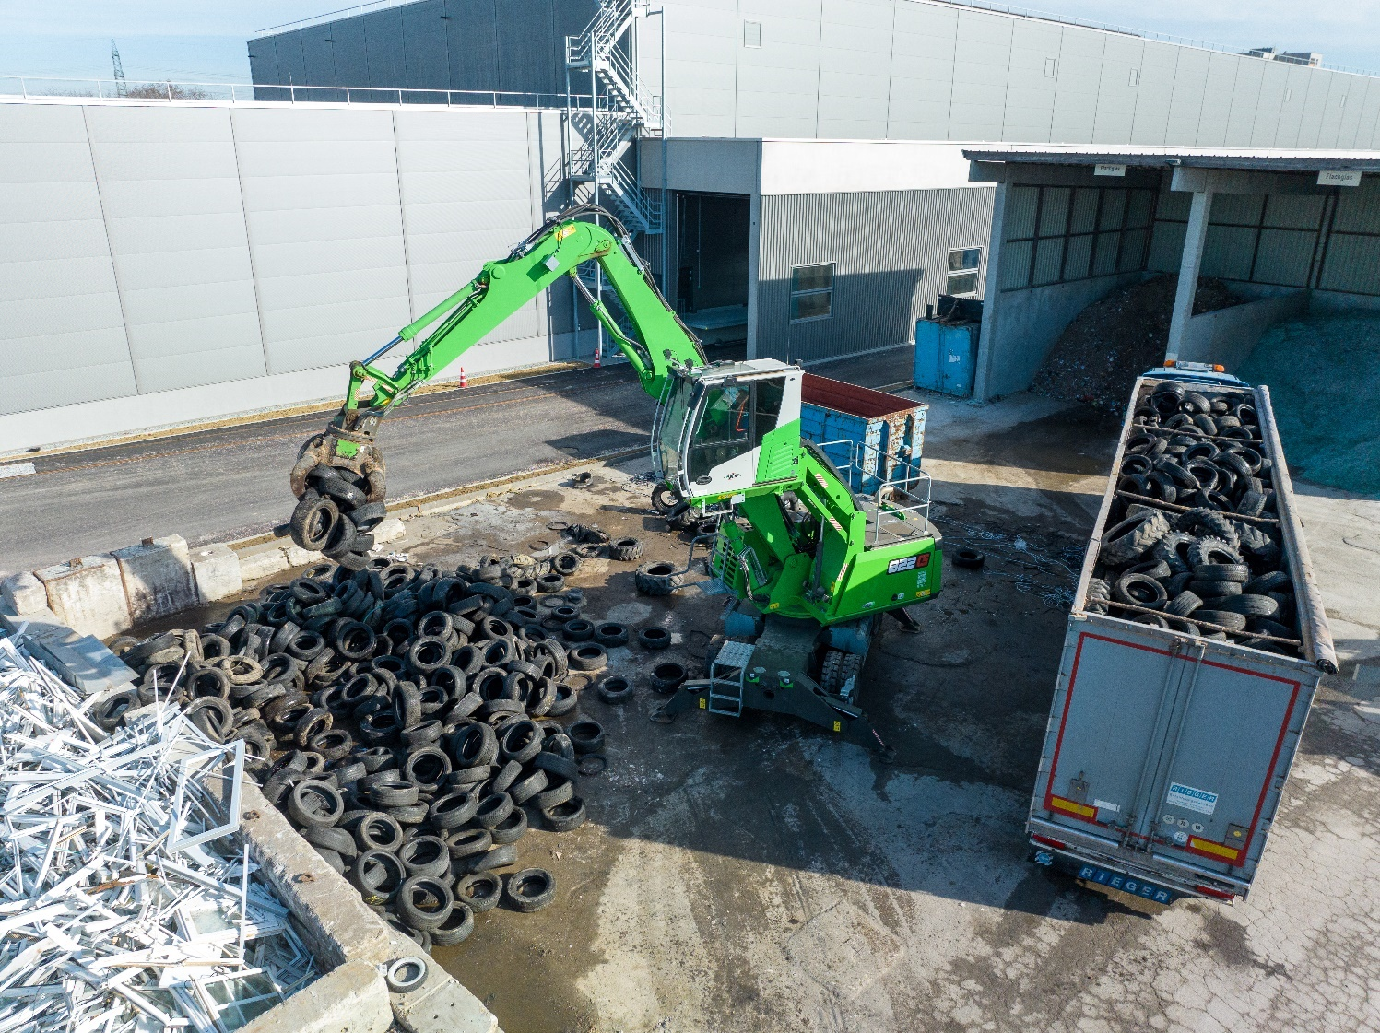
The elevating cab enables optimal visibility and precise loading of the container.
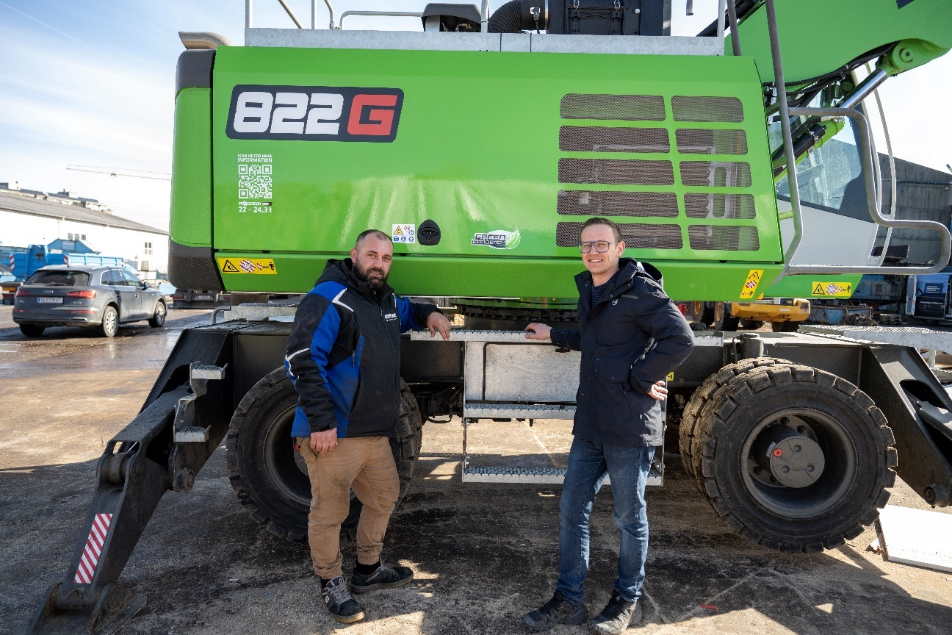
Bashkim Holili, machine operator and Gerhard Pirchner, Ascendum sales representative

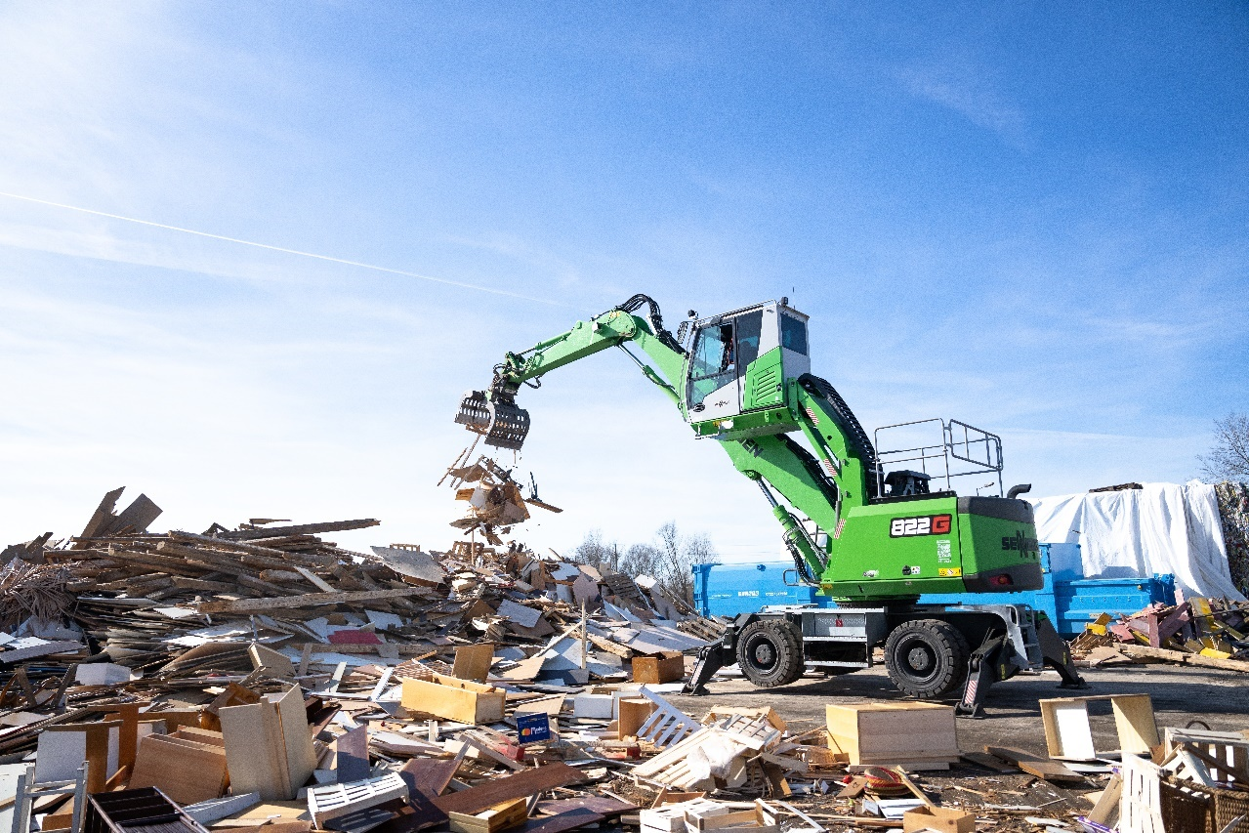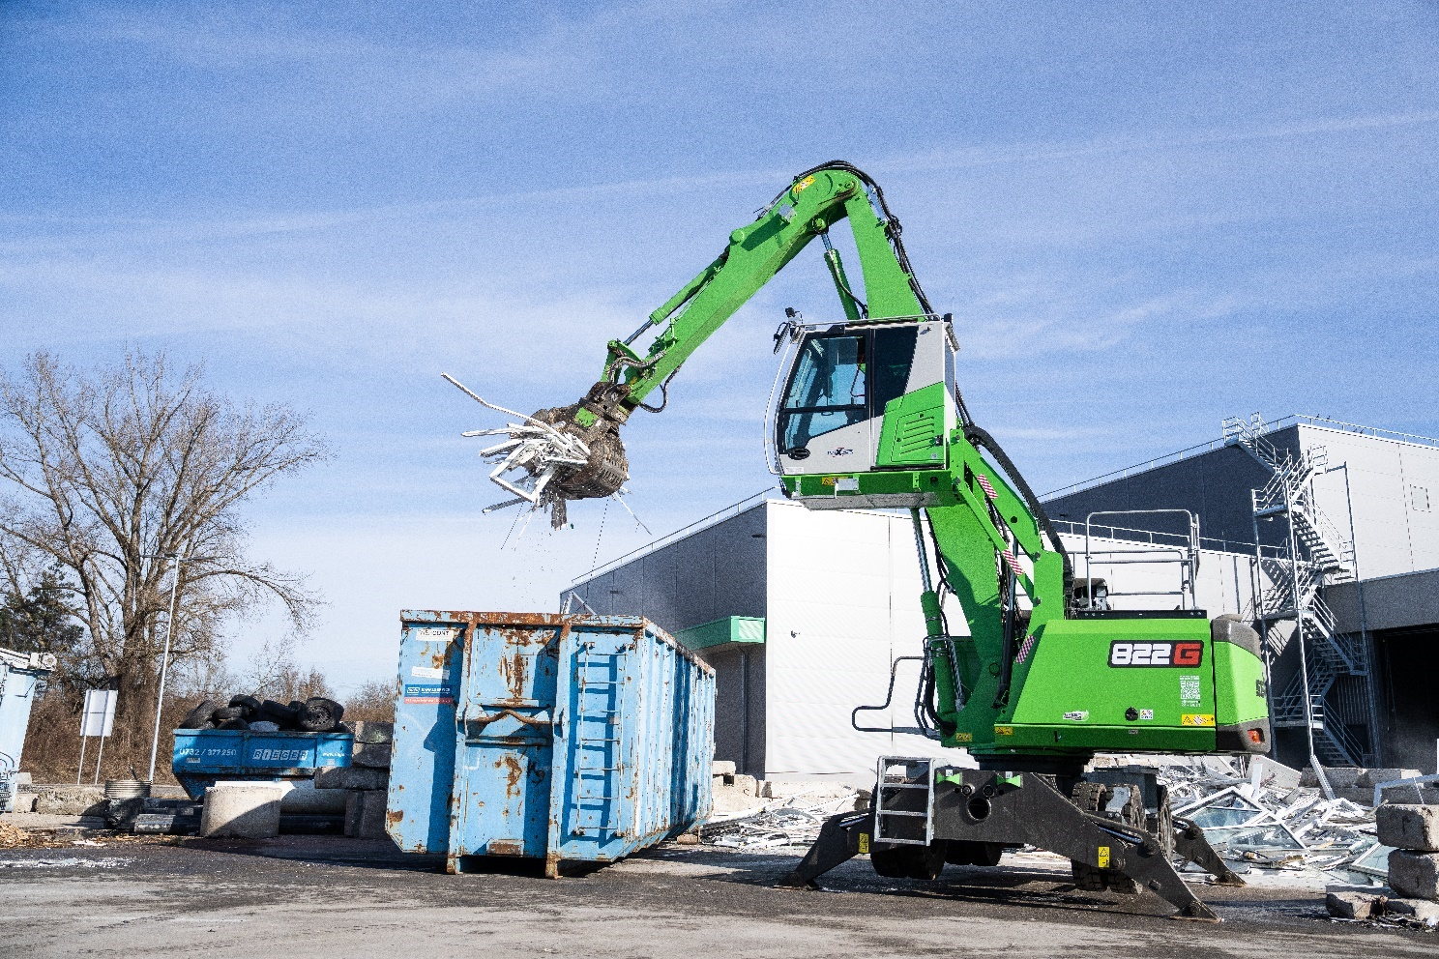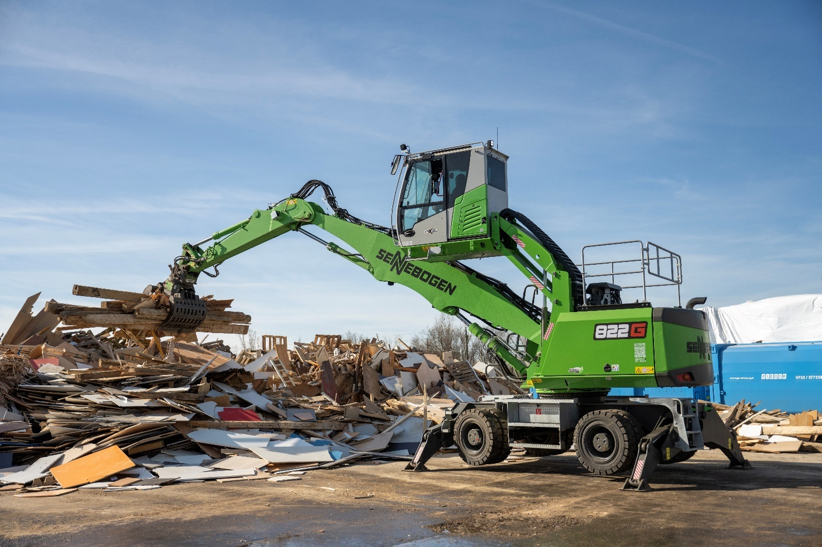
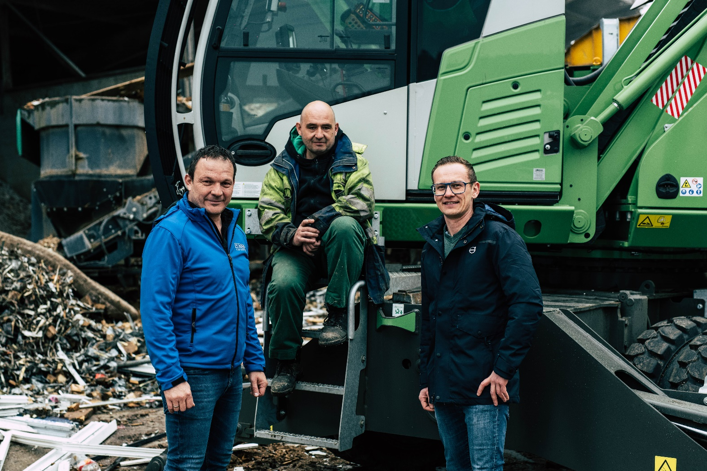
From left to right: Managing Director Johann Rieger, operator Michael Luginger and Ascendum sales representative Gerhard Pirchner

