Bild:
Editor Autor: Jennifer Bortmes
Location Ort: India
Date Datum: 04.09.2023

Timber handling in paper production: electric machines an advantage

Tamilnadu Newsprint & Papers Ltd is one of the world's leading manufacturers of bagasse-based paper and packaging board of combo furnish with an annual production capacity of 600,000 t. At the beginning of the production process, there are four stationary, electric SENNEBOGEN 821 E material handlers, which ensure fast timber handling without any interruption in the manufacturing process under the toughest conditions.

The Indian company Tamilnadu Newsprint & Papers Ltd (TNPL) was established in 1985 by the Tamil Nadu government to produce newsprint and fine paper from bagasse, a sugarcane residue. The company, which employs 2,000 people, has been equipped with three modern high-speed paper machines over the years, increasing its production capacity from 90,000 t annually to 400,000 t. In 2014, the company expanded its business areas to include the production of packaging board in a newly built plant. There, 200,000 t of high-quality packaging board of various grades are produced annually on an area of 874 acres. With the vision of a more sustainable and green manufacturing, TNPL also operates a cement plant in which 900 t of cement are produced daily from the paper mill’s solid waste, such as lime sludge and fly ash. Today, TNPL is one of the world's leading bagasse-based paper manufacturers, whose quality is underlined by FSC, FM, GreenCo and ISO certifications.

High performance for timber handling under extreme conditions

Besides bagasse as the main component, wood is also an important raw material for TNPL's paper production. To unload the logs delivered by trucks, the company relies on four stationary and electrically operated SENNEBOGEN 821 E material handlers, which were commissioned by local service and sales partner Forsenia Engineering Pvt Ltd. With a reach of 11 m each and a 0.7 m² timber grab, the machines mounted on concrete slabs load the timber onto a metal slat conveyor, that feeds the raw material to the chipper. This requires a high degree of speed and efficiency, as the company is under high time pressure when releasing the trucks and feeding the chipper. The machines are in operation minimum 16 hours a day, braving challenging weather conditions. At temperatures of 37 to 40 degrees and a humidity of up to 57 %, they load 500 - 950 t of logs every day and thus enable continuous operation of the plant without costly downtimes in production.

Performance and comfort convince the machine operators

For TNPL, the top priority is to operate the plant as efficiently and environmentally friendly as possible. The four 821 E machines proved to be the optimal choice and convinced the company with their significantly higher handling capacity compared to other machines used: "We need powerful machines that are also reliable, efficient and low-maintenance. SENNEBOGEN machines can offer us all that." Thanks to the powerful electric motor, the machines operate emission-free and with low vibration. Service and maintenance work and the associated costs are reduced to a minimum, while time-consuming fuel stops and oil changes are eliminated. The elevating cab, which enables the trucks to be unloaded and the conveyor to be loaded with precision and optimum visibility, was also particularly convincing. Another big plus is the comfort and user-friendliness of the electric machines: "SENNEBOGEN electric machines work quickly, make hardly any noise and their controls are very smooth compared to other machines. A safe working environment is also provided. All maintenance areas on the machine are easily accessible and clearly marked. It is also very practical that we can equip the machines with different attachments that can be easily exchanged," as communicated by the machine operator.

Captions:
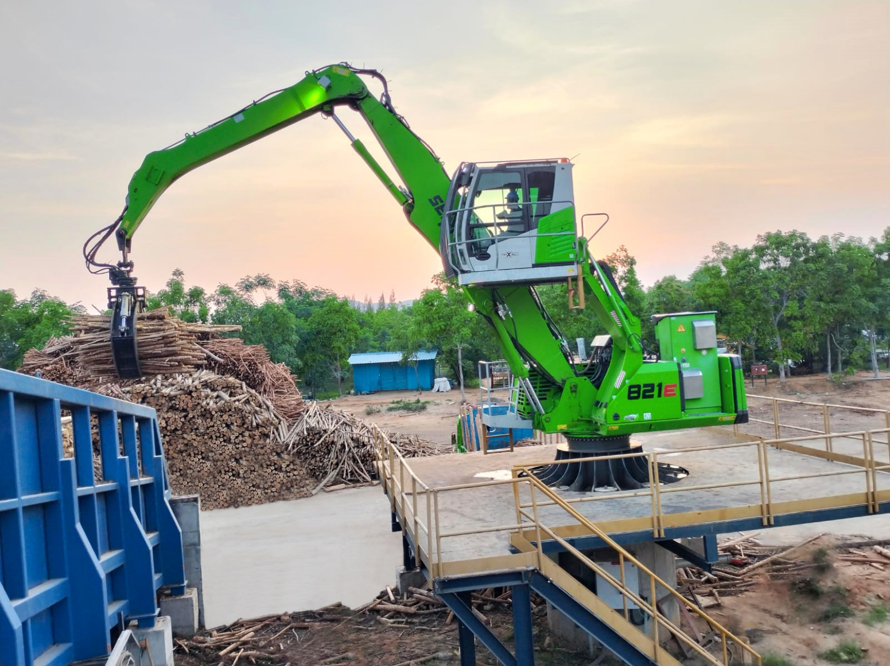
Efficient timber handling: The stationary 821 E Electro proves its high handling capacity when feeding the conveyor belt with logs

