Location Ort: Porto Tolle, IT
Date Datum: Jul-23
Photo Foto: Dr. Franziska Limbrunner, Simone Bergamini
Editor Autor: Dr. Franziska Limbrunner
World's largest duty cycle crane in demolition works with 10 t wrecking ball at a height of 75 m

The site of the former thermoelectric power plant in the Venetian town of Porto Tolle is to be revived and transformed into an ecologically sustainable vacation resort. Before that, however, the decommissioned power plant has to be dismantled. As one of the leading demolition companies in Europe, the Ferraro Group has taken on this challenge. A selective demolition will take place, involving only those facilities that are not functional for the new activities from a circular economy point of view. Site coordinator Calogero Arnone explains, "The controlled demolition work will be carried out with the SENNEBOGEN 6300 HD, a unique machine that makes it possible to hit precisely predetermined points with a wrecking ball at heights of up to 75 m."

The ambitious redevelopment project in the heart of Italy's Po Delta UNESCO World Heritage Site is part of the Futur-e program of power plant operator Enel, which has launched various initiatives to redevelop disused industrial sites and transform them for other sustainable purposes. The 210 h site in Porto Tolle is now also to be given a "new life" with the Delta Farm resort planned for the future – as a tourist village bringing together nature, sports and local cultural features. In August last year, the contracted demolition company Ferraro has already started with the demolition of the former power plant: a mega project in itself, which is due to be completed by October 2023. The entire construction area is segregated and secured in such a way that the highest safety levels and standards are met.

Demolition work with wrecking ball at great heights
Despite the considerable height of the concrete buildings, blasting is not planned in order not to endanger the substructure of the power plant site. To be able to efficiently demolish the buildings, which are up to 65 m high, the demolition specialist Ferraro therefore relies on its SENNEBOGEN 6300 HD, which was specially designed for use at great heights. This is the only duty cycle crane in the world capable of operating a wrecking ball at a height of 75 meters. The powerful crawler crane with a 570 kW engine and an extraordinary winch pull of 350 kN for the main winches as well as 120 kN for the tagline winch is still stable with a track width of 6.80 m when working with the 10 t wrecking ball. Crane operator Peter Hofmann uses this ball primarily for concrete slabs: "For meter-thick slabs, the 10 t ball is ideal, as it brings with it an enormous force that causes the slabs to break apart with a single blow. As a rule, however, I like to use the 5 t demolition ball. This can be controlled even more precisely due to its lighter weight, and it proves even more effective for most jobs because it smashes completely through the concrete walls and thus also carries away a great deal of material."

Selective dismantling in crane operation and with demolition excavators
In addition to the concreted parts of the building - including the stairwell - which are demolished with the ball, the individual power plant blocks largely consist of a solid steel structure that also has to be dismantled in a controlled manner. In crane operation, the SENNEBOGEN 6300 HD has a maximum boom length of 113 m and a lifting capacity of up to 300 t - and these now come into play when the steel components are lifted off. Equipped with a crane head specially designed for heavy lifts, the demolition giant can lift 50 t steel beams with a boom length of around 91 meters.
For sorting work as well as interior demolition work, Ferraro also relies on the SENNEBOGEN 830 Demolition machine. This compact demolition excavator, which specializes in selective deconstruction, sorts the rubble, crushes the broken concrete and extracts the reinforcing steel.

Ferraro Group: demolition specialists for industrial plants
Managing Director Giuseppe Ferraro explains: "As absolute specialists in the dismantling of industrial plants, we are delighted to be part of this challenging redesign project. We were happy to take on the challenges of this dismantling, which is already something very special simply because of the huge dimensions and the variety of objects to be dismantled - from power plant boilers to concrete towers. Thanks to the 300 t duty cycle crane from SENNEBOGEN and our specialized machinery in general, we are able to carry out jobs like this economically and effectively. The demolition work is going very well and we are confident that we can meet the tight schedule."

Captions:
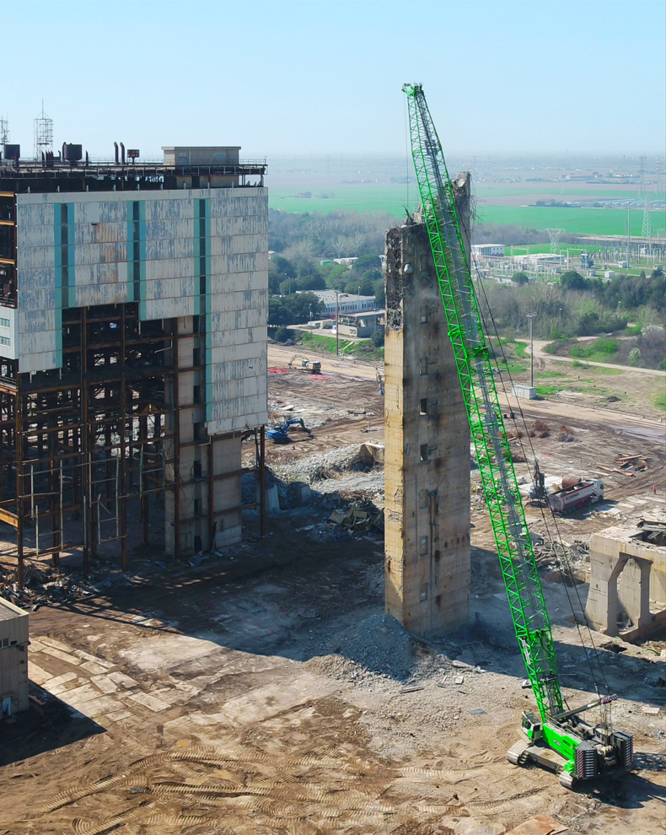
Image 1: For the demolition of the thermoelectric power plant in Porto Tolle, Ferraro is using the SENNEBOGEN 6300 HD, the only duty cycle crane in demolition that can still operate a wrecking ball weighing up to 10 t at a height of 75 m.

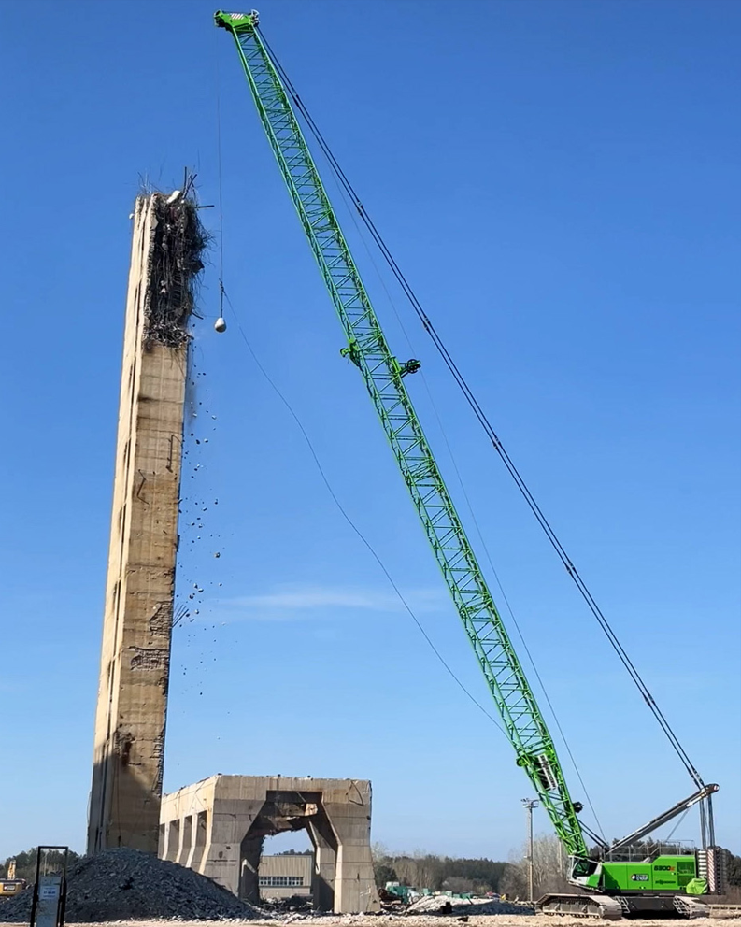
Image 2: The 300 t duty cycle crane from SENNEBOGEN was specially designed for the demolition expert to work at great heights
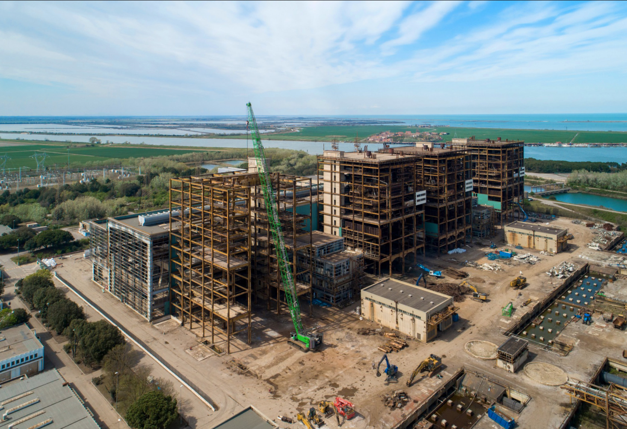
Image 3: In addition to its use with a wrecking ball, the powerful duty cycle crane with a 300 t lifting capacity is also used to lift the heavy steel beams.

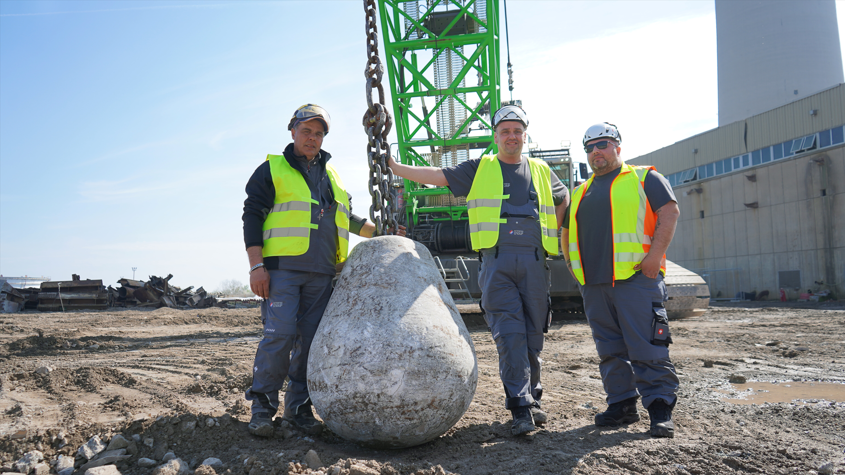
Image 4: Site coordinator Calogero Arnone, crane operator Peter Hoffmann and foreman Calogero Cusumano are very satisfied with the performance of the SENNEBOGEN 6300 HD.
More jobsite pictures:
