Bild:
Date Datum: Dezember 2021
Location: Herne, DE
Photo Foto: Ahrens/Steinbach
Editor Autor: Sandra Hartl

How tree care handlers can optimize traffic safety and tree felling by road maintenance departments

Leading the way for road maintenance depots and municipalities: as one of the first road maintenance departments in Germany, the North Rhine-Westphalia state road construction authority "Straßen.NRW" relies on the SENNEBOGEN tree care handler 718 E for tree felling along state and federal roads in its territory.

Throughout the entire area of Straßen.NRW, there are several tree inspectors who are on duty every day to preserve the tree population and ensure traffic safety. Over 13,000 kilometers of state road, 4,000 kilometers of federal road and 1,000 kilometers of district road make up the road maintenance department's route network. Almost every tree along these roads is meticulously assessed and documented. In the past, this was done on index cards, but today all trees are being tracked in a digital tree cadastre, including the GPS location of each tree. Over 300,000 individual trees are already registered here. Whether stability and breakage safety, fungi or deadwood - all this information is recorded and necessary steps and decisions are derived from it.

Tree felling is often unavoidable

In terms of traffic, street trees primarily serve to provide visual, glare and wind protection, but also to secure slopes. If trees or tree crowns impair the field of vision, professional pruning is usually sufficient. However, if branches or even trees are threatening to fall due to a lack of stability, the only last measure left is tree felling. Which actions are necessary is determined by the responsible tree inspector and documented in the tree cadastre. The duty to ensure traffic safety and the responsibility for the professional implementation of all the measures specified lies in each case with the responsible authority or municipality. Meanwhile, Straßen.NRW uses a 718 E tree care handler with a grapple saw for tree felling along roads. "The high volume of orders and operations due to increasingly extreme climatic influences, such as drought or flood disasters, lead to a rethinking.
Occupational safety and efficiency in daily work are taking on an increasingly important role," says tree inspector Michael Göckeritz. Straßen.NRW is being supported by SENNEBOGEN sales and service partner BRR Baumaschinen Rhein-Ruhr.

Efficiency increased many times over through the use of SENNEBOGEN tree care handlers

The extreme drought of 2018 and 2019 has also had an impact on German road maintenance services. Road trees are permanently under stress due to the drought, causing them to become diseased and unstable. The only last step left here is felling. The consequence: more operations, more effort, more staff. By using SENNEBOGEN tree care handlers, the work along the roads can be made much more efficient, especially during the cutting season. "Jobs for which we would have needed a whole week in the past, we now sometimes manage in one day," confirms tree inspector Göckeritz.

Occupational safety in the focus of road maintenance companies

The use of chain saws and boom lifts for pruning along roads has some disadvantages compared to tree care handlers. The issue of occupational safety in particular plays an important role here. Operations with tree care handlers are less labor-intensive. In addition, the operator is protected by safety features such as a full protection guard and cab windows in bulletproof glass design. With the help of the SENNEBOGEN 718 E, the logs are gripped in a controlled manner, sawed off and laid to one side. In addition to the machine operator, another colleague can optionally assist with felling if the log diameter exceeds the capacity of the 718 E. The logs are then sawn off by the excavator. Sawing off is then carried out by the chain saw. At the same time, the tree care handler holds the log so that it can be laid down in a controlled manner.

[Caption:]

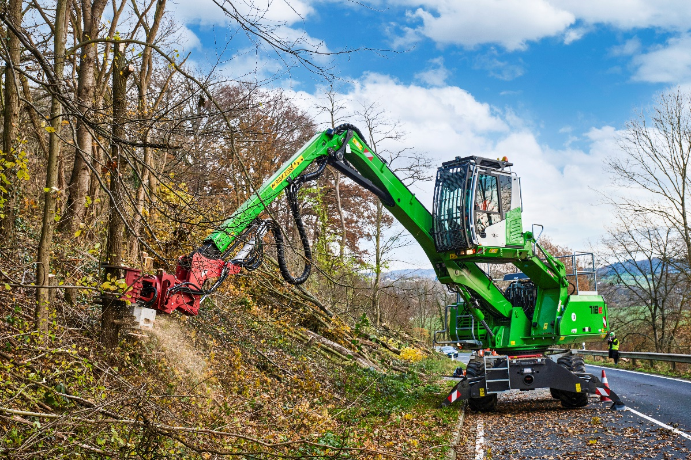
Precision and efficiency: felling excavator 718 E grips, saws and lays down logs in a controlled manner
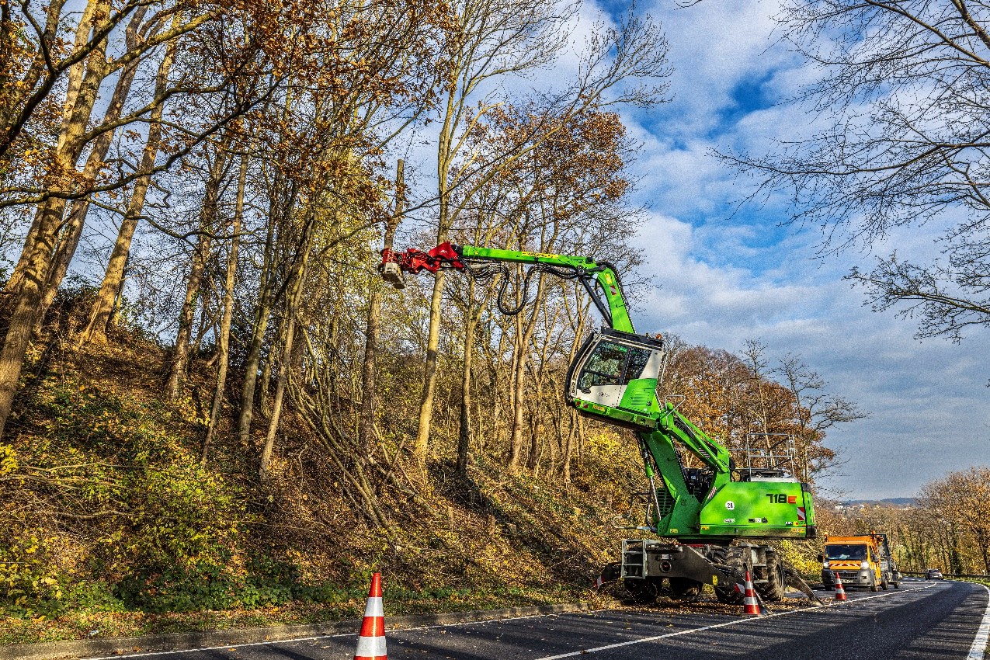
Road approval possible: SENNEBOGEN 718 E is mobile on site 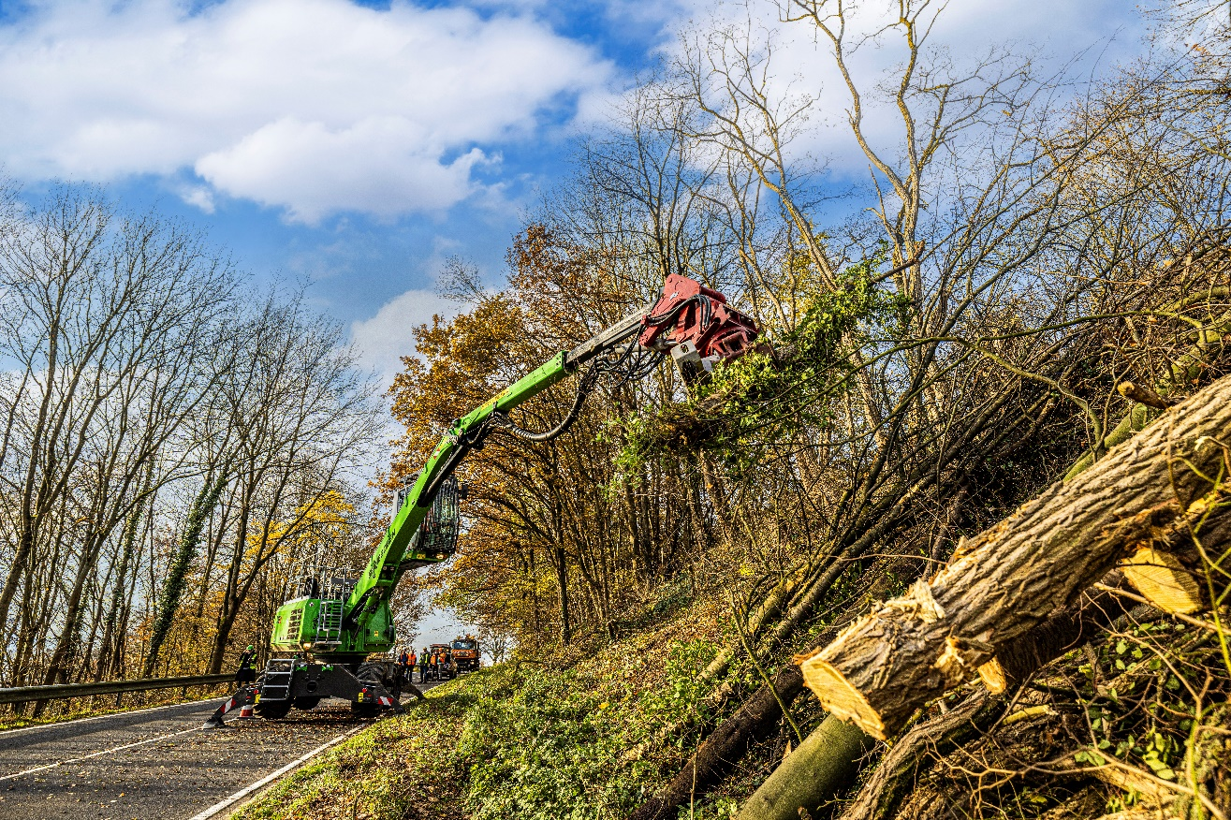
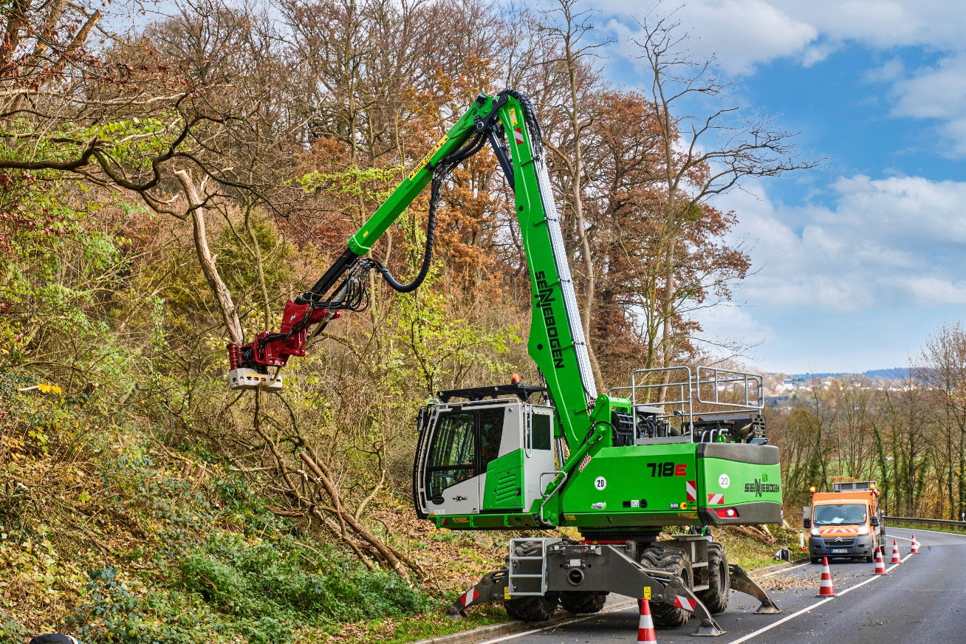
13 m outreach speaks for itself – tree care handler 718 E ideal for use along country roads Landstraßen

