Bild:
Photo Foto: Louis Scheuch GmbH; Fa. Schlotmann
Editor Autor: Jutta Meißner, Franziska Brielbeck
Location Ort: Hövelhof, DE
Date Datum: Jun-22

Gravel extraction with dragline bucket: recultivation of a gravel pit with the SENNEBOGEN 655 E duty cycle crane
The German construction company Schlotmann acquired an old gravel quarry lake near Bentfeld in order to initially use it for gravel extraction and then recultivate it as a nature-friendly cultural landscape. For efficient and natural regraveling, the company opted for a SENNEBOGEN duty cycle crane for this challenging project.

The Senne is located in the German state of North Rhine-Westphalia between the cities Bielefeld and Paderborn and contains large sand and gravel deposits, which is why several companies in the construction industry have settled here. This is also the case with the Schlotmann company in Hövelhof. The core business of the family-owned company, which was founded in 1955 and is currently managed by the 2nd generation, is civil engineering, sewer and road construction. Furthermore, the company now also operates its own recycling business as well as various sand and gravel pits. Recently, Schlotmann acquired an old gravel quarry lake in nearby Bentfeld, which they intend to make usable again for gravel extraction and subsequently recultivate.

Focus on nature-friendly and efficient treatment of the gravel quarry lake
The gravel pit was last worked in the 1970s and dredged to a depth of 5 m at that time. The construction company is now reactivating these former extraction areas and dredging the lake to a target depth of 9 meters. The subsequent reclamation is being carried out under the premise that the dredged lake will subsequently be restored to a near-natural state. It was immediately clear to managing director Mathias Schlotmann that they needed new machine technology for this project that could perform the complex extraction work both efficiently and in a manner that would protect nature. He turned with confidence to Klaus Bräutigam from the local SENNEBOGEN dealer Louis Scheuch GmbH, with whom he has been working since the 1980s, and together they looked for the right solution.

The choice fell on the 655 HD duty cycle crane from SENNEBOGEN, which is designed for such demanding quarrying operations. The 55-ton duty cycle crane is equipped with an almost 30-meter lattice boom, which is ideal for heavy-duty dynamic operation. In addition, it can be moved under full load thanks to the strong tractive force of the crawler undercarriage.
Gentle dredging of the 5 hectare gravel pit
The SENNEBOGEN 655 R has now been in operation at Schlotman since October 2021. In the first step, the 55-ton duty cycle crane works its way across the lake and builds its own embankment, which is then compacted and lined with dredge mattresses. Once at the front, the machine is then put into reverse gear, so to speak. On the way back, the duty cycle crane extracts material from a working area measuring a good 50 meters with its 2.2 cubic meter dragline bucket and loads the extracted gravel directly onto a dumper. The material is then processed and used in the concrete industry. As soon as the pit section will be successfully dredged to the target depth, the next one will be tackled - until the 5-hectare lake is completely dredged. In total, the project is expected to take about 1.5 to 2 years.

Duty cycle cranes prove ideal for gravel extraction
The fairlead and the deflection pulleys integrated in the boom ensure optimum and gentle rope guidance, so that long-term safe and coordinated control of the duty cycle crane and the dragline bucket is guaranteed. The dredging of the lake can thus be carried out with maximum precision: "With this duty cycle crane technology, the effort required of us is considerably less than when using a suction dredger, which we have traditionally used. The duty cycle crane works reliably, does not need any power supply, for example, and thanks to the precise working movements, the gravel processing plant can also be dispensed with. As well as this is going now, we will continue to rely on duty cycle cranes for gravel extraction," says Managing Director Mathias Schlotmann, looking forward to future projects.

The customer appreciates the cooperation with the family company
Mr. Bräutigam has absolutely kept his word and the trust placed in him and Louis Scheuch has paid off," says Schlotmann. "It was the right decision to work with a family-owned company of this size and not, say, with a corporation. This point was also decisive for us in the purchase. Here, the cooperation is much closer, the coordination paths are shorter and the support from the technicians is excellent. At first, of course, we had to get used to the new technology, but now it's running smoothly."

Captions:
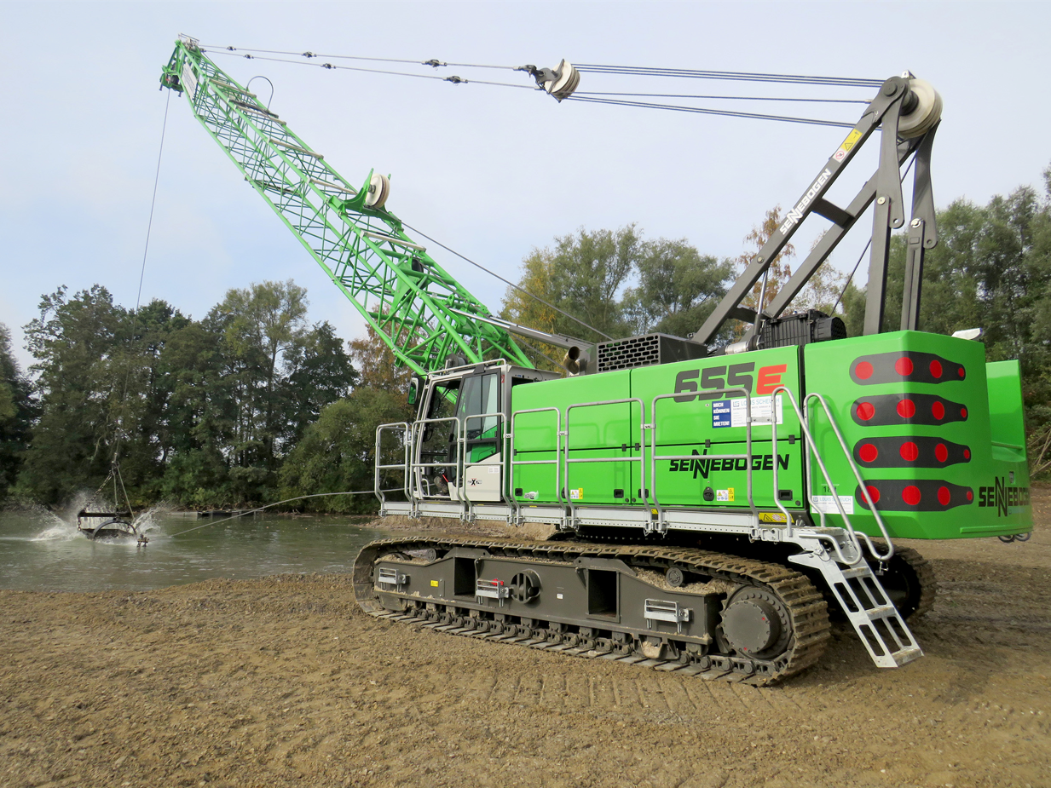
Image 1: The 55 t duty cycle crane with a boom length of 30 m and a 2.2 m³ dragline bucket is ideally suited for excavating the gravel pit to a depth of 9 m.

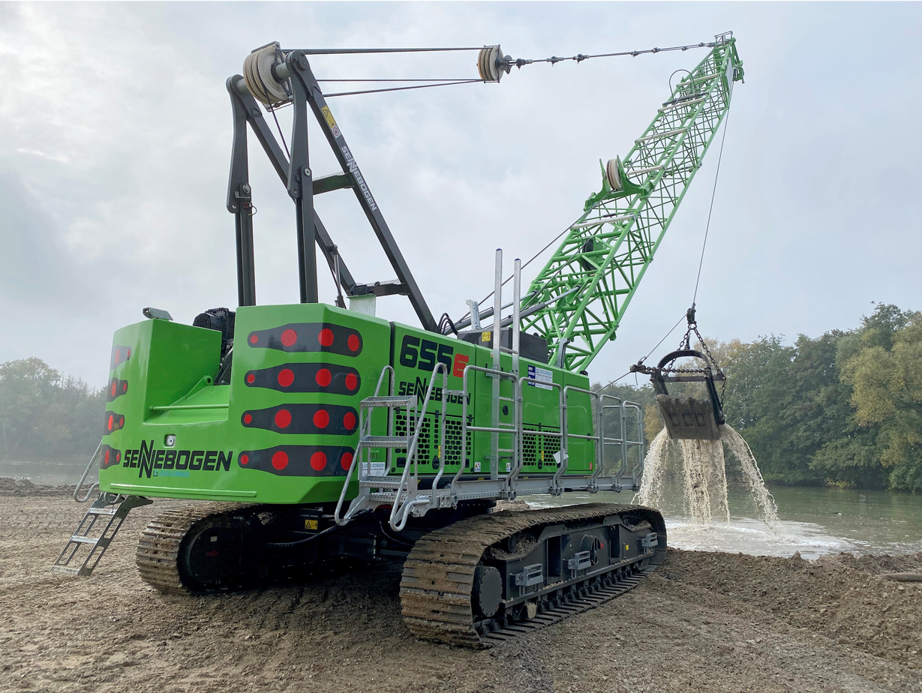
Image 2: Thanks to the optimized rope guide, the SENNEBOGEN 655 R can be controlled very safely and precisely.

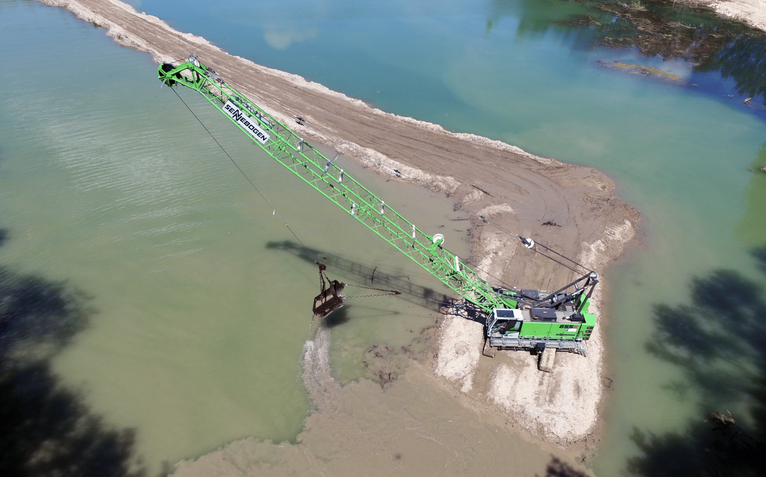
Image 3

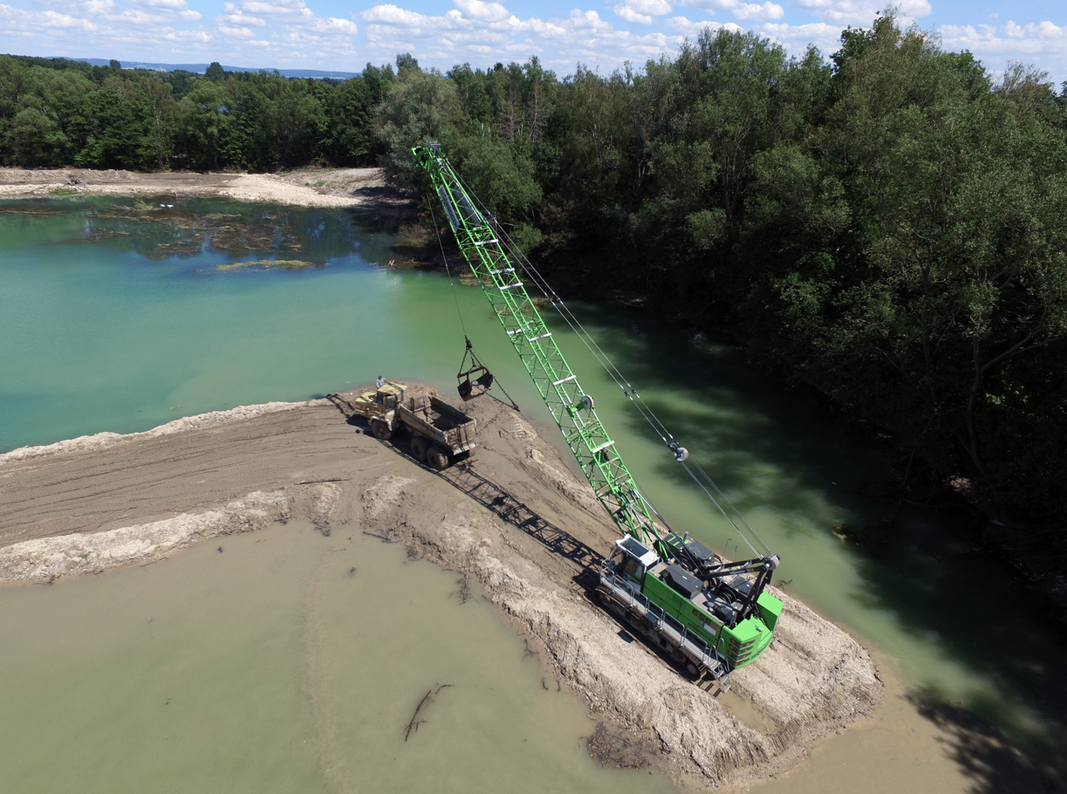
Image 4

