Bild:
Location : Hengersberg (DE)
Photo Foto: Stefan Hanke
Editor Autor: Sandra Hartl
Date Datum: 07.12.2020

Investment for a green future: timber log logistics with SENNEBOGEN 835 E material handler and trailer

Schwaiger Holzindustrie is located in the heart of Lower Bavaria with direct access to the A3, and has been supported by a SENNEBOGEN 835 E material handler and trailer since this year. From here, the company supplies customers from all over the world, from the USA to China, with sawn timber and wood pellets.

The traditional family business was founded over 100 years ago as a craftsman's business and is now managed as an internationally operating industrial company in the third and fourth generation. Continuous growth and investments now enable the processing of over 1.2 million solid cubic meters per year. In order to cope with this challenging volume, ongoing optimization is required to make production even more efficient. This year, for example, Schwaiger Holzindustrie not only invested in a 1,000 m extension of the factory track, but also in its largest material handler to date, the SENNEBOGEN 835 E.

Material handler 835 E in a special trailer design pulls an impressive 80 t of timber

In general, the company focuses on sustainable production and fuel-saving, low-emission handling solutions that pave the way to a "green future". The 835 E has been designed in cooperation with the sales partner SENNEBOGEN Vertriebs GmbH & Co. KG. A mobile undercarriage in a special version for trailers, large single tyres and a protective shield that is indispensable for timber applications proved to be the ideal solution.
The material handler is equipped with a powerful 231 kW diesel engine of exhaust emission standard stage 5 and an all-wheel drive for increased tractive power, so that a considerable 80 t of round timber can be transported by a hydraulically braked trailer. This significantly reduces the internal transport distances: "With the 835 E including trailer, we can now transport twice the amount in the same time. This ensures a more effective and sustainable operation and saves valuable fuel and above all time," confirms Quirin Schwaiger, responsible for Business Development at Schwaiger. In addition to transporting logs up to 5 m in length, the 835 E with a reach of 16 m is also used for unloading the wagons and feeding the plant in the sawmill.

SENNEBOGEN 835 E material handler offers optimum operator comfort and safety

The SENNEBOGEN Maxcab cab, which can be infinitely adjusted up to 2.70 m via hydraulics, relieves the driver, who has an ideal overview of his working area and can move the load with great accuracy. Various features, such as the piston rod protection, a FOPS grid on the cab roof and a cab windshield in bullet-proof glass, provide additional safety in woodworking. The steering can be switched individually between joystick and steering wheel. The 835 E impresses the enthusiastic operators, who particularly emphasize its comfort and ease of operation: "Driving the 835 E is already a highlight in our operations, and you feel a little proud when you are allowed to steer such a large machine across a busy square," says driver Matthias Kornatzki at the Hengersberg site.

[Caption:]
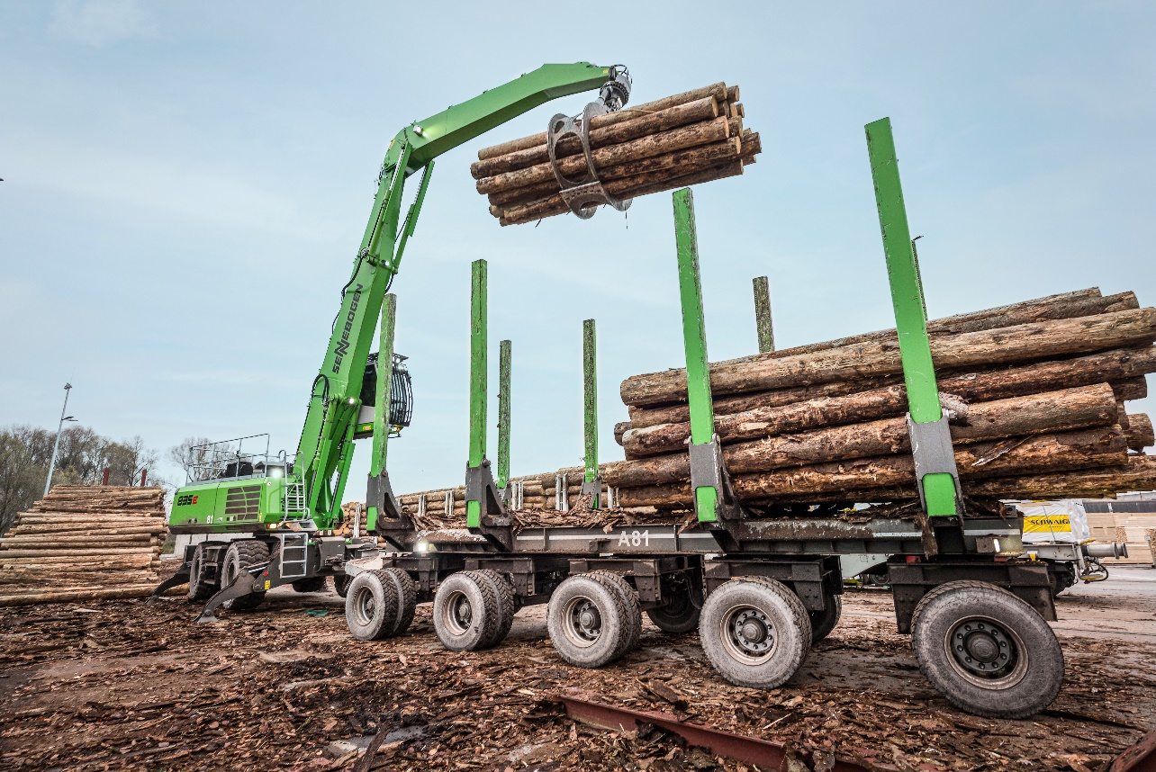
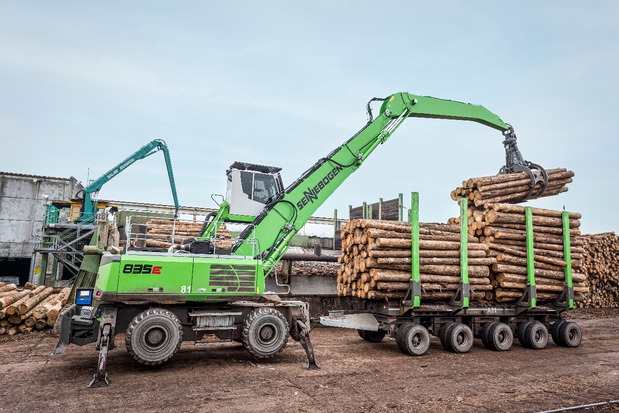
All-rounder in the sawmill: material handler 835 E with trailer feeds the plant, transports and loads logs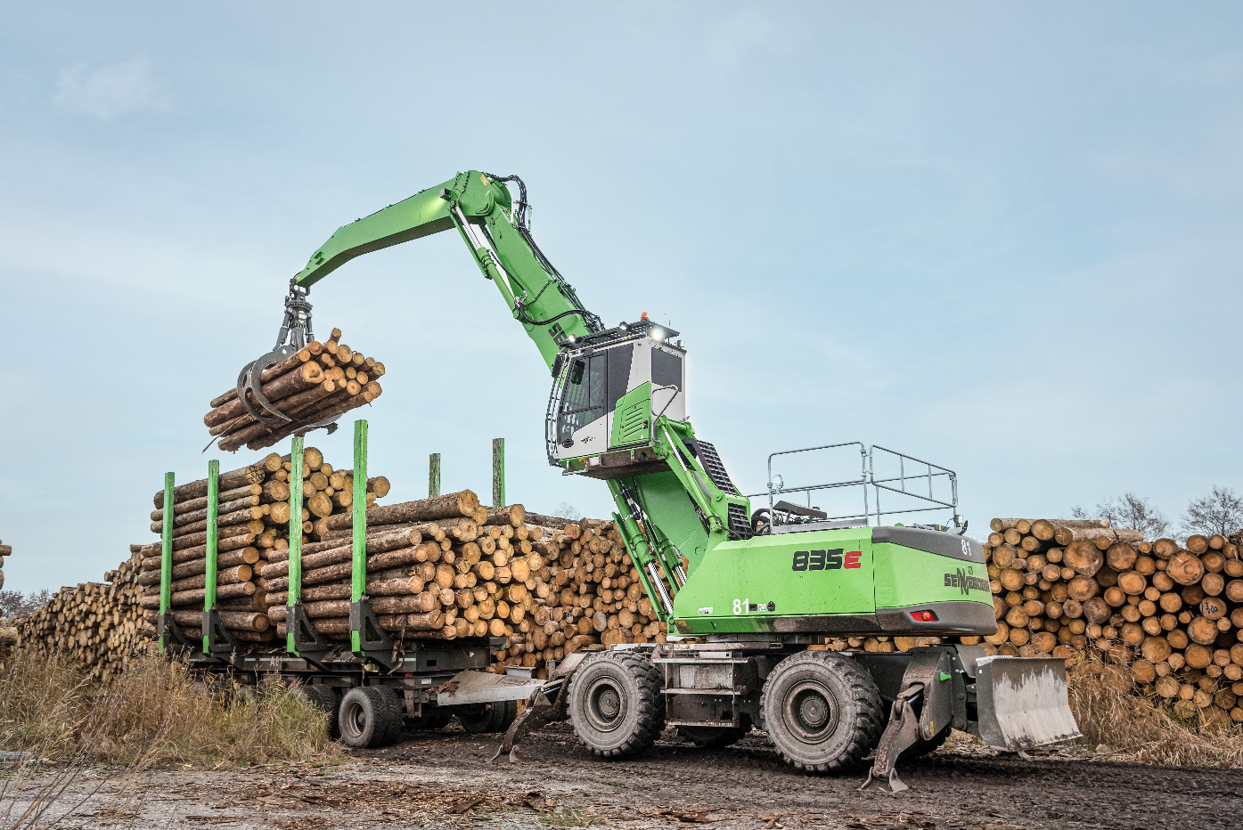
Stacking at storage area with comfortable cabin elevation: 835 E when removing from the trailer

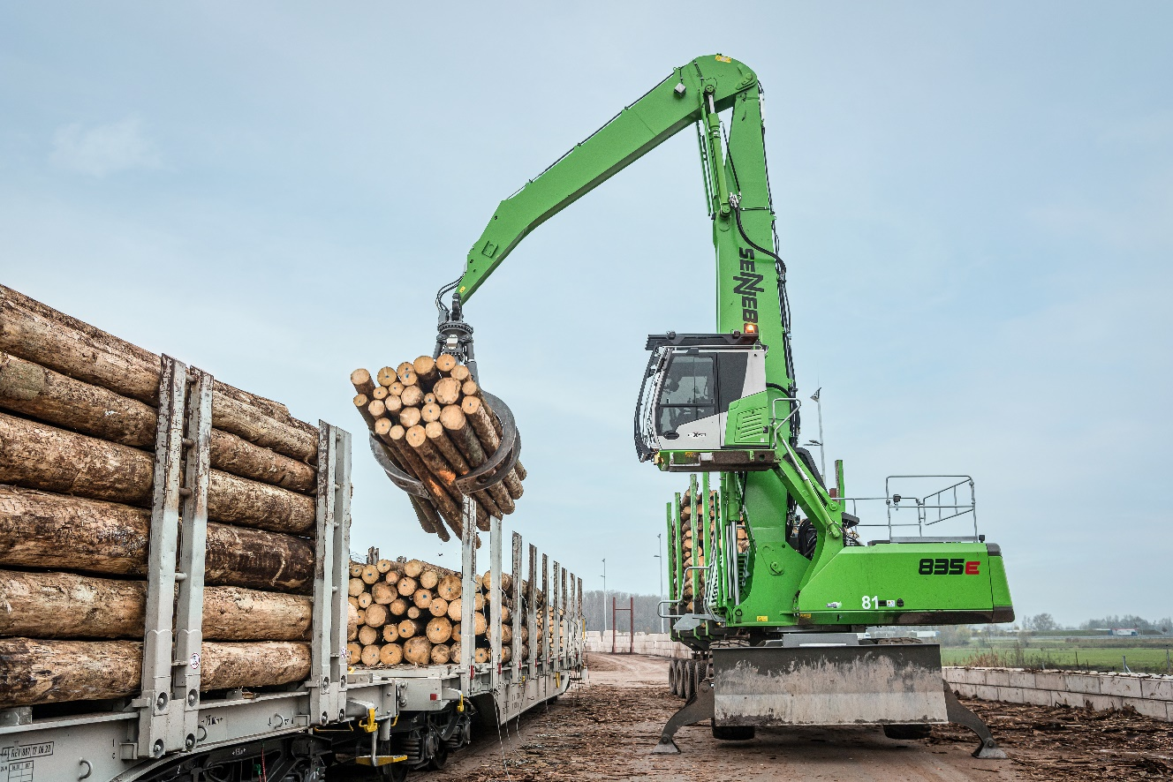
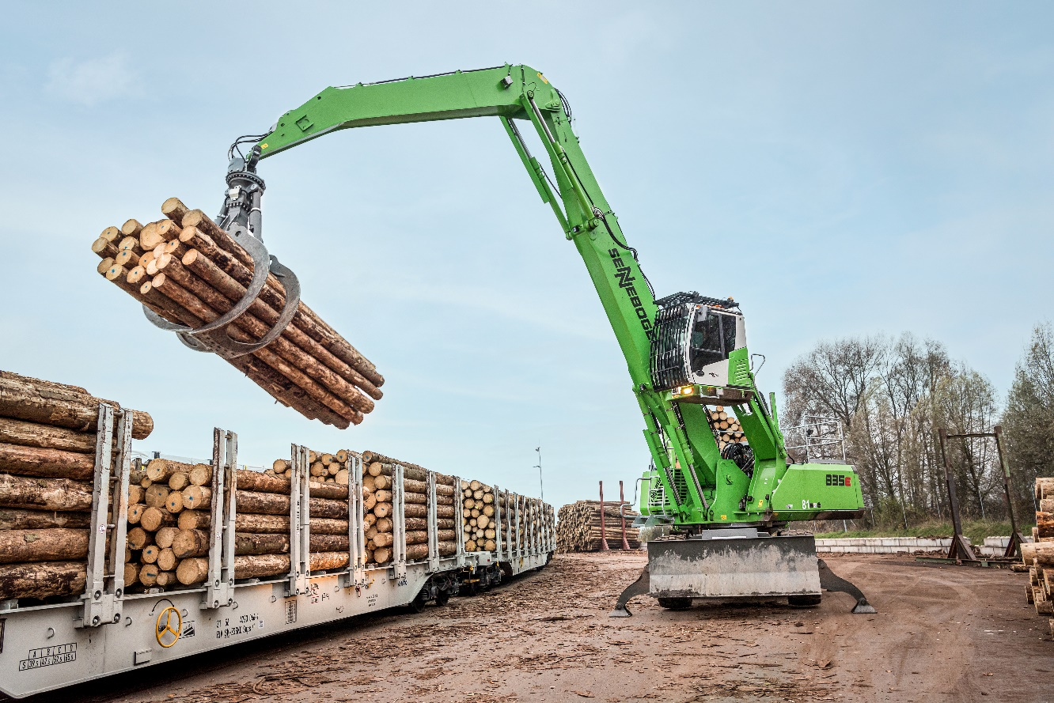
16 m range: Wagon unloading made easy with the 835 E material handler

