Bild:
Photo Foto: SENNEBOGEN
Location: Wunsiedel (DE)
Editor Autor: Sandra Hartl
Date Datum: 04/2021

SENNEBOGEN 835 E electric machine in state-of-the-art sawmill - GELO Timber relies on gantry solution for timber handling

The sawmilling industry's trend continues to rise despite the strained economic situation in many other industries. One of Germany's largest wood processing companies, GELO Holzwerke, therefore decided last year to make a far-reaching investment in a new small-diameter wood sawmill. A SENNEBOGEN 835 E electric material handler now takes care of log handling at the state-of-the-art mill.

At the end of 2020, the 70,000 m² plant in the Wunsiedel Energy Park went into operation, punctually after 11 months of construction. Together with a partner, the successful traditional company invested almost 40 million euros in the new site, at which 1400 solid cubic meters per day will be processed in two-shift operation in the future. Accompanied by the sales and service partner IBS Industrie- und Baumaschinen Service GmbH, an electrically driven SENNEBOGEN 835 E in a unique rail gantry design with a track width of 32 m and a travel distance of 112 m now fits into the processes of the new plant. When unloading the incoming trucks and feeding the saw, the pick & carry machine 730 E with all-wheel drive and 168 kW exhaust stage V engine is also used.

In many respects, the company is committed to the major goal of sustainable management: the processing of the renewable raw material wood, regional value creation through the neighboring, densely wooded Fichtelgebirge, and low-emission systems and machines that allow the large demand on the market to be well served. The decision in favor of an electric machine was therefore a further step for the managing director Wolf-Christian Küspert towards building a sustainable business.

Low operating and service costs thanks to the powerful 200 kW electric motor of the 835 E

A SENNEBOGEN material handler with a 200 kW electric motor is used to transfer the logs from the sorting boxes to the stackers and to feed the saw, which enables environmentally friendly timber handling by eliminating exhaust emissions. Another advantage of electric operation is obvious, because compared to diesel machines, enormous savings in operating and service costs can be achieved through longer service intervals.

In addition to the cost and emission savings, flexibility also played a major role in the purchase decision. The gantry design in particular gives the operator maximum degrees of freedom: the machine can be rotated through 360 degrees and at the same time genforward, reverse and sideways movements are possible thanks to an integrated trolley, which means that the gantry covers a generous working area. Thanks to the 8.9 m long and curved compact boom of the "Banana" type and a loading stick with a length of 7.9 m, the 835 E electric material handler achieves a reach of 15 m. Attached is a SENNEBOGEN 2 m² hydraulic timber grab, which allows the manipulation of logs up to 6 m in length.

Large-capacity SENNEBOGEN Mastercab provides excellent view for the operator

Excellent all-round view is provided by the SENNEBOGEN Mastercab industrial cab, which impresses drivers with various features such as a large-area floor window and an air-suspended comfort driver's seat with seat heating. Manuel Wildgans, one of four machine operators, is apparently satisfied with his new workplace and is particularly enthusiastic about the ease of operation of the electric material handler: "The SENNEBOGEN 835 E is the first machine of this size that I have been able to operate. In the meantime, all of us drivers have become accustomed to it and are pleased with the simple control using the joysticks. At a height of over 10 m, we can now enjoy the best view over the entire site every day."

[Caption:]

SENNEBOGEN 835 E material handler on gantry in operation in new sawmill at GELO Timber in Wunsiedel, Germany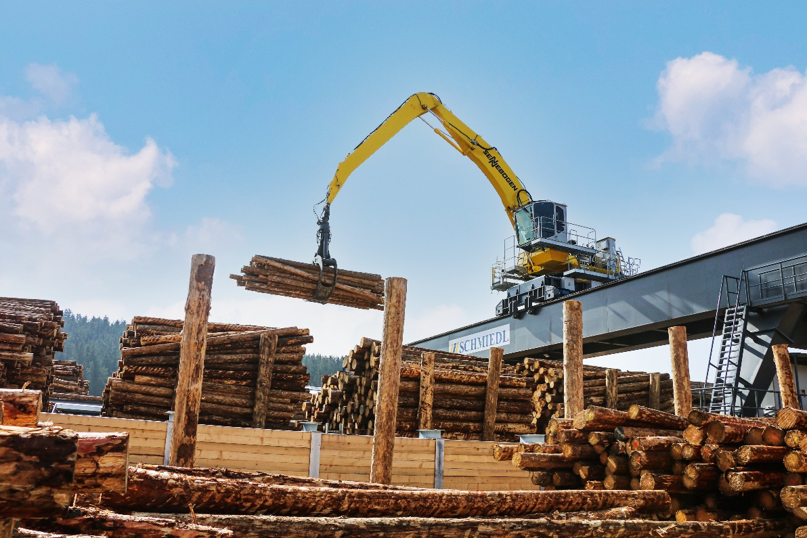
New construction of a small-diameter wood sawmill by GELO Timber: SENNEBOGEN 835 E supports log shifting 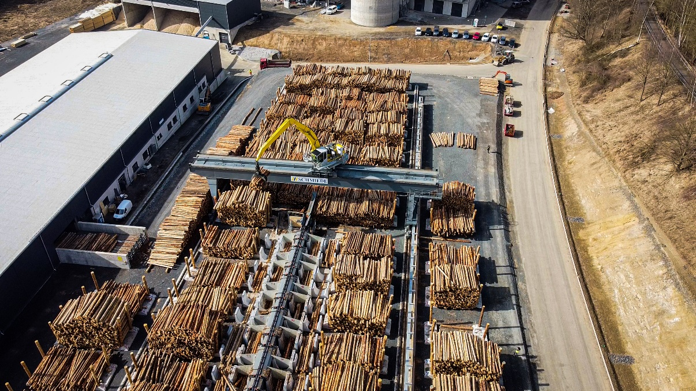

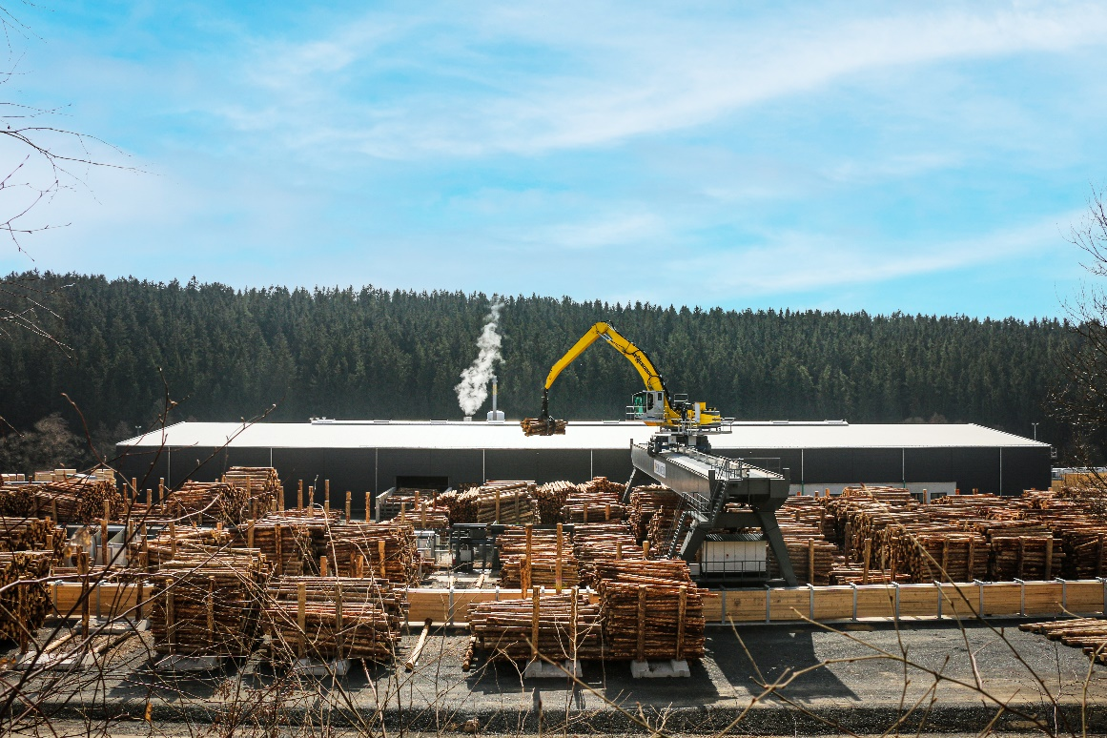
SENNEBOGEN 835 E and a gantry solution with 32 m track width and 112 m travel distance at GELO Timber

Electric material handler 835 E feeds the modern saw with logs up to 6 m long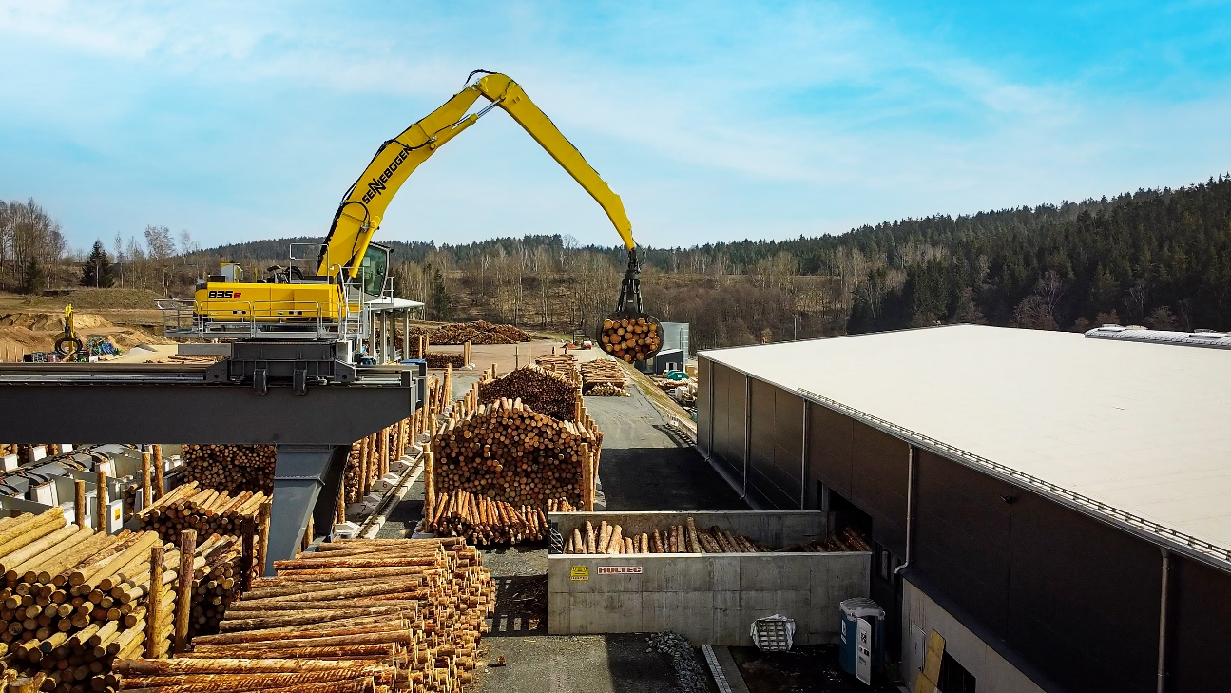

Pick & Carry timber handler 730 E with 1.75 m² hydraulic grab feeds the saw with logs 