Bild:
Photo Foto: German Popp / Kerstin Wabner
Location Ort: Straubing,
Germany
Date Datum: 12.02.2021
Editor Autor: Kerstin Wabner

825 E Demolition makes room for something new at SENNEBOGEN's own plant in Straubing, Germany

An on-site demolition job? Luckily, SENNEBOGEN has the necessary products at hand in the Rental & Used fleet of its own subsidiary SENNEBOGEN Vertriebsgesellschaft. The engineering company from Straubing, Germany, initiated the demolition of a paint shop built in the 1960s as part of the plant modernization. Hans Eberhardt GmbH, a local company specializing in building construction and civil engineering, is providing valuable expertise in performing the demolition job. They rely on the green 825 E-Series demolition machine which has the stability, reach and power required for the demolition work in the main plant: Thanks to the powerful 129 kW diesel engine, configured in accordance with the latest emission stage V standards, it operates in a fuel-saving, environmentally friendly and quiet manner – a major plus when carrying out demolition work in inner-city areas.

Investing in the future is important to the owners of the Straubing-based family company SENNEBOGEN in order to create new jobs and continue the company's success story. In addition to the other expansion projects, such as the newly built and nearby service center on the A3 freeway with state-of-the-art warehouse technology, a second plant specializing in steel construction in Líter, Hungary, the focus is also on modernizing the main plant in Straubing's city center. Currently, a paint shop built in 1964 with a length of 85 m is being dismantled: another milestone for using the latest production standards in the heart of Lower Bavaria.

BIG advantages of the SENNEBOGEN 825 demolition machine dismantling the paint shop
The advanced demolition machine, which has a rear radius of 2.8 m and specializes in confined spaces, is a perfect fit for the three-week demolition project on the company's own premises: SENNEBOGEN's 825 E demolition machine has an operating weight of 34 t and a telescopic undercarriage that can be conveniently extended from a transport width of 2.3 m to a maximum of 3.5 m in the working position. Due to the widened contact surface of the telescopic undercarriage, the weight of the demolition machine is optimally transferred into the ground, which ensures a stable stand when removing the concrete from the building and when slewing. Equipped with an Oilquick quick coupler, the operator can also set the machine up for a new task comfortably from the driver's seat: the special additional hydraulics on the stick enable the operation of various attachments, including those that require high pressures. With SENNEBOGEN's Tool Control system, pressure and oil delivery rates can be easily pre-programmed, so that after one click in the control system and after coupling the attachment, you can start work immediately.

Demolition in inner cities: The 825 E is very compact and operates with low emissions
Inner-city demolition sites are often limited in terms of the space available: This is also the case at the SENNEBOGEN plant, because directly adjacent production facilities must not be disturbed during the project, and residential units in the immediate vicinity must also remain unaffected by the operation. Controlled, selective dismantling is the keyword here, which perfectly describes the planned removal and eco-friendly sorting of the construction waste.

Like its bigger brother, SENNEBOGEN's 830 Demolition, the 825 E is a specialist for working in 360° mode: In other words, once placed, the machine hardly needs to be moved at all to grab, remove, sort or load material into containers. At the same time, the economical Stage V diesel engine is cleaner than ever, thanks to the latest technology for exhaust gas aftertreatment: demolition machines in this setup now emit around 97% fewer soot particles and 96% fewer nitrogen oxides than 20 years ago – an essential requirement for inner-city demolition projects.

[Caption]
The SENNEBOGEN 825 E-Series demolition machine is designed for confined spaces: Thanks to its telescopic crawler undercarriage and low rear radius, it can be maneuvered effortlessly; Source: German Popp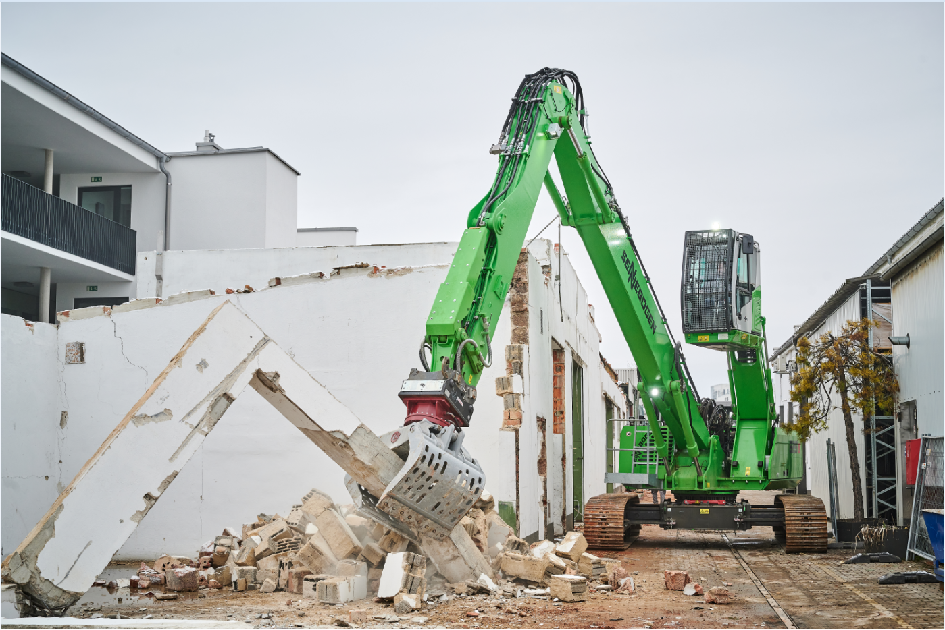

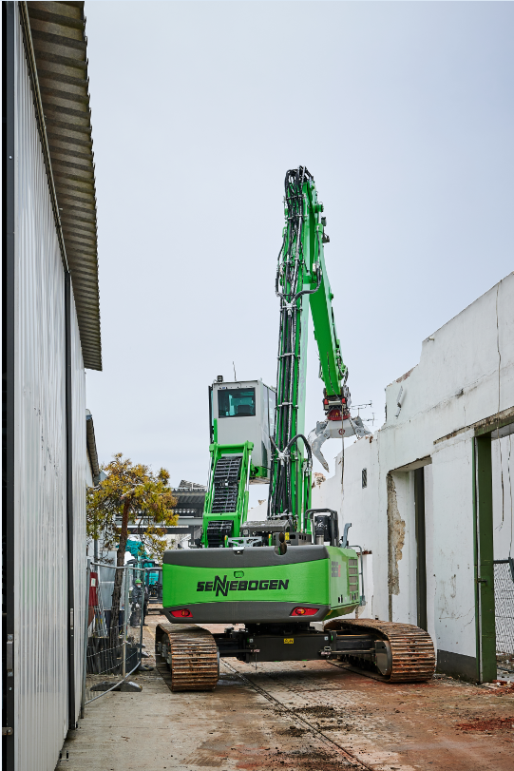

The 30° tilting and elevating cab of the SENNEBOGEN 825 E-Series demolition machine gives the operator a perfect view of his work area; Source: Kerstin Wabner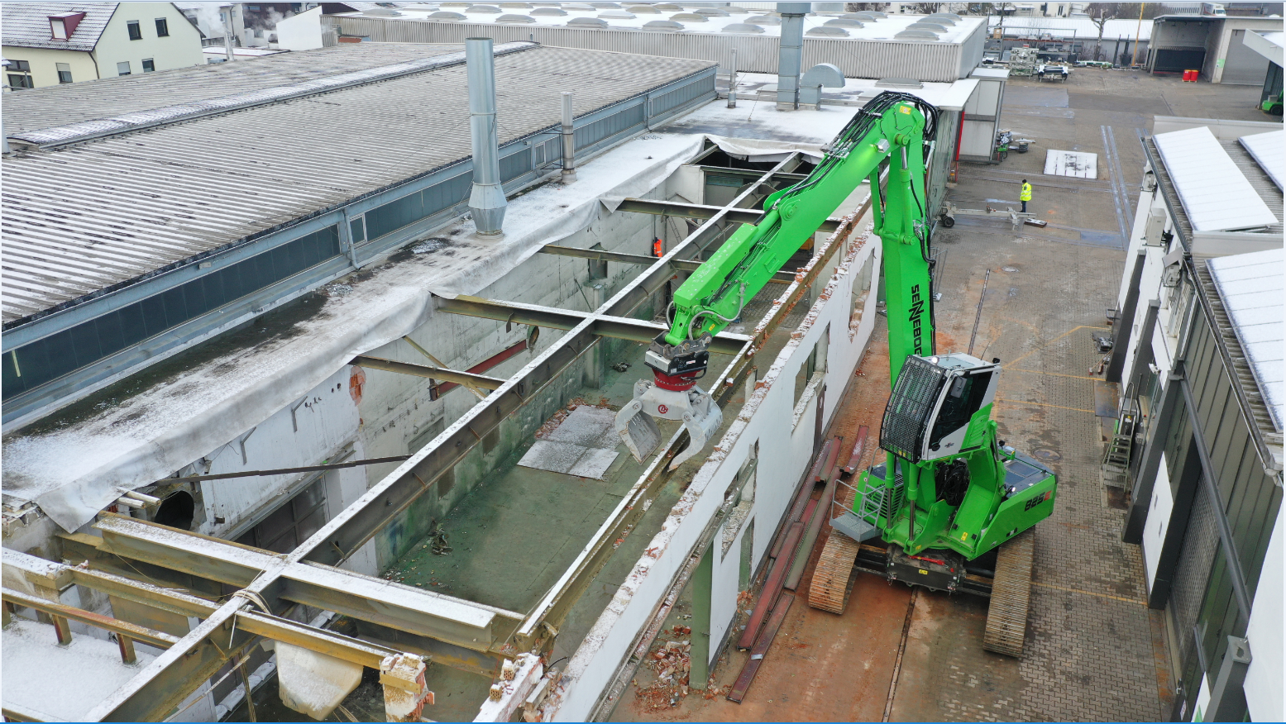
Source: German Popp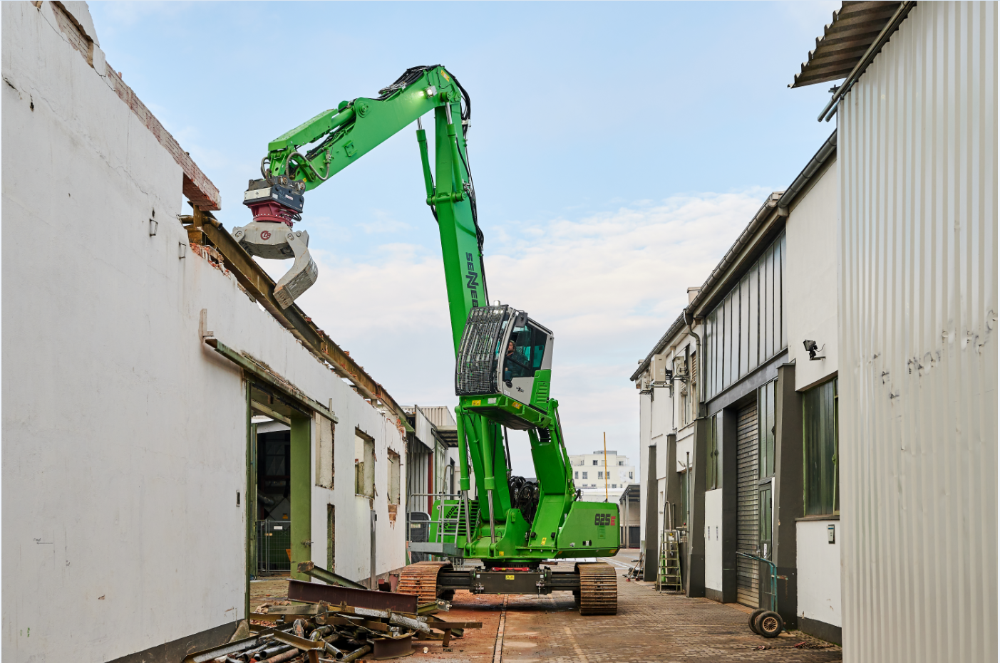
Using demolition grabs, shears or hammers, the SENNEBOGEN 825 E demolition machine effortlessly removes building components and composite materials, such as reinforced concrete; Source: German Popp