Bild:
Location Ort: Emsdetten, Germany
Date Datum: 29.01.2021
Photo Foto: Stefan Hanke
Editor Autor: Kerstin Wabner

Lohmann Entsorgung relies on a total of nine SENNEBOGEN material handlers for its recycling activities
The disposal center of the recycling company Lohmann is located in Emsdetten in Germany. With a workforce of around 200 employees, the company is dedicated to the holistic processing of recyclable materials: Using its own container service and a fleet of 80 trucks, the family-owned company keeps the flow of materials from customers to the recycling center constantly high. They take care of the processing of various types of waste, the professional disposal of hazardous materials, packaging waste or bulky waste from households, and also scrap metal recycling. With state-of-the-art material handling technology from SENNEBOGEN, including three new 825 E material handlers, each in the mobile version, the recyclers do a great job every day by processing a wide variety of materials.

In these uncertain times in particular, many employees are spending more time in their home offices, arranging a lunch or two to be delivered, placing orders online more frequently, and thus generating significantly more waste than on average in previous years. Disposable hygiene products, such as medical masks and gloves, also contributed to greater waste volumes in 2020: Due to the many pandemic-related changes, the amount of plastic waste from private households in Germany exceeded the average by around 10 percent, according to a major German recycling company.

Unfortunately, it is often forgotten how much time and effort is involved in sorting and properly processing recyclables. Therefore, it is time to take a look at the hidden heroes of everyday life: Because, relentlessly, the roughly 11,000 German waste management companies with well over 310,000 employees ensure that we are allowed to live in orderly conditions: Working for us day and night, they literally keep things running smoothly and play a key role in society.

At Lohmann Entsorgung, operators work comfortably and safely
One of these important cogs in the state of North Rhine-Westphalia is the company Lohmann Entsorgung, which takes care of the processing of various types of waste, the professional recycling of electronics, but also the disposal of hazardous materials, such as acids and chemicals. With their in-house container service and a fleet of 80 trucks, the family-owned company, founded in 1950, focuses on waste logistics for their industrial clients. They also operate a recycling center for residential customers on their premises: "During the pandemic, we also observed that many citizens increasingly used their extra time for renovation work or cleared out their basements due to reduced working hours. The increase in waste from private households was quite impressive last year," reports Johannes Lohmann Jr., son of the managing director, with whom now already the 4th generation has joined the family business.
Given that Lohmann constantly has to process large quantities of waste from private households and the surrounding industry, the drivers of the SENNEBOGEN material handlers in particular spend long shifts in their machines. For this reason, the family-owned company attaches great importance to comfort inside the cab, which is ensured by the easy to use controls and the convenient seat: "Our operators repeatedly emphasize that the SENNEBOGEN material handlers perform extremely well, with their stability, viewing height and reach, especially when unloading containers. They feel safe all around."

Lohmann relies on low-emission material handlers with green, ecological approach
These machines are put to heavy use in the company, which explains Lohmann's clear focus on their reliability. Moreover, the North Rhine-Westphalians emphasize within their corporate philosophy their role as a recycling company and their responsibility towards the environment and society: "For us, waste disposal is active environmental protection," the policy states. This is why the company decided exclusively in favor of the reliable, fuel-saving and low-emission material handlers from SENNEBOGEN, according to Johannes Lohmann's final conclusion.

Pleased with the reliable operation of the SENNEBOGEN material handlers at the waste disposal center in Emsdetten (from left): Plant Manager Helmut Heitjan and Sales Representative Johannes Lohmann Jr.
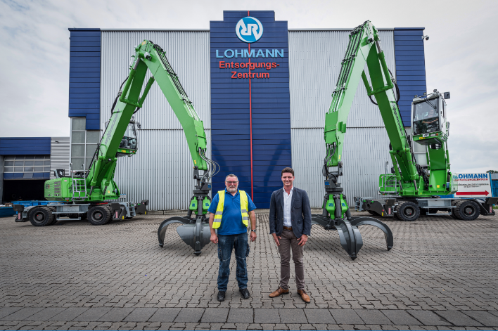

A total of nine material handlers: Lohmann Entsorgung's team takes care of the recycling of industrial waste, electronic scrap and waste from private households. With the green SENNEBOGEN fleet, the job can be done quickly and in an eco-friendly manner.
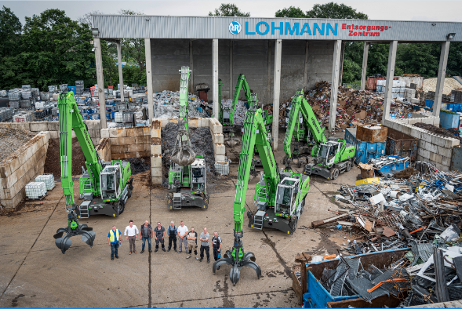
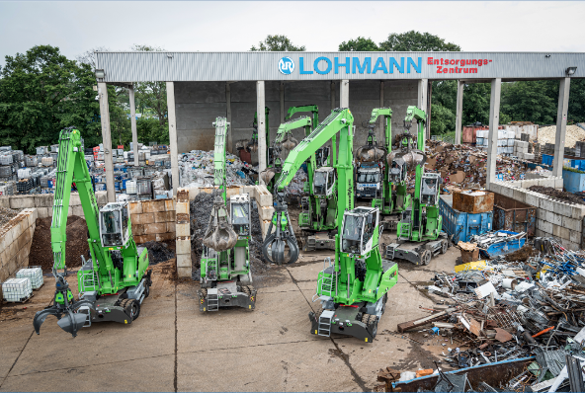

In 2020, two new material handlers were put to use: The fuel-saving and low-emission diesel models of the SENNEBOGEN 825 E series are always stable thanks to the outriggers, whether used for scrap sorting or loading cardboard boxes with a 13-meter boom