Bild:
Location : Hereford (UK)
Photo Foto: Molson Green
Editor Autor: Sandra Hartl
Date Datum: 08.12.2020

SENNEBOGEN 730 E material handler: Pick & Carry operation at Pontrilas Timber

One of the largest privately owned sawmills in Great Britain, Pontrilas Timber, invested recently in a new material handler, the SENNEBOGEN 730 E. The pick & carry machine with all-wheel drive and a powerful 168 kW diesel engine now supports the company in internal log transport, feeding the plants and unloading the large number of trucks that supply the mill every day.

In order to maintain a constant supply of wood, the company has now opted for a SENNEBOGEN 730 E, which impressed the customer with its high load-bearing capacities and outstanding operator comfort. Brian Pugh, the man in charge for the facility at Pontrilas Timber, emphasizes that the acceptance of the machine operators in particular is a key purchase criterion: "We take the views of our operators into account when it comes to purchasing new machines. They are the ones who have to spend a whole shift in them. We need the operators to be able to get the best out of our investments". The 730 E can score points here with various features, such as the modern SENNEBOGEN Maxcab, a sliding side door for more comfort when getting in, a traditional steering wheel and a fully suspended driver's seat.

SENNEBOGEN 730 E with 2 m² grab manages 4 minutes unloading time per truck

Consulted and sold by Molson Green, SENNEBOGEN's service and sales partner in Great Britain, the new material handler now helps to load the up to 70 loads of timber that arrive daily. Equipped with a 2 m² timber grab, the 730 E offers a grab size that is almost 10% larger than the machines used previously. With the use of the new timber handler with a reach of 11 m, the unloading time has been reduced to an impressive 4 minutes per trailer, resulting in a significant increase in efficiency.

730 E material handler stands for robustness and safety

Another advantage for the customer is the robust upper carriage construction. The machine weighing more than 34 tons is built around a compact, slewable upper carriage, which allows stacking and unloading in all directions. In addition, the chassis is protected by a set of galvanized steel mud guards, which protects the tires from falling wood while keeping the upper carriage free of mud. A sturdy galvanised boxing ring which is equipped with a number of LED lights and a heavy FOPS guarding on the cab provide additional safety for challenging wood operations.

The special design of the 730 E Pick & Carry machine allows the boom foot to be mounted further to the rear of the machine, which provides a clear view to all sides and at the same time a low rear ballast is sufficient for weight compensation. The material handler thus impresses with its compactness and a tight tail swing. This also proved to be a decisive feature for the customer Pontrilas: "The smaller overhang allows us to put this machine in between some of the stacks of timber and still work it effectively.", confirms Brian Pugh.

[Caption:]
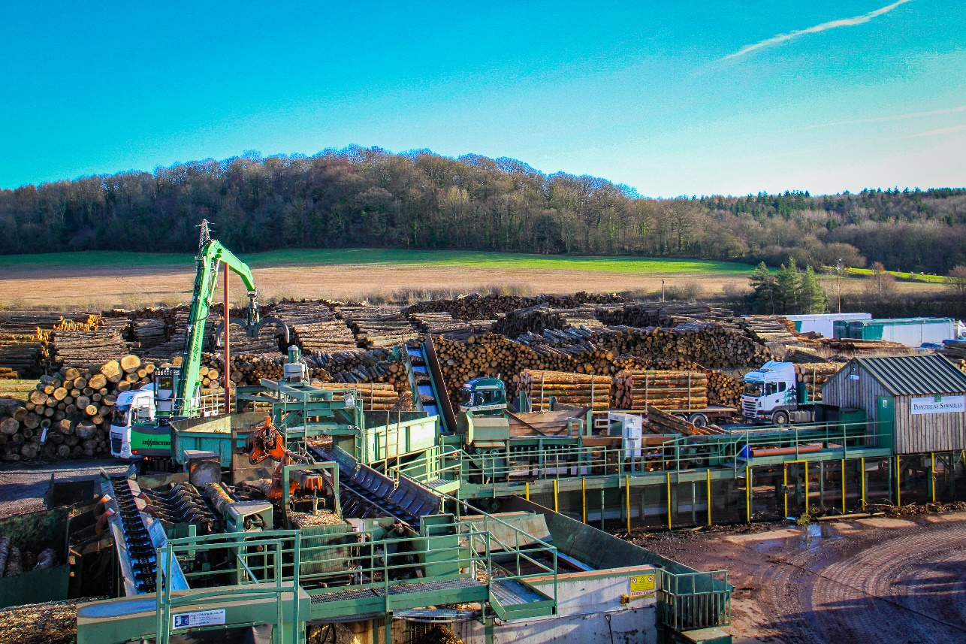
One of the largest privately owned sawmills in the UK: new 730 E material handler in operation
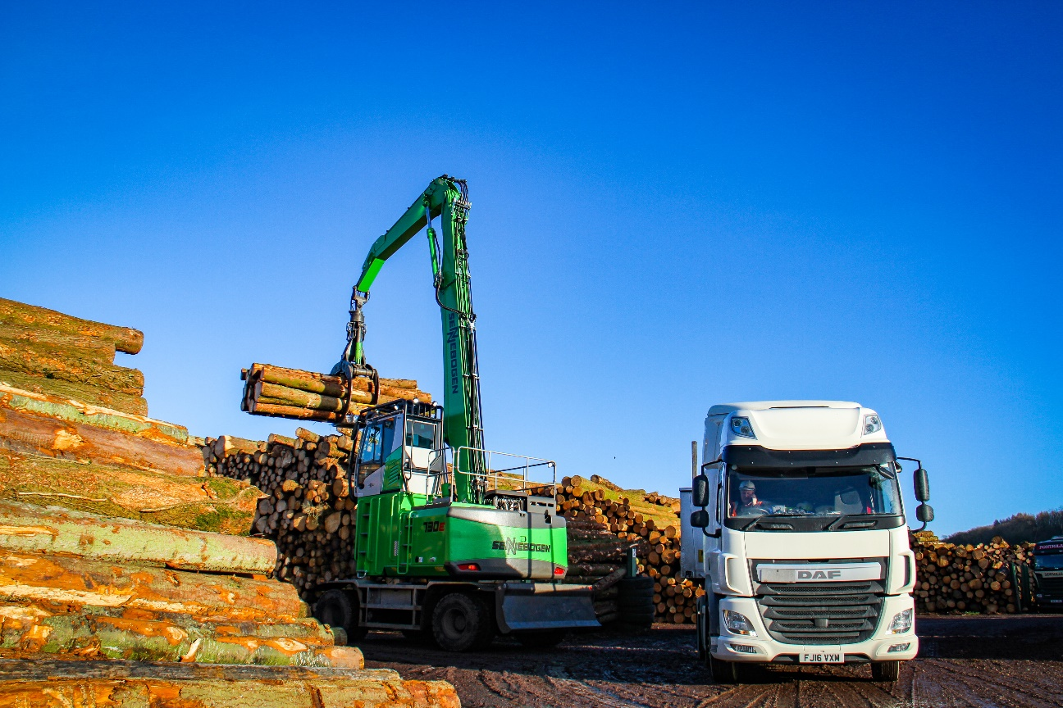
Pick&Carry operation for the SENNEBOGEN 730 E material handler
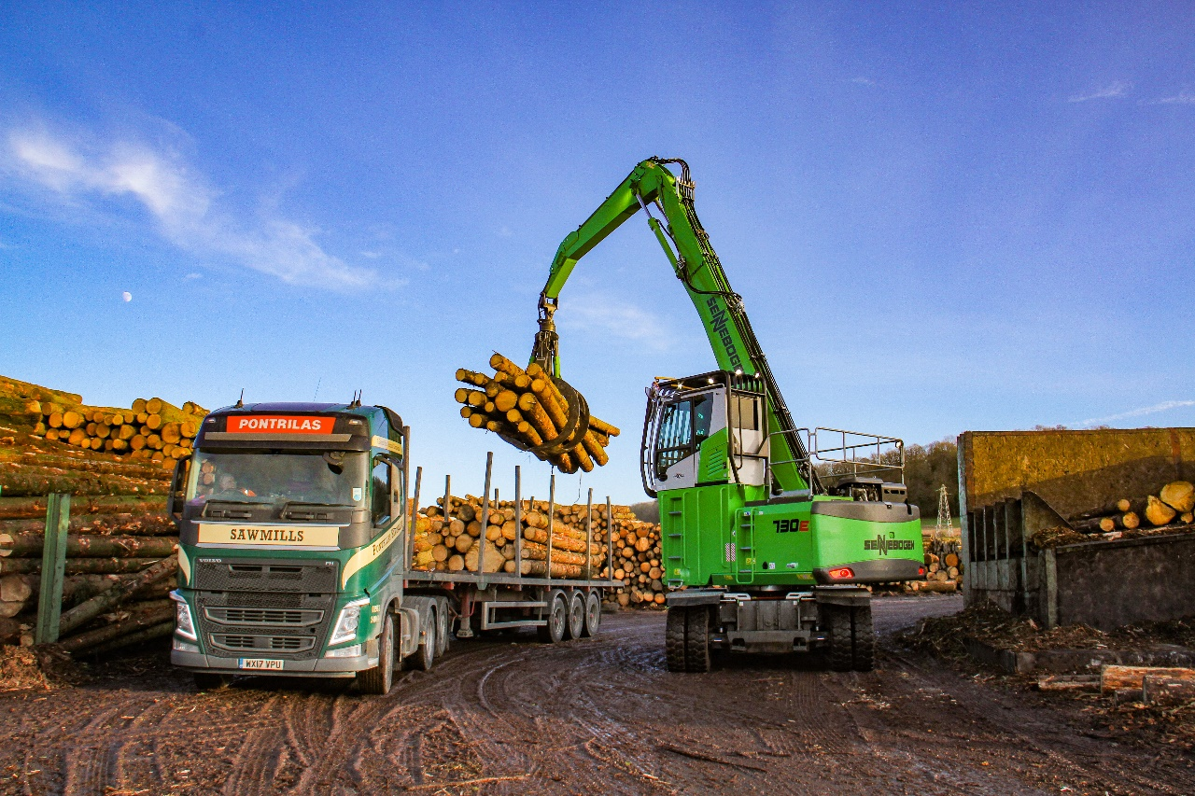
730 E material handler unloading a truck at Pontrilas Timber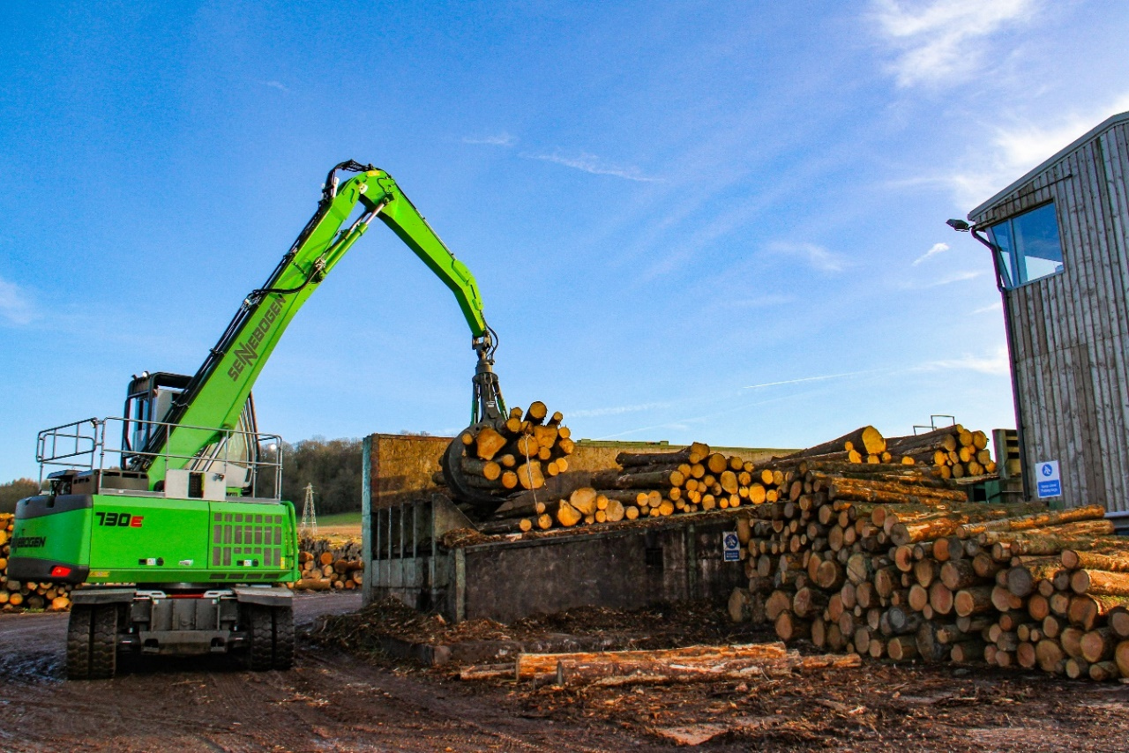
Feeding the table in the sawmill: SENNEBOGEN 730 E for effective timber handling

