Bild:
Photo Foto: Michel Matthey de l'Etang, German Popp, Martin Heying
Editor Autor: Kerstin Wabner
Date Datum: 19.11.2020
Location Ort: Birsfelden, Switzerland

SENNEBOGEN 875 E Hybrid with premium rail gantry solution – Port handling at Birsterminal AG in Basel, Switzerland
As a logistics company in the port of Basel, Birsterminal AG benefits from its perfect geographical location at the border triangle of Switzerland, France and Germany. Various materials reach the premises of the material handling and logistics professionals on the banks of the Rhine via water. Three SENNEBOGEN material handlers have been supporting the company since the end of 2019. The main player, which moves material safely and efficiently from water to rail or storage facilities and vice versa, is now an electric material handler SENNEBOGEN 875 E Hybrid: installed on a rail gantry with 16 m track width across three rail tracks, with 29 m of port equipment for heavy-duty operation and a 390 kW electric motor.

The Swiss company Birsterminal AG in Basel, Switzerland, managed by CEO Martin Ticks, is characterized by a highly diversified portfolio: the day-to-day variety of bulk and general cargo handling, timber storage, storage area rentals, container handling and construction material recycling directly on the 90,000 m² site not only makes the Swiss company crisis-proof, moreover it has grown from a coal storage company founded in 1938 to an integrated and internationally active logistics platform in the Basel Rhine port.

Advanced material handling: SENNEBOGEN 835 E, 855 E Hybrid and 875 E Hybrid
To master these vast logistical challenges with the appropriate equipment, the Swiss team recently invested in three SENNEBOGEN material handling machines: An extremely maneuverable SENNEBOGEN 835 E with 18 m equipment and a 231 kW diesel engine operates, depending on the task at hand, throughout the entire premises and excels above all when loading and unloading wagons thanks to its stable, liftable cab. The operator thus enjoys a perfect view of his loading area and positions material carefully and safely. As the timber sector at Birsterminal has also been growing steadily, the second material handler, a mobile SENNEBOGEN 855 E Hybrid, was equipped with a quick coupler: Be it with a timber grab, clamshell or orange peel grab, the solution with the second mobile material handler also led to an increase in flexibility for Birsterminal.

The 875 E Hybrid electric material handler, which is unique in its kind in Switzerland to date, is built up on an impressive rail gantry with a 16 m track width and, thanks to its enormous 29 m equipment, can easily reach across the three tracks to the storage areas. With it, the company relies on more than 35 years of SENNEBOGEN’s experience in the field of electric drives. In combination with state-of-the-art recuperation technology, Birsterminal will save considerable amounts of energy in the future: Starting from machine size 855 E series, SENNEBOGEN is installing the Green Hybrid system for energy recovery as standard, which provides an additional hydraulic cylinder between the two lifting cylinders. The additional hydraulic cylinder is connected to an energy storage module at the rear of the machine, which consists of nitrogen and piston accumulators: This is where the downward movement of the boom compresses gas according to the so-called hydropneumatic principle, by enabling the hydraulic oil to flow back from the hybrid cylinder and generate oil pressure in the piston accumulator. Especially for vertical and particularly deep boom movements, as is typical in port handling operations, the compressibility of the gas is used to temporarily store large amounts of energy. During the next lifting task, this energy is available again to lift the boom with significantly reduced power requirements. What is special about this type of recuperation technology is the large system volume of the four piston accumulators at the rear, which enables an almost constant force transmission over the entire cylinder path. When correctly preloaded, the system can substitute around 50% of the power actually required, thus saving energy costs on a large scale – ideal for port applications.

BIG increase in efficiency with electric material handler SENNEBOGEN 875 E Hybrid
At bauma 2019, the official machine handover ceremony took place between Birsterminal, sales and service partner Kuhn and SENNEBOGEN. Shortly afterwards, the assembly work on the new rail gantry started: "We made a big leap forward with the electric material handler: The machine was quickly available, is very economical to operate, always ready for use and handles far more material per hour than our previous crane solution: in the past, we could only achieve a throughput of 120 t per hour, today it is 450 t," explains Martin Ticks, CEO of Birsterminal AG in Switzerland, about the positive experience with the new machine since its commissioning.

Official handover of the material handler at bauma 2019 (from left): Heinz Gerber (Kuhn Schweiz AG), Simon Gröschl (SENNEBOGEN), Adrian Stauffer (Kuhn Schweiz AG), Martin Ticks (CEO, Birsterminal AG), Walter Sennebogen (Managing Director, SENNEBOGEN) and Kuno Schörlin (Birsterminal AG) – Source: German Popp
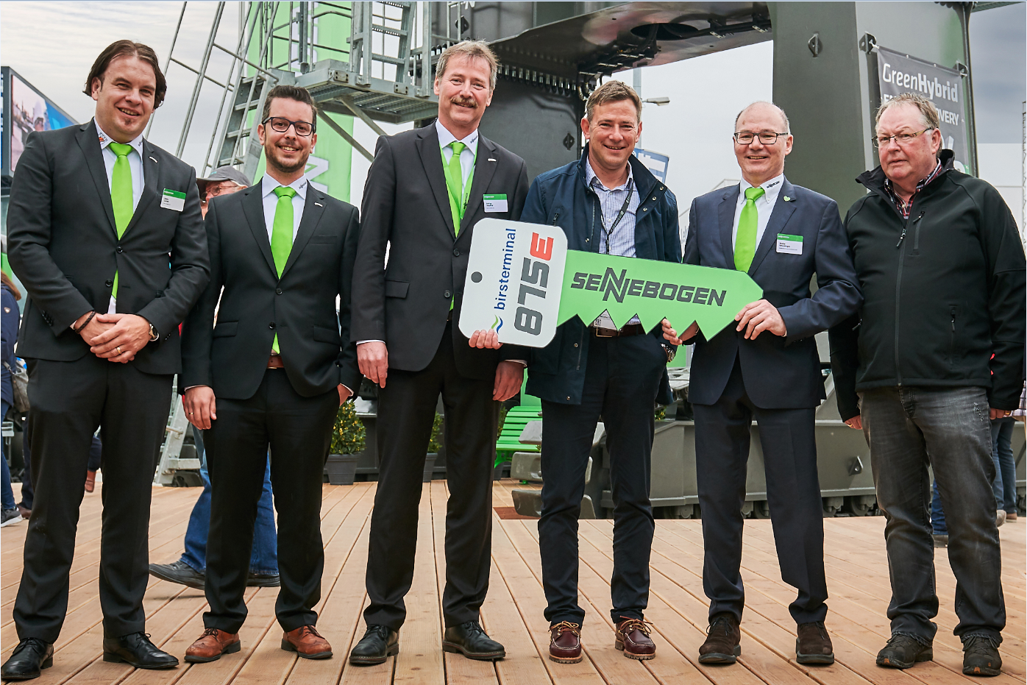

Unique in Switzerland: 875 E Hybrid electric material handler in Basel's Rhine port with an impressive, customized rail gantry with a track width of 16 m – Source: Michel Matthey de l'Etang
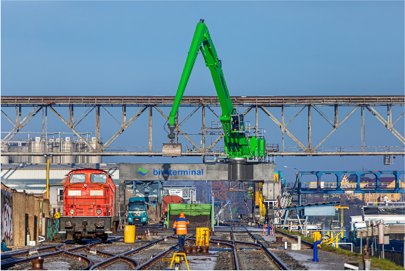
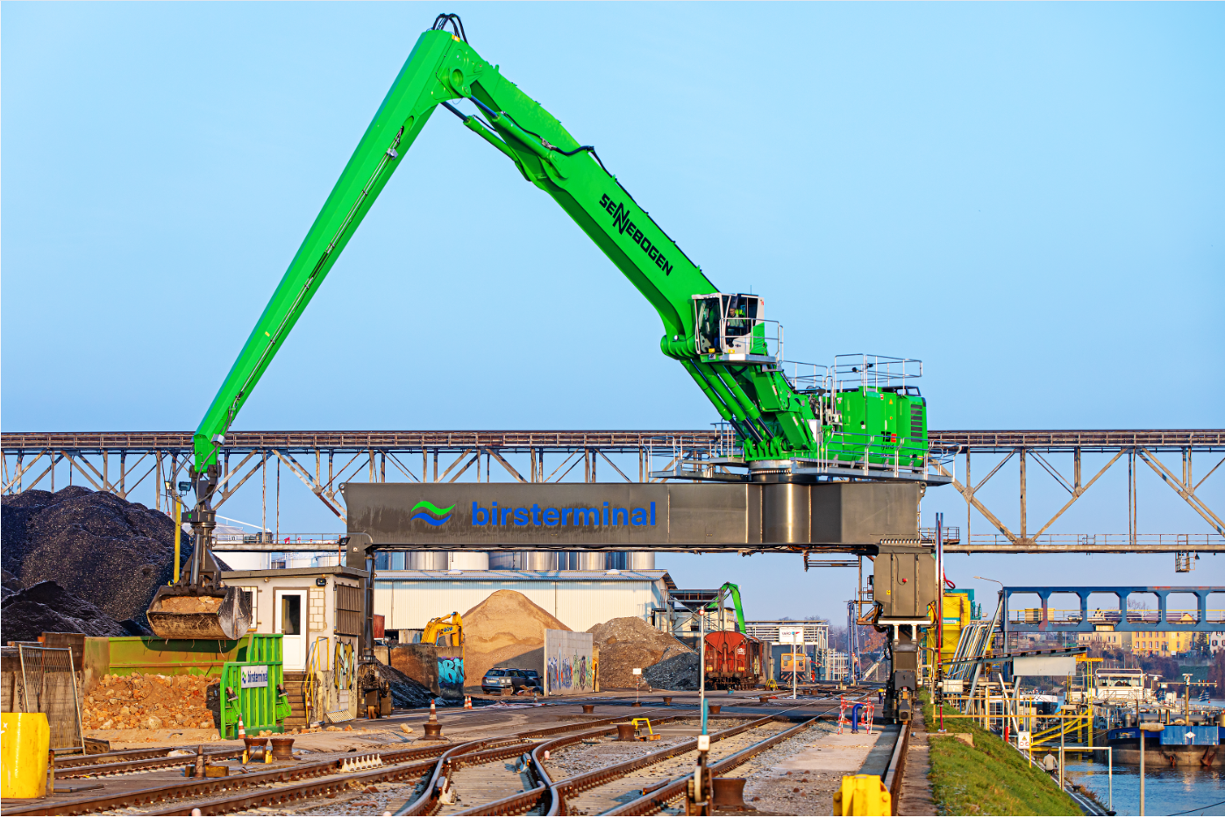

29 m equipment with special port stick in a very light construction with high-strength steel: the weight reduction allows even more lifting capacity – Source: Michel Matthey de l'Etang
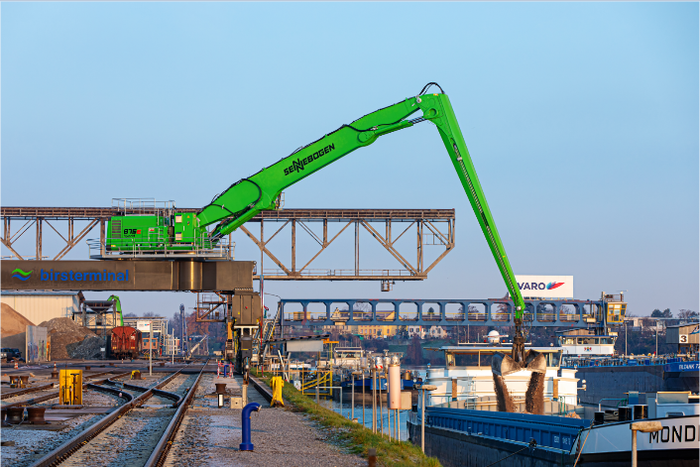

More flexibility thanks to quick coupler: Birsterminal AG uses the 875 E Hybrid with rotating loading hook or 5,000 l clamshell grab – Source: Martin Heying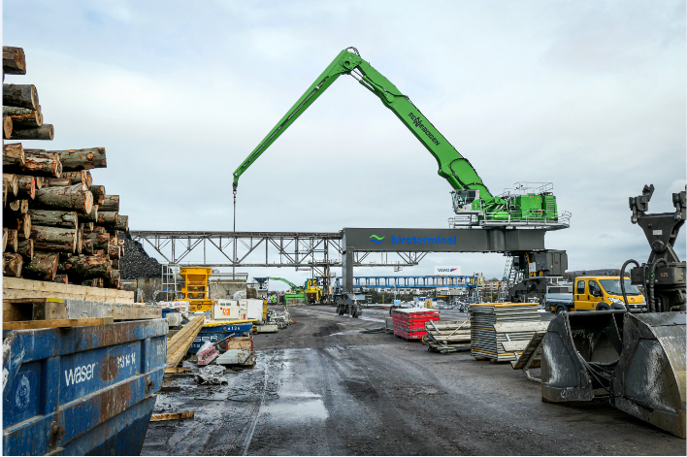

Two more mobile material handlers were added to the fleet: SENNEBOGEN 835 E and 855 E Hybrid for a wide range of loading and unloading tasks – Source: Martin Heying