At home at sea and in the ports of the north: Efficient material handler SENNEBOGEN 860 Hybrid on cargo vessel
A new fleet member of Berge Rederi AS has been defying the rough conditions on the high seas since 2019: With the ship mounted version of the 860 Hybrid E series from SENNEBOGEN, the Norwegian company is aiming high and can now make their handling processes even more efficient. The material handler has been installed on a special trolley construction on the cargo ship "Kjervaagsund", so that it can be loaded and unloaded comfortably while virtually floating above the loading area. Thanks to a special, curved 21-meter-long port equipment of the type "Banana", it is particularly easy to grasp the material in the cargo hold due to the increased reach depth.

Berge Rederi AS has a long family history on the Nordic waters. In 1997, the company was founded in its present structure and has enjoyed strong growth over the years. Around 130 employees are currently responsible for the operation of the nine vessels with a capacity of 2,400 to 6,000 tons. With their fleet they mainly transport raw materials for the animal feed industry, including fish meal, grain and corn, but also various other bulk materials such as sand or dolomite. On their routes, the shipping experts operate in the ARAG ports (Amsterdam-Rotterdam-Antwerp-Ghent), ports in Norway and in the Baltic Sea.

Efficient material handler creating competitive advantages
The Norwegians have chosen an intelligent E series material handling solution: The proven Green Hybrid system consists of a combination of a nitrogen piston accumulator module in the rear of the machine and an additional hydraulic cylinder at the boom. When the boom is lowered, the energy is stored in separate compressed gas cylinders, which are located in safe, enclosed areas in the rear of the machine. The energy retained there is then available again for the next hoisting task. To gain a better understanding of the principle, it is best to think of a spring that is compressed and sets its energy free again when it is released. Compared to conventional, diesel-hydraulic models without an energy recovery system, this principle reduces energy costs by up to 35 %. The SENNEBOGEN Green Hybrid system offers a decisive strategic advantage, especially in the highly competitive port business and in times when it is essential to use resources carefully.

"The new SENNEBOGEN has further advantages compared to the previous solution with a conventional excavator: The Banana boom has allowed us to increase the reach and working depth, giving us more flexibility in everyday use. We are also very pleased with the material handling speed of the machine," says Managing Director Øivind Berge. The cargo vessel "Kjervaagsund”, named after the place of origin of the Berge family in Norway, has a deadweight of around 6,000 tonnes. However, depending on the capacity of the port of call, the Kjervaagsund does not spend more than twelve hours at the piers to unload its freight. As a result of the gain in cargo handling speed with the 860 E series, the costs for berthing times in the ports will therefore also be significantly reduced in the long term.

An investment for the future
The 860 Hybrid solution on their vessel Kjervaagsund is a great success, but Øivind Berge is already planning the next steps: "We are currently working at full speed on our latest acquisition. "Sletringen", another cargo ship, will be equipped with SENNEBOGEN's next larger Green Hybrid solution, the 870 E series. What is special about this project is that we will be using an electrically driven material handler in order to reduce our CO₂ emissions and benefit from lower operating costs in the long term”.

[Caption:]
- SENNEBOGEN 860 Hybrid E series: Ship mounted version on integrated trolley over the loading area of the cargo vessel Kjervaagsund
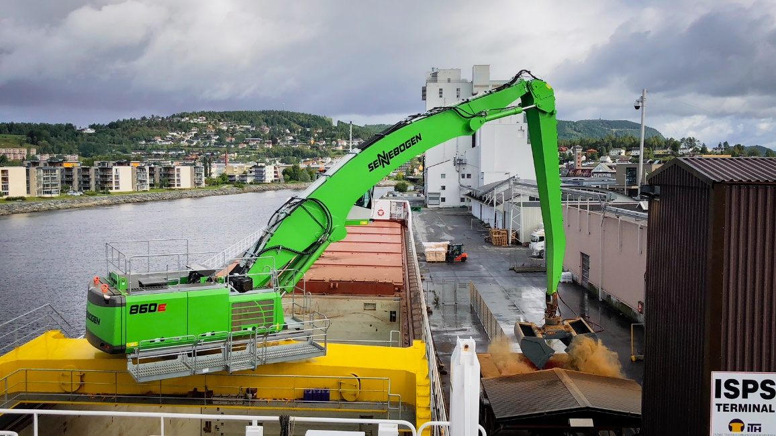
- Visiting international destinations while the German flag is hoisted: Sighting of the vessel Kjervaagsund in Vierow port, Germany
