Bild:
Editor Autor: James Dodkins /Kerstin Wabner
Photo Foto: Molson Green
Location Ort: Doncaster
Date Datum: 27.08.2020

Scrap recycling company SYNETIQ from the UK turns green with SENNEBOGEN 830 E series
When reliability is key, choosing a Sennebogen is a must. SYNETIQ, the largest salvage and vehicle recycling company in the UK, has invested in a new Sennebogen 830 E series scrap material handler supplied by Molson Green. The mobile scrap specialist with 17 m equipment has recently become the new eye-catcher at the scrap yard.

SYNETIQ has been on a remarkable growth trajectory since it launched last year, following the merger of four well-established businesses from the salvage and vehicle recycling industry. Now arguably the largest business of its kind in Europe, SYNETIQ has sites positioned throughout the UK, including the impressive 27-acre site in Doncaster that is home to their new Sennebogen 830 E series now.

End-of-life vehicle recycling on a multitude of levels
There are several avenues a vehicle can go down once it arrives through the gates at SYNETIQ. Vehicles which are listed as Category S or N write-offs have been deemed as suitable for repair, so these are prepared and sold on the SYNETIQ’s own online salvage auction. This market-leading platform is typically used by vehicle traders and repairers worldwide.

Category B vehicles are not suitable for repair, but some may contain non-safety-related parts which are perfectly suitable for reuse – such as doors, lights and engines. These are cleaned, prepared and quality-controlled, before being sold to a wide range of customers, including fleets, repairers or the general public. SYNETIQ crushes the shells of these vehicles on site, ensuring they can never return to the road. After this process, Category B and other ELVs (End-of-Life Vehicles) can begin the compliant recycling process. Once an ELV has been de-polluted and harvested of any undamaged or reusable parts, the remainder of the vehicle is transported to the baling plant to be recycled.

830 E series integrated in the core processes on site
Ray Curry, Operations Director at SYNETIQ, describes the baling plant at the flagship Doncaster site as the “beating heart of the business”, with approximately 80% of the vehicles being handled by the SENNEBOGEN as they are put into the baler and subsequently loaded into articulated wagons. Ray Curry continues: “On a busy week the baling plant can process around 700 vehicles. With that sort of throughput, the reliability of our plant and machinery is key. With lorries constantly delivering new stock and taking away processed vehicles, a breakdown can easily cause our operation significant problems”.

A wide variety of equipment options
SYNETIQ decided to go with an 830 with mobile undercarriage, which offers an impressive 17m reach. Using the four outriggers to stabilise the mobile undercarriage, the operator can remain in one location and pick the stripped vehicles safely, load them into the baler, stockpile them once processed and even load incoming trucks without having to move.

To assist operators in completing tasks more efficiently, this 830 E series has an elevating cab, with additional windscreen and roof protection allowing the operator’s eye level to raise up to approx. 5.65 m. The operator can then see clearly into trailers when loading, ensuring the load is filled to maximum capacity and with a greater degree of accuracy. Inside the cab, the operator has an uninterrupted forward view thanks to the SENNEBOGEN joystick control. The advantage of the ergonomically designed joystick controls is that there is no steering column blocking the operators’ view to the ground where the majority of sorting is completed in this application. Another big plus is that they were built to show a sensitive response behaviour for precise sorting and piling tasks.

Molson Green Sales Manager, Dave Peacock said, “Ray and his team were very clear from the outset on what the machine had to do and underlined how we had to support them as a dealer. Any concerns about the after-sales backup support from Molson where quickly addressed when we discussed our 10 service locations, significant stock holding of spare parts and the network of over 75 service engineers.”

[Captions:]
- 830 E series in the mobile version loading the baler with orange peel grab
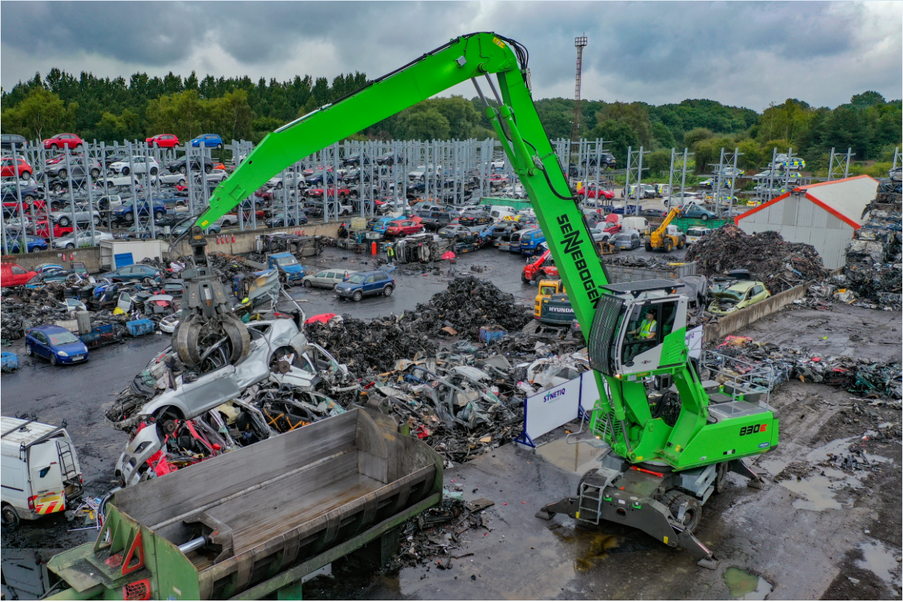
- The heart of the site: Thanks to the 17 m equipment, the baling press and trucks can be loaded almost without repositioning the machine 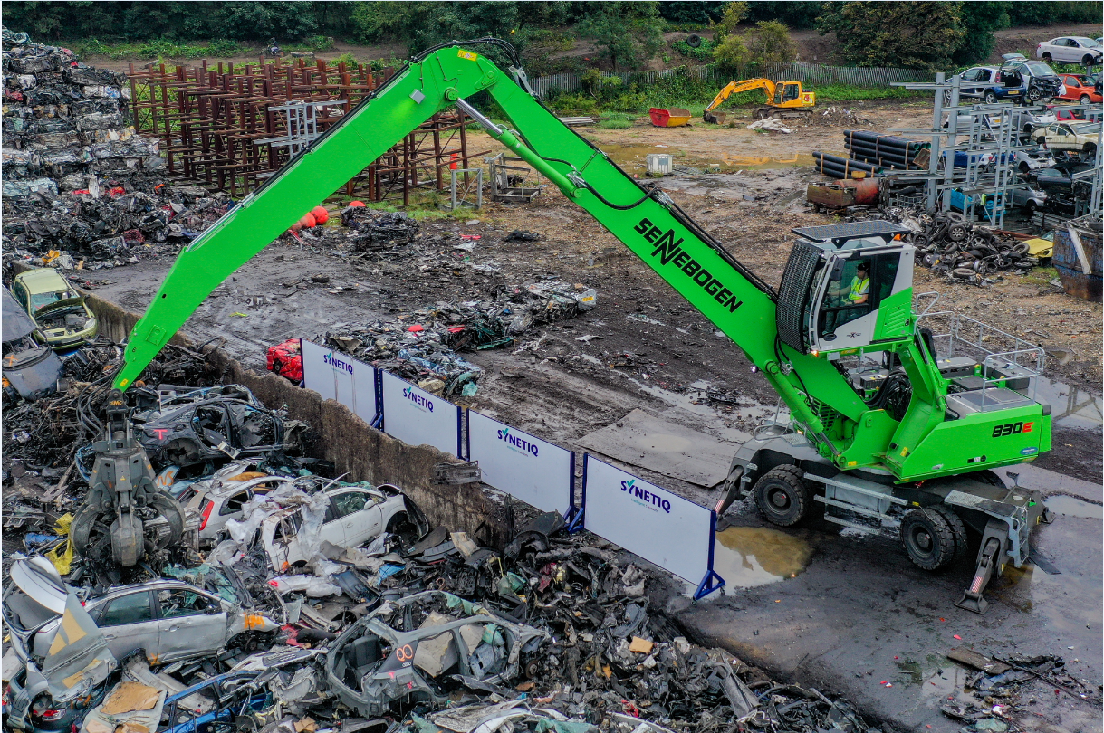
- Safety grids on the roof and windscreen of the Maxcab guarantee a safe working environment for operators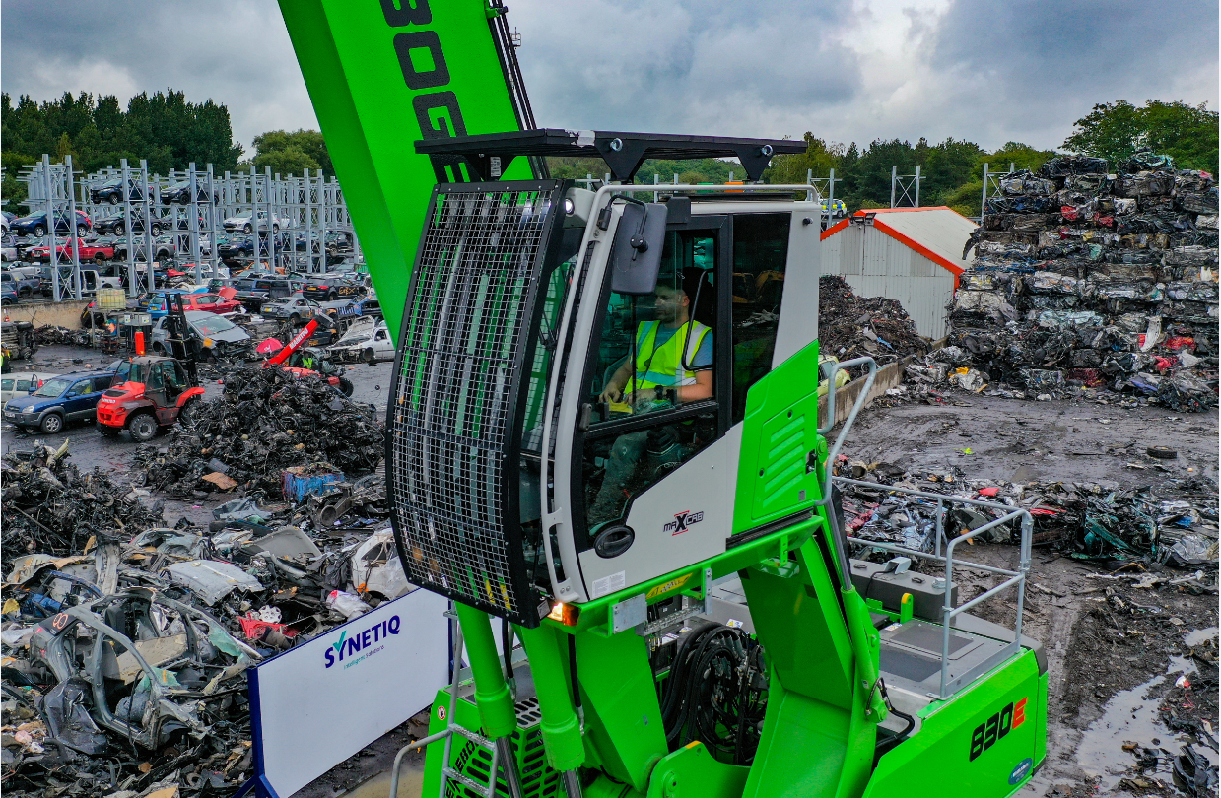
- Strong partnership through good service: SYNETIQ Operations Director Ray Curry with Molson Green Sales Manager Dave Peacock (from left)