The 895 Hybrid E-Series material handling giant by SENNEBOGEN moves material on a grand scale in the port of Iskenderun
If Jurassic Park was not just a movie and we were able to walk among peaceful brontosaurs in real life, it would probably feel something like being close to the 895 Hybrid E-Series. There is no need of either a time machine, or a ticket to the Hollywood film studios to have this experience, a visit to the port of Iskenderun in Turkey is all it takes. Since October 2019, a gentle giant from SENNEBOGEN has been moving masses of old scrap every day and in the shadow of the enormous port machine, one simply remains a small, impressed observer of what is happening. The largest material handler in the world, launched at bauma 2019, is now an integral part of port operator Tosyali’s green fleet.

Everything about this machine is big and record-breaking. Following its smooth transportation in sections on a total of 16 trucks and successful installation and commissioning by Turkish sales and service partner Forsen Machinery in just a few days, the largest material handler in the world is now setting new standards in terms of size and efficiency in the loading and unloading of ships up to panamax and post-panamax size. The environment in operator Tosyali’s port is perfect for the machine. Tosyali Holding’s transhipment port, located in one of the largest metal producing areas of Turkey, supplies the local steelworks with scrap, among others. Boasting a net weight of around 420 t and a 500 kW electric drive, the SENNEBOGEN 895 E-Series is the central linchpin of the specialist port’s fleet. Despite its remarkable size, the machine works quickly, efficiently and without emissions.

“Our experience with SENNEBOGEN machines has shown us that using electric material handlers does not mean compromising on flexibility or speed,” explains Harun Karaarslan, Technical Port Director at Tosyali. “Quite the opposite. The machines cover a large work area as they can move up and down the pier quickly and easily. By not using diesel we also save a lot of money every year.” Tosyali has been relying on green support in the large machinery sector for the past 12 years. Amongst others, the specialist port’s fleet includes two 880 EQ Balancers with crawler tracks, both electric versions. The 895 Hybrid E-Series joined the ranks as the seventh and biggest material handler on site, fitting seamlessly into the port’s processes.

Energy Recovery System – simple and effective
The unique Green Hybrid system also contributes to the machine’s efficiency and reduced operating costs. In the case of the 895 E-Series this means a maximum energy saving of up to 55 %. How is it possible for a machine weighing 420 t, itself as heavy as two adult blue whales, to operate so efficiently? The port giant’s boom has two in-built hydraulic systems that compensate for the dead weight of the 53 t steel structure. Along with the hybrid storage modules installed on either side of the machine right next to the boom pivot point on the uppercarriage, they make up SENNEBOGEN’s Green Hybrid energy recovery system. Like a spring, gas is compressed in separate gas cylinders, storing energy that can then be used during the next lift. This subsequent lifting motion is just like the spring being released and the energy from the compression being let out again. Just a brief look at the annual volumes handled by the Tosyali port shows how important the energy and cost savings from using the giant machine really are.

“We handle 10,000,000 tons a year in this port alone, our machines are in constant use. We are reliant on the machines in our fleet working constantly, downtime would be fatal,” explains Harun Karaarslan. In this context, he mentions further decisive advantages of the electrically driven material handlers in his port. On one hand, there is the constant availability and not needing to interrupt the work flow to refuel. On the other hand, maintenance frequency is significantly reduced and the overall wear and need for replacement parts including transport costs is significantly lower on electric machines than on their diesel counterparts.

Precision is what it takes!
What skills are looked for when hiring an 895 E-Series operator? Quite simply, a head for heights. In order to have the best possible view of everything in the surrounding area, the operator can raise the large port cab up to a height of 22 m thanks to the Skylift cab elevation. This helps with the placing of bulk goods and cargo in ships’ hulls and makes unloading freighters much easier, not to mention the fantastic panoramic view of the port. The operators are supported by additional cameras at the rear and on the right-hand side of the machine, conveniently observable via a screen in the cab. There is also the option of installing a camera on the stick of the 40 m long equipment which makes placing or grabbing materials in ships’ loading areas much easier.

Tosyali is currently using the machine to unload scrap. A 12 t orange peel grab with a capacity of 10 m³ is installed on the stick. In the future, a wide range of bulk cargo will also be handled with a clamshell grab. Thanks to the green giant’s sensitive controls, the grab moves gently over the hopper and loads up the waiting trucks in a cycle time of around 40 seconds.

[Captions:]

- The electric version of the 895 Hybrid E-Series material handling giant in the Tosyali Liman port, Iskenderun, with a 40 m long port attachment
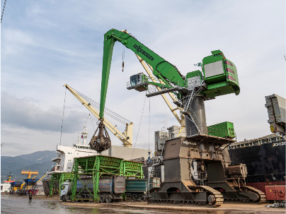
- Gentle giant: the sensitive and precise control of the 12 t grab being used to safely and efficiently load trucks
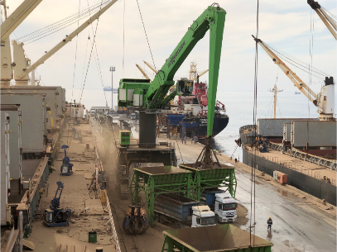
- All-round view guaranteed: operators can keep everything in view in the SENNEBOGEN port cab
