SENNEBOGEN Multi Line deployed at Metallverwertung München GmbH & Co. KG

Metallverwertung München (MVM) processes more than 10,000 t of cables and power lines a year. It sorts and chops the cables it receives in order to extract any reusable components such as precious metals and plastics. Once they have been processed, the single-variety pellets are a valuable resource that can be fed back into the economic cycle. MVM extracts up to 4,500 t of metal in this way annually. This is just one reason why MVM is classed as one of the leading cable recycling companies in Europe.

Johannes Würzberger, CEO of the family company founded in 1947, is clear, "We need a powerful, multi-functional machine for our sorting and loading activities. A machine that, on the one hand, can do the precise lifting of a telescopic handler, and, on the other hand, works like a traditional wheel loader and can load heavy metals and scrap."

The SENNEBOGEN 355 E telehandler combines the best of both worlds - it is sturdy and stable like a telescopic handler but also strong and robust like a wheel loader.

Thanks to the series standard SENNEBOGEN quick change system, the 355 E can be fitted with any equipment in a matter of seconds, whether that be a lifting fork, a bucket or a rotating clamping fork. It is not without reason that the SENNEBOGEN Multi Line is said to be multi-functional. Mr. Mathias Kloo, Operations Manager at MVM, also appreciates this flexibility, "The attachments have to be changed multiple times a day in order to properly execute the varied work we do. Every minute counts."
There is a lot for the 355 E to do on the MVM site. It works alongside two other SENNEBOGEN material handlers to sort and untangle the cables that are received.

The SENNEBOGEN 355 E telehandler's Z kinematics, usually associated with wheel loader technology, play a key role in the loading of heavy precious metals. "The Z kinematics in the boom head give the machine very high breakaway torque. This means I can use the 355 E for the challenging task of loading heavy metals. Your typical telehandler cannot do this and I would usually need an additional wheel loader to do it. The 355 E is simply more powerful and I can use it to kill two birds with one stone," says Mr. Kloo.

The machine's robust steel construction, its powerful and reliable engine, and its steel reinforced tires are all ideally suited to the challenging tasks of industrial and recycling plants, and multi-shift operations.

The unique elevating cab means that the operator has the work area quite literally in their sight e.g. when loading bulk goods into trucks using the bucket. With an eye level of 4.25 m, the operator has an optimum view of how the goods are spread out, and can, therefore, work more efficiently. Mr. Kloo adds, "The view from the SENNEBOGEN 355 E is unique. The elevating cab provides a true all-round view and the operator is much safer than they would be in a competitor's machine. In my view it is the best machine in the world - strong, agile, flexible and reliable."
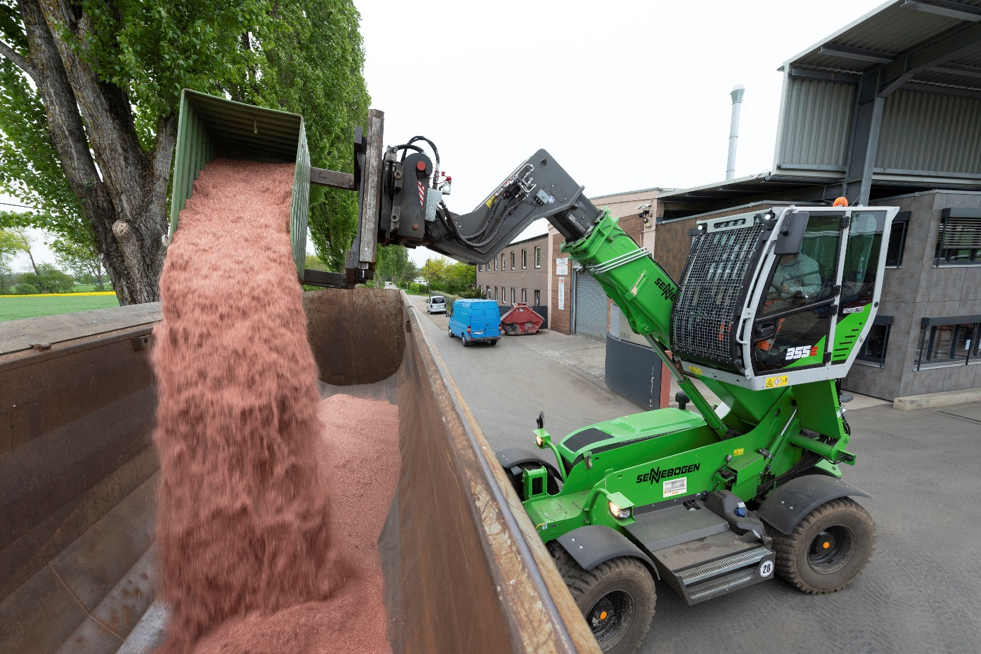
The elevating cab provides the perfect view for loading copper granulate
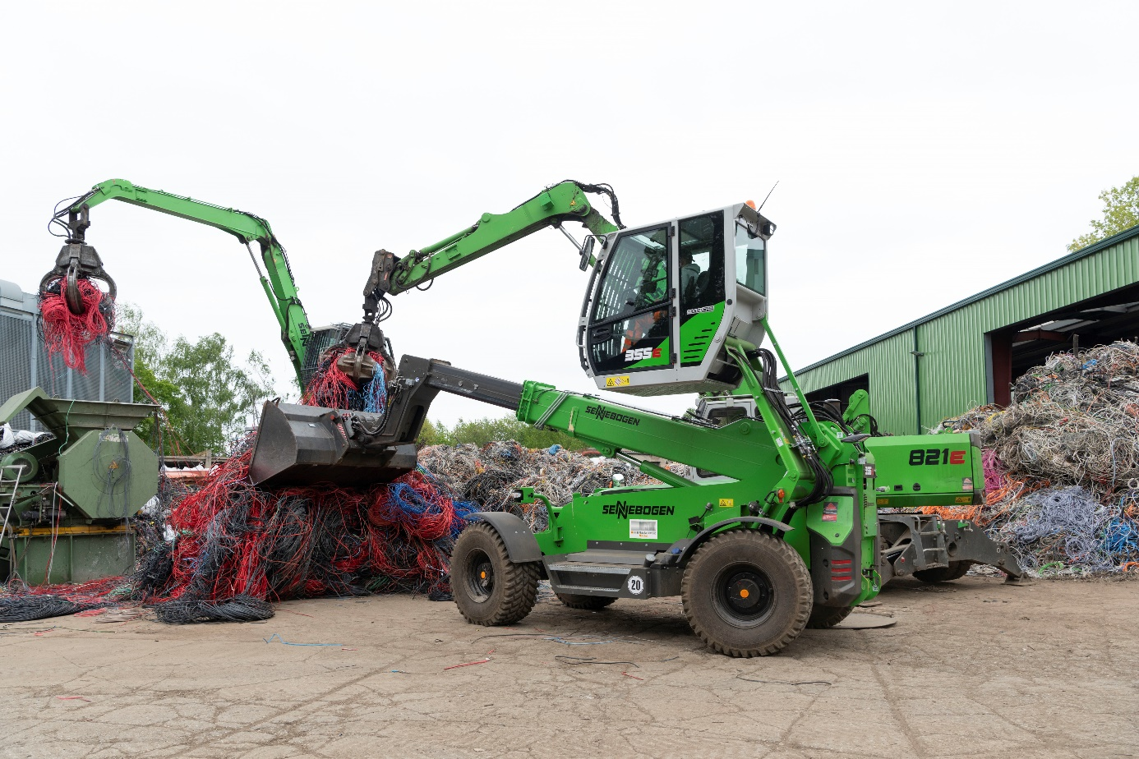
SENNEBOGEN machines working together to sort cables

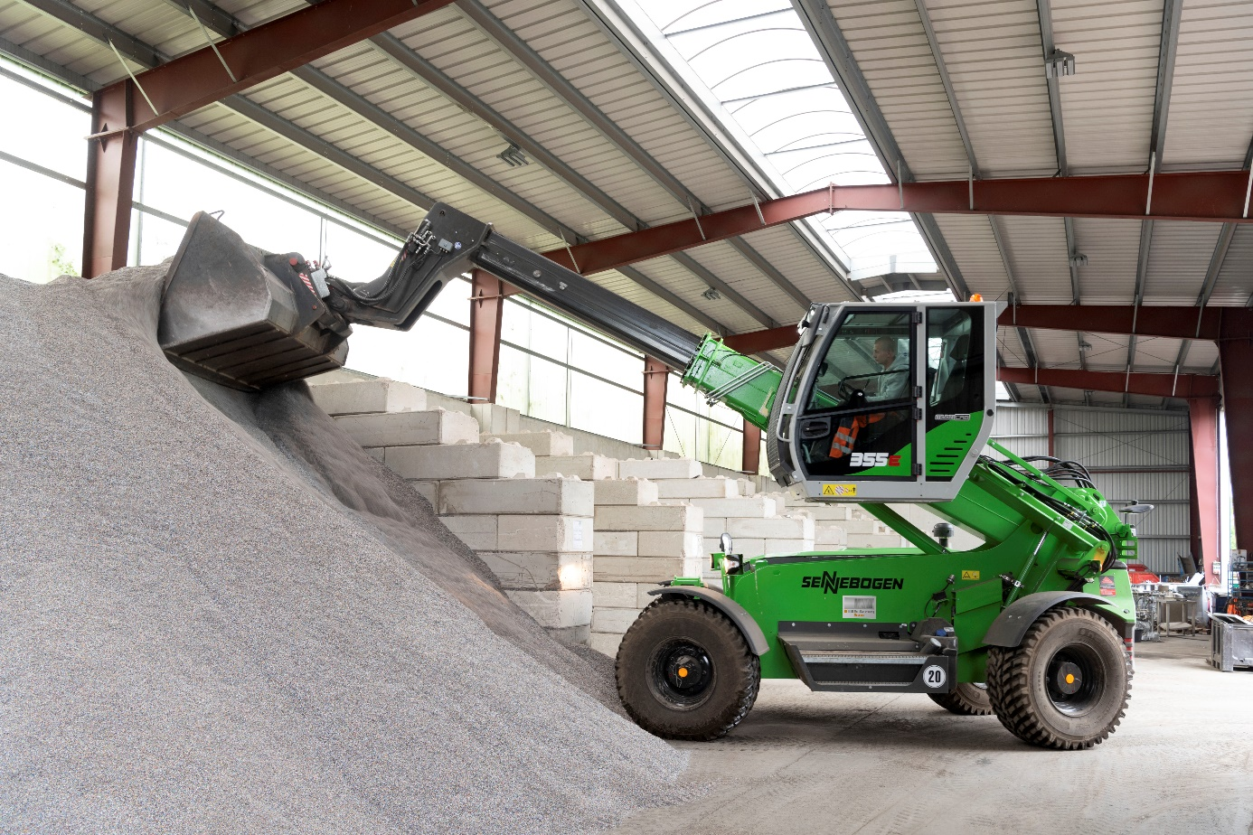
Thanks to the telescopic boom, bulk goods can be piled up particularly high. And yet the machine is still compact - ideal for hall use.
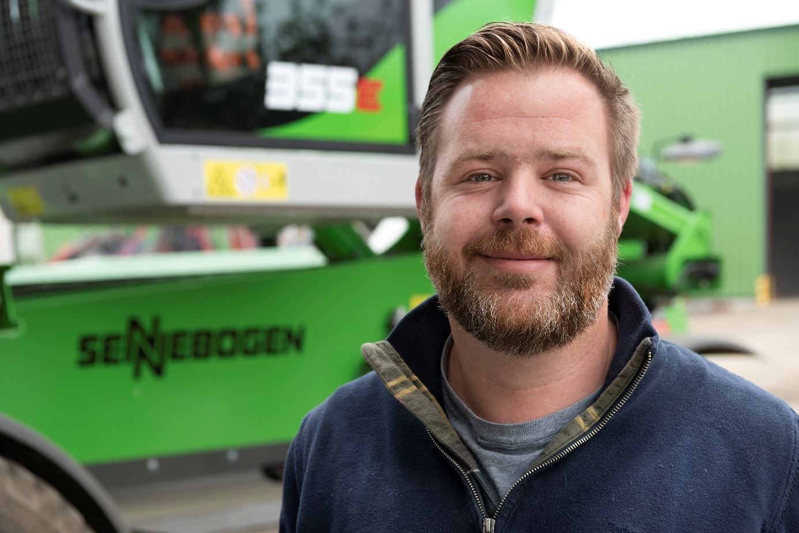
Johannes Würzberger, CEO of Metallverwertung München GmbH & Co. KG

