Automation in the timber industry driven by gantry solutions – a project partnership between SENNEBOGEN and HOLTEC
Date / Datum: May-23
SENNEBOGEN, a Lower Bavarian manufacturer of material handlers and HOLTEC, a specialist in plant engineering in the timber sector with headquarters in the Eifel region, have been working on projects together for years. With their gantry solutions for sawmills, they are now driving forward automation in the timber industry. An example of this is an impressive exhibit at the LIGNA timber trade fair in Hanover from May 15 - 19, 2023 at the HOLTEC stand, hall 25, stand no. D50.
Timber processing is one of the oldest industries in the world. The raw material offers a huge range of processing options, which have been designed and developed over thousands of years. In the meantime, sawmills have developed into true high-tech centers that are at the forefront of automation. Gantry solutions are an important building block for automation in sawmill technology. In joint projects, HOLTEC and SENNEBOGEN implement gantry solutions for sawmills that simultaneously automate and optimize timber manipulation.

Increased efficiency and quality
(Partial) automation in the processing of logs can make an important contribution to increasing efficiency and quality. On the one hand, the installation of automated systems usually goes hand in hand with the streamlining of processes and the optimization of log storage. In addition to maximizing storage capacity, warehousing becomes more intelligent overall, as automated log handling solutions generally require less space than concepts based on manual handling. What’s more, the operator’s workload is relieved by the fact that they have fewer decisions to make. The reduced potential for errors also ensures consistent quality.

Economic benefits – flexible and sustainable
On the other hand, automation is also highly interesting from a purely economic point of view. Gantry solutions can cover a wide range of applications in timber handling without compromising on flexibility. The operator can slew the machine 360 degrees, and can also move forwards, backwards and sideways with built-in trolleys. Thanks to its modular machine concept, SENNEBOGEN offers a wide range of equipment options depending on the machine size and the material handler equipment, with ranges of up to 20 m possible. There is also the length of the gantry’s individually definable travel path. This saves both time and personnel, as a single operator can cover a very large working area in a very short time.
In addition, material handlers with gantries can be implemented as purely electric solutions. The electric engines are particularly environmentally friendly due to the elimination of fossil fuels and exhaust gases, and also offer enormous savings in daily operation. From the outset, they are more economical and require less maintenance than diesel engines and thus reduce operating and service costs. They also work with reduced noise and generate fewer vibrations, which relieves the strain on nature and people around the machine over the long term.

Reference for gantry solutions in the timber industry: Dold Holzwerke GmbH
A brand-new example of the cooperation between HOLTEC and SENNEBOGEN is at the company Dold Holzwerke GmbH in Buchenbach. Here, a new SENNEBOGEN 840 E electric machine with rail gantry recently replaced an old cable gantry crane after a project phase of only 9 months. With its 20 m reach and gantry design with 36 m track width and 45 m travel distance, the machine takes care of the box emptying and supplying two cutting lines with logs. An expansion involving the extension of the track system is already being planned. The new, all-electric drive concept with 200 kW electric engine fits perfectly into the processes of the sawmill, which has stood for sustainable, economical and ecological action for more than 130 years. For similar reasons, the SENNEBOGEN 735 GED Pick and Carry material handler (Green Efficiency Drive) with electric travel drive has been used for unloading incoming trucks on site for quite a while. For Dold Holzwerke GmbH, the decision to use the all-electric gantry solution from HOLTEC and SENNEBOGEN was a further step towards achieving the company’s goals: "With our sustainably managed timber as a competitive alternative to hard building materials, we make an effective contribution to climate protection and CO ₂ reduction through our product portfolio alone. The fact that we are now implementing this even more consistently in our processes, thanks to the new log handling concept, definitely sets standards for modern, sustainable management in our industry."

To be seen at LIGNA 2023
An example of a gantry solution will be on display at LIGNA 2023. At HOLTEC stand no. 25 in hall D50 from May 15 - 19, 2023, a 67 t material handler with a reach of up to 20 m, the SENNEBOGEN 840 E, will be on a gantry. Go ahead and take a look.

Captions:
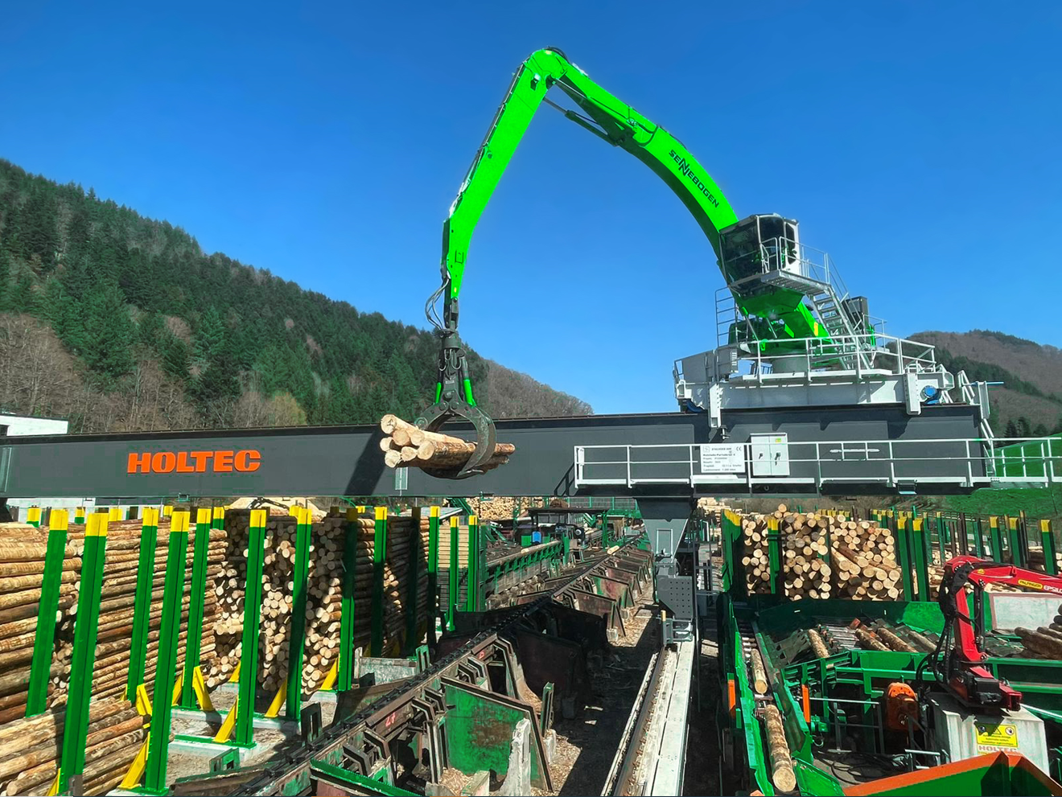
Picture 1: Successful project cooperation – here at Dold Holzwerke GmbH. HOLTEC and SENNEBOGEN have been providing solutions for the timber industry together for years.
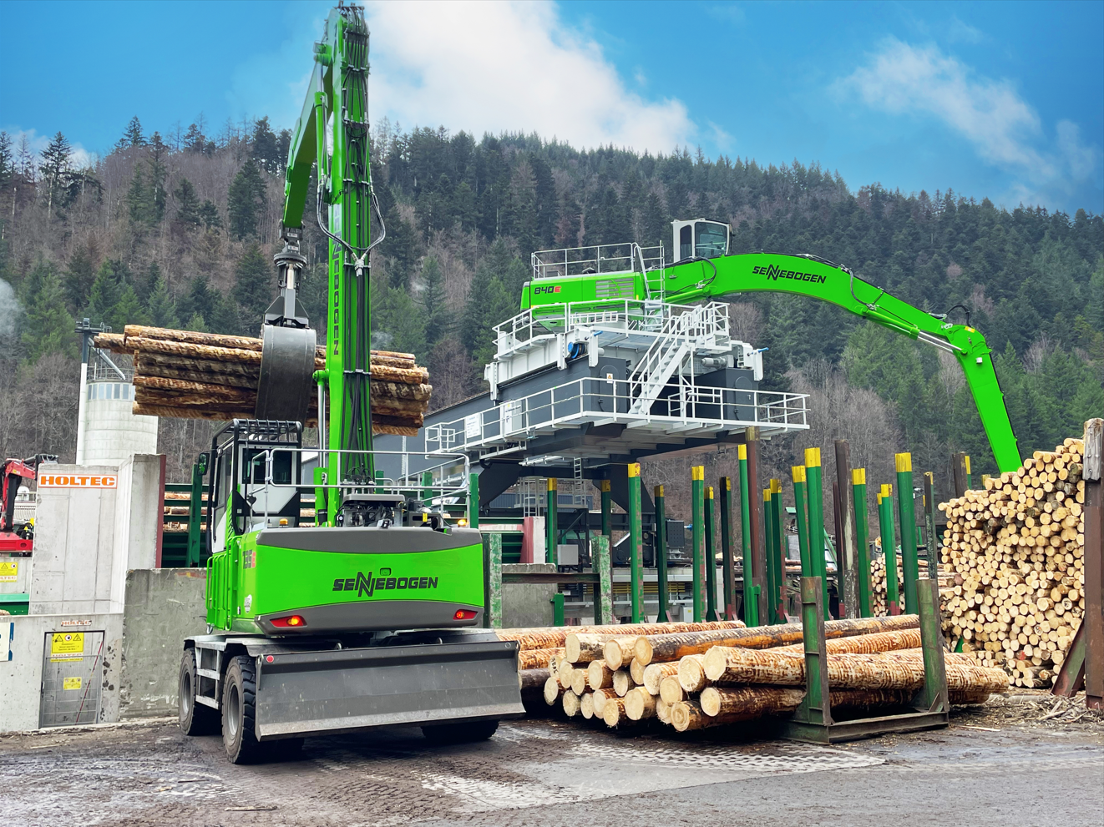
Picture 2: At Dold, the machines run on electricity: an electric gantry version of the SENNEBOGEN 840 E and a SENNEBOGEN 735 GED with electric travel drive take care of timber loading at the Buchenbach site.

