SENNEBOGEN presents the new 30 t battery-powered material handler 825 Electro Battery at bauma 2022: a zero emission innovation project
Date / Datum: Sep-22
Date / Datum: Sep-22
Sustainability in the circular economy not only means returning valuable resources to the cycle and using them again and again, but also using durable and economical machines for the recycling itself. Against the background of the joint goal of project partners SENNEBOGEN and CRONIMET to significantly reduce CO₂emissions in the recycling process, SENNEBOGEN has developed the battery-powered 30 t electric material handler 825 Electro Battery, which allows completely emission-free working.
The Bavarian manufacturer of material handlers SENNEBOGEN and the metal recycling and trading company CRONIMET, headquartered in Karlsruhe, have had a strong partnership since 2014. When it came to putting the vision of a climate-neutral recycling process into practice, the two companies quickly decided to work together. As an innovative SENNEBOGEN project and with the participation of CRONIMET as a partner in the field of scrap recycling, a mobile 30 t electric material handler with battery technology was developed, which guarantees maximum CO₂ savings. Both in battery operation and with a cabled power supply, the modern battery-powered material handler works without restrictions in terms of space and time – essential for really proving itself in practice in the recycling industry, which is mostly organized in shift operation.
825 Electro Battery: practical recycling material handler with battery technology
As the market leader in the field of electric machines, SENNEBOGEN is known for offering solutions that are individually tailored to the needs of the customer. It has developed a battery-powered electric material handler that works completely climate-neutrally and is perfectly tailored to the requirements of demanding metal recycling. The CRONIMET key account not only contributed significant practical expertise during product development, which was implemented, for example, in the form of intelligent add-ons relating to battery technology, but also actively contributed during the machine's prototype stage.
Like the battery-supported variant of the 817 Electro Battery, which has already been launched on the market, the 825 Electro Battery impresses with its intelligent dual power management, which allows autonomous working in battery operation as well as when connected to the mains. Depending on the power requirement, the 378 kW lithium-ion battery pack installed in the rear enables working times of up to eight hours without recharging. If the machine is connected to the power supply via the charging point on the undercarriage, stationary work can be carried out. A great highlight is that when charging, excess power being fed in simultaneously recharges the batteries. The machine can also be connected to conventional power sockets thanks to the on-board charger and the 63A CEE plug system used. Additional investments in charging stations are no longer necessary. It also offers more comfort for employees, as it is quieter, has lower vibrations and is completely emission-free. The lower service costs and thus also the reduced operating costs associated with the electric machine are another plus point of the battery-powered material handler.
Already in operation: SENNEBOGEN 825 Electro Battery as an important step for CRONIMET towards climate neutrality
CRONIMET currently uses the machine for feeding its scrap press, preparing material for the press and for sorting incoming goods. The battery-powered material handler runs on 100 percent certified green electricity and saves up to 125 tons of CO₂ emissions per year in two-shift operation compared with the previous solution - and with the same freedom of movement. “With this innovation project, we are taking a decisive step towards climate neutrality,” says Marijo Zeljko, Managing Director of CRONIMET Ferroleg. GmbH.

To be seen at bauma 2022
The SENNEBOGEN 825 Electro Battery will be presented to the public at bauma 2022 - to be seen from 24 to 31 October at the SENNEBOGEN stand at the FM.712 outdoor area, Messe München.

Captions:
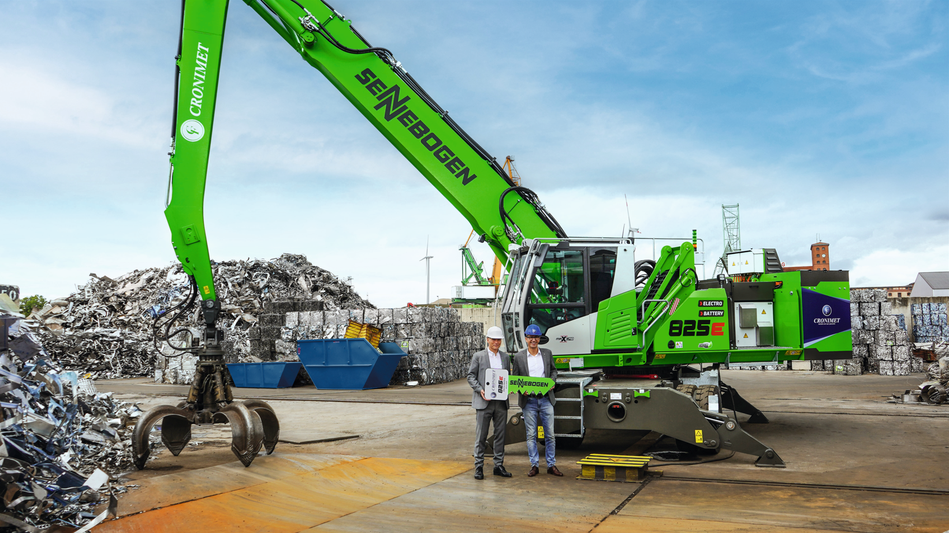
Picture 1: Successful cooperation: SENNEBOGEN Managing Director Erich Sennebogen (left) and CRONIMET Ferroleg. Managing Director Marijo Zeljko (right). As an innovative SENNEBOGEN project, the 825 Electro Battery was developed with the participation of CRONIMET as a partner in the field of scrap recycling, and will be presented to the public at bauma.
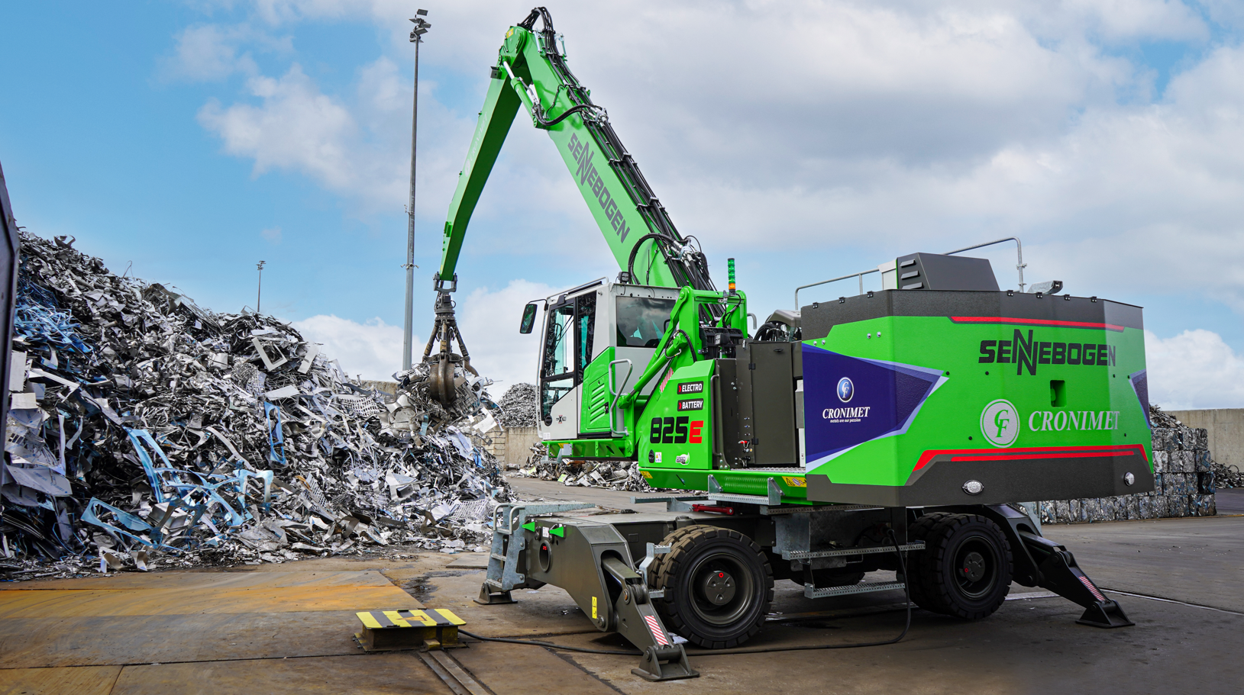
Picture 2: When feeding the scrap compactor, the 825 Electro Battery operates in mains mode. Power is supplied via the charging point on the undercarriage.

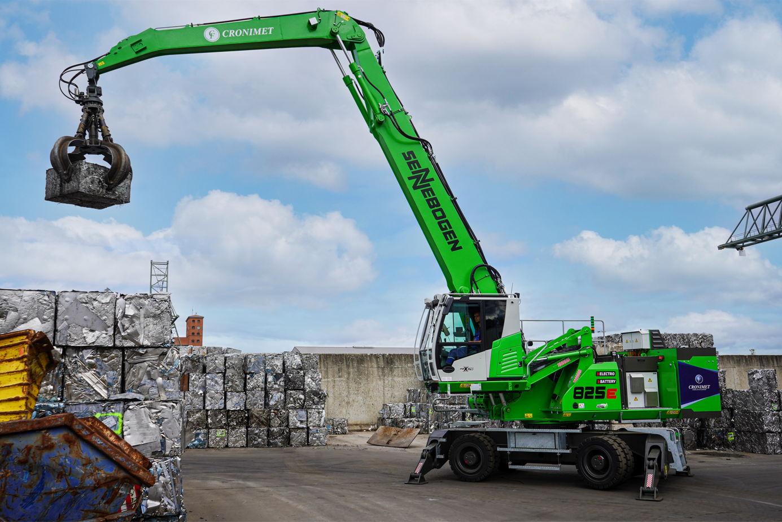
Picture 3: In addition to feeding the scrap press, the machine also performs sorting and stacking work operating flexibly in battery mode.

