Location Ort: Frankreich
Date Datum: Jan-24
Photo Foto: Epvre Delquie
Editor Autor: Epvre Delquie, Selina Retzer
Shell construction at the touch of a button: fully radio-controlled construction site
COMET PACA is relying on innovative construction technologies in the midst of construction work for a new, nature-oriented residential complex in the municipality of Hyères les Palmiers on the French Riviera. The shell construction work is being carried out by a telescopic crawler crane, the SENNEBOGEN 683 E, supplied and operated by M&S TRANSLEV.

COMET PACA, a major company within the MELLONE CONSTRUCTION Group, is established in south-east France as a construction partner for detached houses and apartment blocks. As a long-standing SYGMAT customer, the company maintains a fleet of compact SENNEBOGEN telescopic cranes in the Île de France and in the south of France. For a new residential construction programme on the Côte d'Azur, local regulations prevented the use of a tower crane on the entire construction site. The solution: the ultra-modern SENNEBOGEN 683 E crawler crane. This crane handles all the lifting work in one part of the construction site and fulfils the transport requirements for the three four-storey building complexes.

COMET PACA combines different construction techniques to optimise their construction sites and to ensure the best environmental and energy performance of their buildings. The SENNEBOGEN 683 E lifts common precast elements, conventional or insulated blocks, concrete buckets, rubble and the most important conventional building components such as columns, beams or formwork.

Dynamic and resilient on the move
The crane is positioned in the centre of the site and moves on its crawler tracks as required to cover a large working area and meet the needs of each team.
Thanks to its 42 m telescopic boom with full-power boom, it can extend its reach by up to 40 m, ensuring efficient lifting across the entire site. The key advantages of SENNEBOGEN telescopic crawler cranes are demonstrated more than ever on this construction site. Moving and telescoping under load over the entire length of the boom is no problem at all.

100% radio-controlled telescopic crawler crane
In addition to the special performance of the 683 E, the way in which it is used is also exceptional. The crane was chosen to replace a high-capacity tower crane that is usually used on such construction sites. The significant advantage here is the use of radio control for all operations: Moving with or without a load, lifting or positioning is controlled remotely.
Sébastien Greuzard, Managing Director of M&S TRANSLEV, has been working in Hyères for several months: "It is unique that I can operate the crane precisely with the 683 E radio control both from the ground and in the working area on the floors of the buildings. I can carry out lifting operations on the ground and position the loads precisely by being right next to the workers in the assembly areas."

Safety through innovation
The increased safety is an essential element that was also highlighted by the teams on the construction site: "With this working technique and thanks to this crane, the operator has the entire working area of the machine directly in view and the manoeuvres are much safer when the crane operator is operating close to his colleagues instead of blindly with a radio link or a camera."

Bildunterschriften:
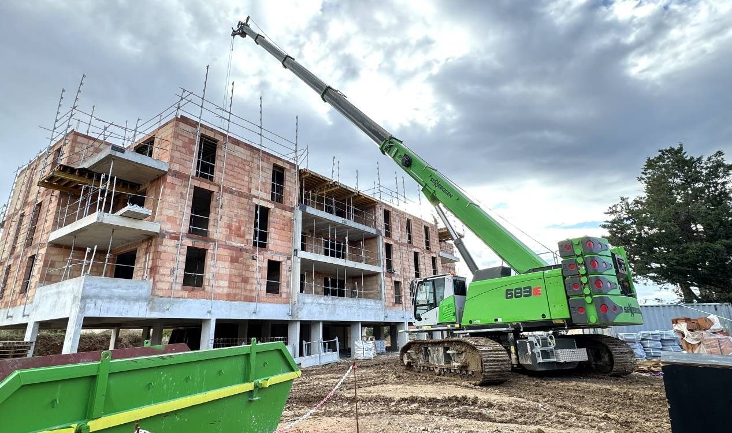
Bild 1: Lifting precast concrete parts, positioning with a span of up to 40 m, final adjustment very close to the teams: the SENNEBOGEN 683 E crawler crane was the right choice on this varied construction site.

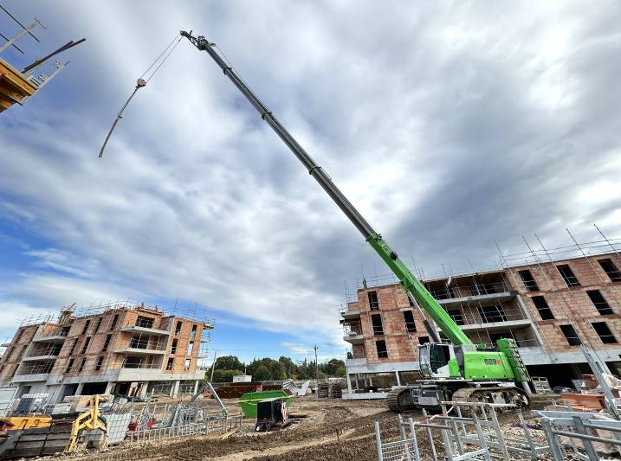
Bild 2: With a 42 m full-power boom, the SENNEBOGEN 683E crane covers a large working area to ensure the simultaneous construction of three buildings.

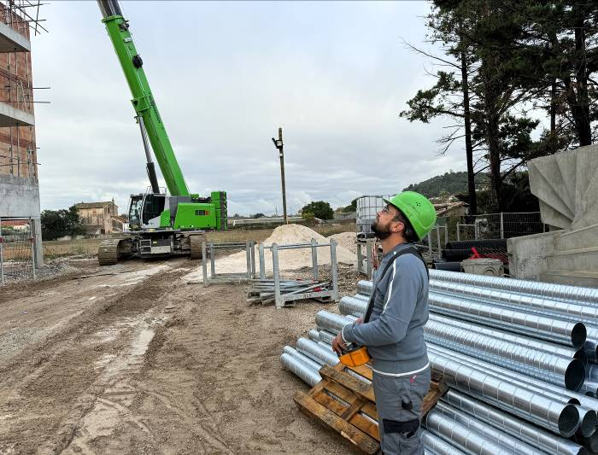
Bild 3: The crane is remote-controlled by Sébastien Greuzard, M&S TRANSLEV, both on the ground and from the floors.

Weitere Einsatzbilder:

