Bild:
Editor Autor: Andrea Heinrich-Jobst
Location Ort: Dingolfing, Deutschland
Date Datum: 23.03.2023

Demolition excavator hire: selective deconstruction in the city centre

When something new is to be built, sometimes the old has to give way. Since the Herzog-Tassilo-Realschule in Dingolfing is to be expanded, the neighbouring, aging dormitory had to make way. The company Karl Mossandl GmbH & Co. had been commissioned with the project. The company is not only active in sand/gravel extraction and processing, ready-mixed concrete and civil engineering, but also in demolition. And this is where the SENNEBOGEN 830 comes into play. Used as a rental machine by SENNEBOGEN Vertriebs GmbH & Co. KG, the demolition excavator impressed in several disciplines.

SENNEBOGEN demolition machine for hire in Dingolfing city centre

The SENNEBOGEN 830 E did a great job, a two-week operation was planned to demolish the dormitory step by step. The fact that the SENNEBOGEN demolition excavator didn't even need a week was a surprise, and the responsible planners were amazed.
Fa. Mossandl was so satisfied and almost a little sad when the rental machine from the SENNEBOGEN rental park was transported back to Straubing.
"I started on a Sennebogen and I will end my career on a Sennebogen," said the machine operator. "The machine has only advantages!" he enthused.
And the advantages are quite impressive. The SENNEBOGEN 830 E was exactly the right machine for the demolition of the dormitory, which is located in the centre of Dingolfing. Right next door is the secondary school, which is now bursting at the seams and urgently needs to be extended. A three-storey building with a partial basement in solid construction is to be built.

Comfortable operation from the cabin

The quick-change system for attachments allows attachments to be changed quickly from the cab. Whether demolition grapple, demolition hammer or pulveriser or the classic demolition tongs, each attachment can be changed quickly and as required at the push of a button. The demolition grapple can be used to sort the building materials. This allows for subsequent raw material recovery and processing.
The selective demolition of a building in a built-up area must always be carried out safely for everyone involved.
The crawler track, which can also be telescoped at the push of a button, offers optimum stability, especially on uneven ground.
GREEN EFFICIENCY is the motto when it comes to environmentally friendly drive technology. With rental machines from SENNEBOGEN Vertriebs GmbH & Co. KG, you always have the option of using the latest machine types that are technically up to date and have environmentally friendly drive technology.
The reliable machines are also easy to maintain, as all service points are easily accessible.

The elevating cab, which can be tilted up to 30°, allows a clear view of the demolition object and offers the operator plenty of space and freedom of movement.

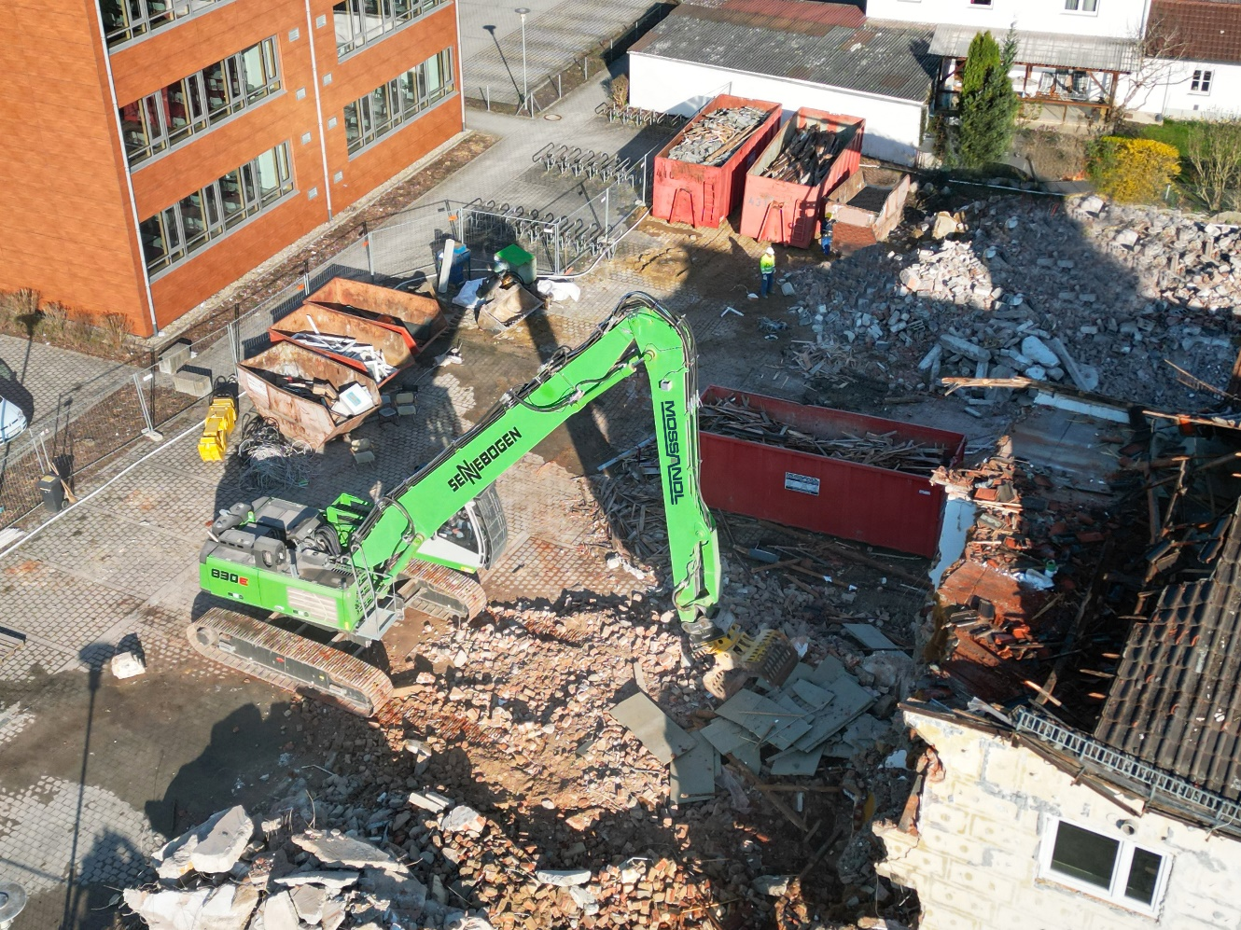
The demolition site in a confined space.
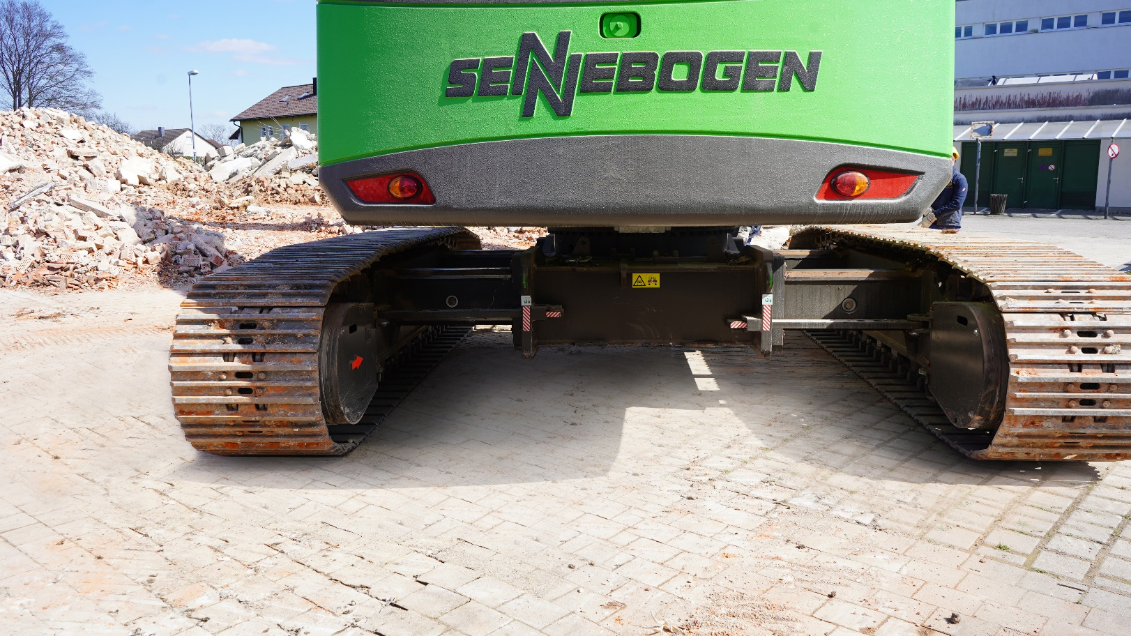
The telescopic crawler undercarriage with a track width of 3.80 m, which can be telescoped at the push of a button, offers optimum stability.

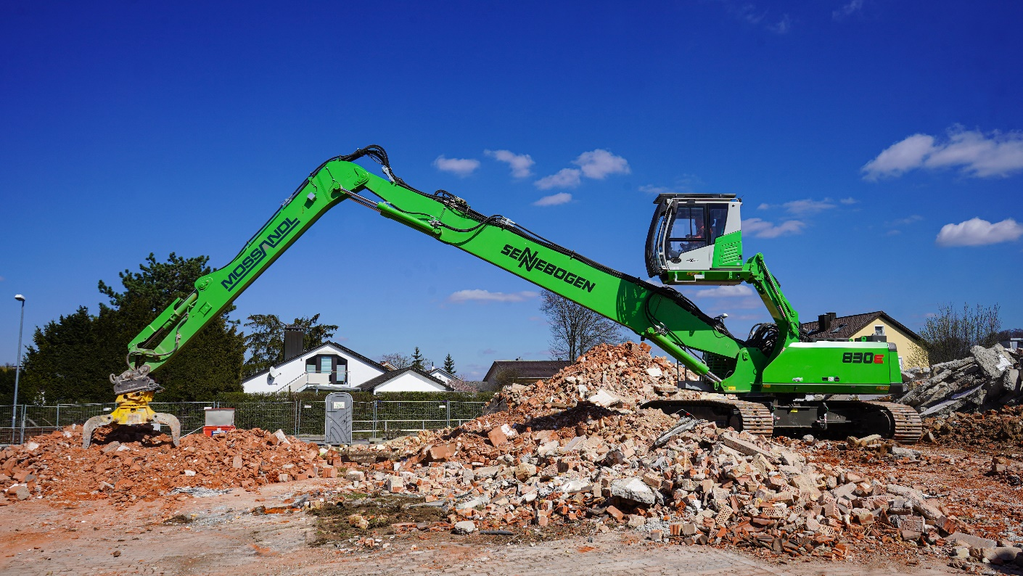
The reach of 18 m, which can be swivelled 360°, means that frequent moving of the machine can be avoided.

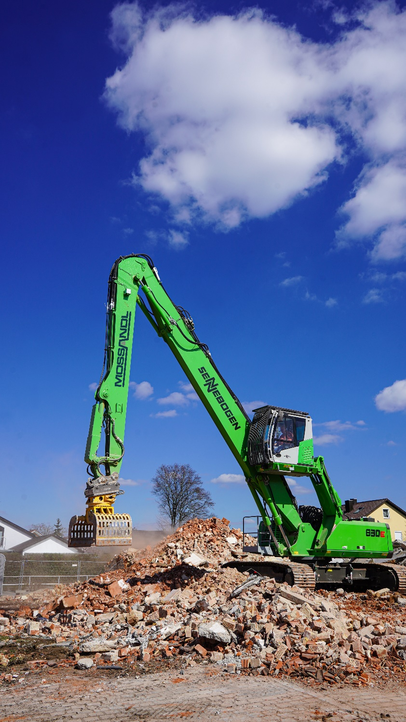
With the elevating and 30° tilting cab, you have an overview of the entire demolition site.

