Bild:
Editor Autor: Jennifer Bortmes
Location Ort: Chemnitz, Deutschland
Date Datum: 20.03.2023

Efficient loading of winter service vehicles with salt

As a modern service provider, the waste disposal and municipal cleaning company of the city of Chemnitz serves a number of business areas. In addition to collecting waste from all households in Chemnitz, operating five recycling centres and disposing of waste water, ASR also provides winter services. Sustainable and quality-oriented action is always in the centre of its attention. For 10 years now, ASR has relied on the use of SENNEBOGEN machines to help make operational processes more efficient. The latest addition and now the 6th machine owned by ASR - the 355 E telehandler - ensures fast and safe salt loading all year long. The machine was delivered and commissioned by the service and sales partner Sander Fördertechnik.

Salt loading already starts in summer

Approximately 70 employees work for ASR Chemnitz in the winter service, fighting snow and icy roads as early as 3 a.m. in a three-shift system. ASR deploys 17 large-capacity vehicles as well as other smaller vehicles on the main roads in Chemnitz. A total of around 900 km of roads and pedestrian crossings at about 330 intersections are taken care of. Priority is given to the main roads, public access roads to hospitals and fire brigades as well as the public transport network in order to prepare the roads as best as possible for the upcoming rush hour.

But even before the sub-zero temperatures set in and the first snow falls, winter maintenance is being thought of. Salt delivery already starts in summer, while during this period the telehandler unloads 4 to 6 trucks daily and fills up the salt storage in continuous operation. Equipped with the salt package, the machine is optimally protected against corrosion and can thus work in the demanding environment without any problems. About 6,000 tonnes of salt are stored in the hall, and 400 tonnes each in two other silos. Mixed with an anti-caking agent to prevent clumping and maintain its gritting ability, the salt can be stored in the hall for an unlimited period of time. Before being spread on the roads, the salt is mixed with a certain amount of lye, whereby the mixing ratio is determined according to the weather conditions. In addition to the improved de-icing effect, the so-called wet salt sticks better to the road surface and is therefore less affected by wind drifts.

Efficient and precise loading of high-sided vehicles

Before the winter service vehicles move out in the cold winter months, they are loaded with the road salt by the telehandler 355 E from SENNEBOGEN. Due to its enormous manoeuvrability, the telehandler is able to move effortlessly, especially in the narrow hall. Here, the machine picks up the salt and loads it onto the vehicles waiting in front of the hall. In addition to its high performance and off-road mobility, ASR is particularly impressed by the excellent visibility from the cab, which provides a clear view even of high-sided vehicles. "It is very important for us to be able to see into the truck containers unhindered during unloading. The same applies to the loading of the winter service vehicles. SENNEBOGEN telehandlers are the only machines on the market with which this is easily possible“, says Sebastian Rehor.

Captions:

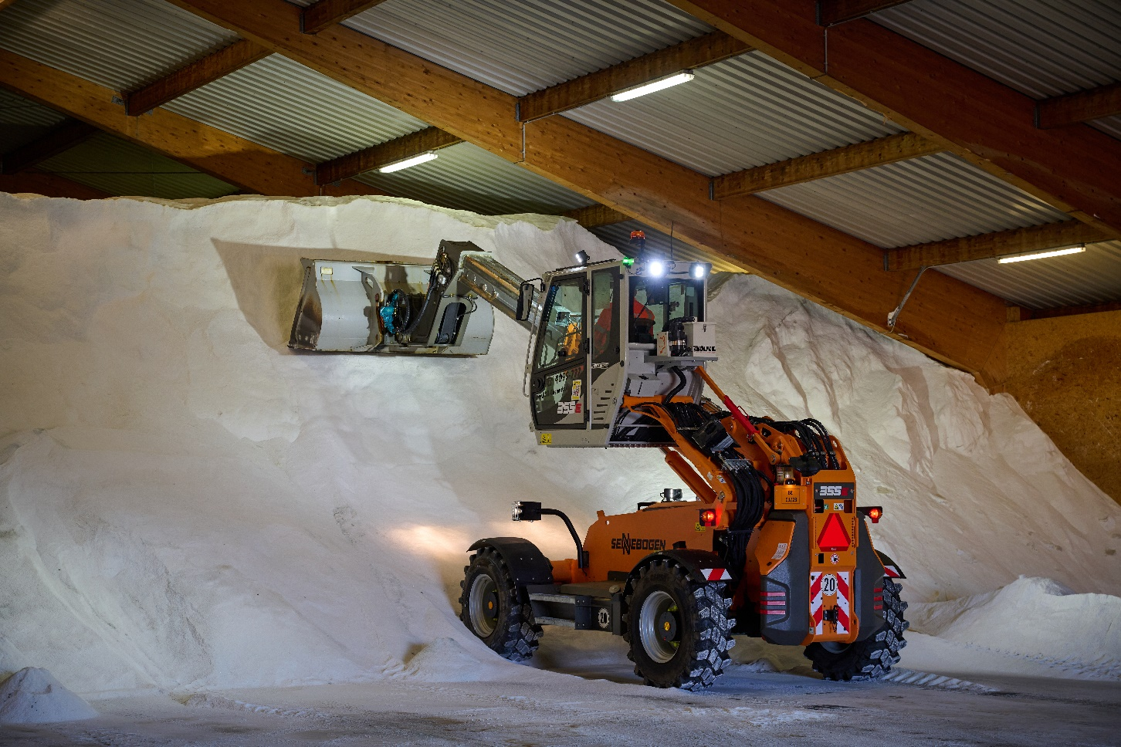
The 355 E telehandler picks up the salt in the hall.
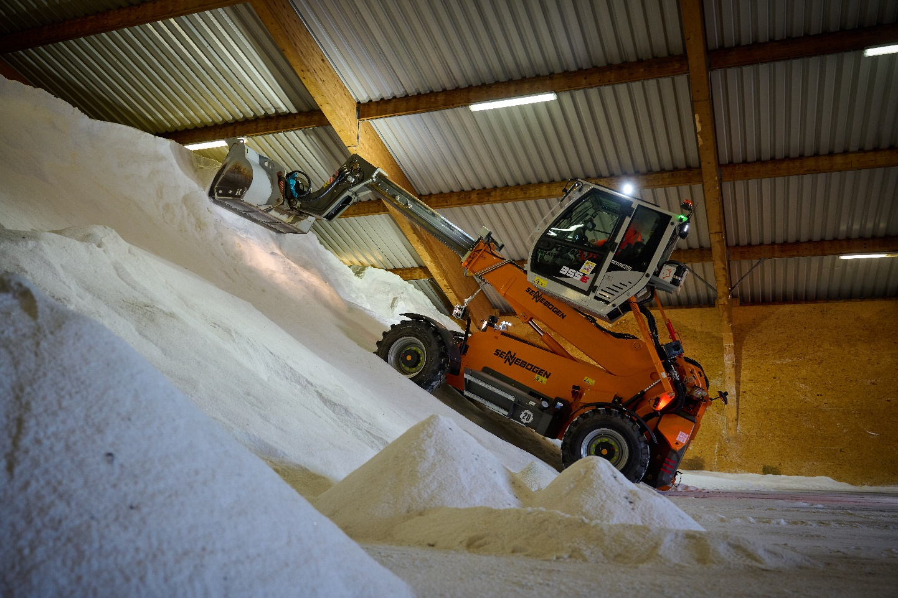
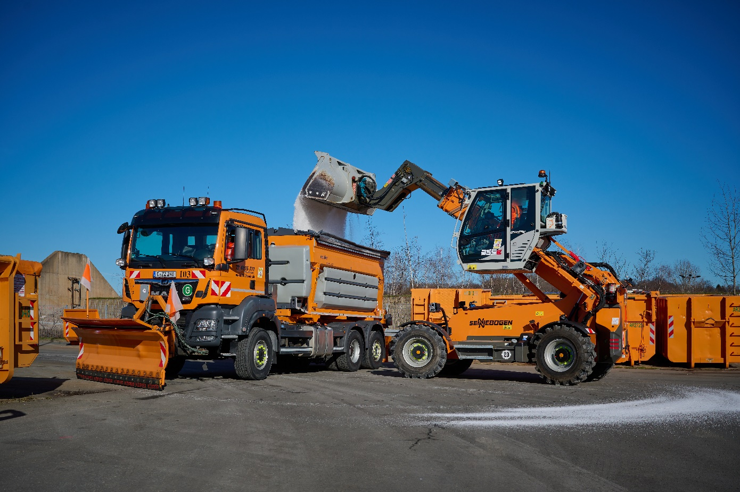
The elevating cab enables efficient and precise loading of the winter service vehicles.
