Bild:
Editor Autor: Niklas Kühle, Jennifer Bortmes
Location Ort: Freiberg, Deutschland
Date Datum: 23.11.2022

Customized rail undercarriage and electric motor: perfect combination in port handling

For bulk handling by the ton in the port, Schlüter for construction equipment delivered a new SENNEBOGEN electric material handler to Freiberg to Valet u. Ott GmbH & Co. KG. Thanks to the installed electric drive, the 835 E not only impresses with its low operating costs, but also with its special rail undercarriage, which was specially adapted to the rails already existing in the port at the customer's request.

Valet u. Ott Group: A medium-sized family business with a long tradition

In 1926, the company founders August Valet and August Ott laid the foundation for the medium-sized family business Valet and Ott with the first gravel plant in Freiberg am Neckar. The Valet u. Ott Group operates gravel plants in Baden Württemberg, Mecklenburg-Vorpommern and Saxony for the production of high-quality concrete aggregates and road construction materials. The focus of production is on the manufacture of high-quality gravel, crushed stone and sand products. In addition to its products, the company offers its customers a wide range of services, which include logistics, construction materials monitoring and structural investigations, civil engineering as a concrete pumping service provider and as a receiving point for uncontaminated excavated material. In total, Valet u. Ott GmbH & Co. KG employs almost 300 people at 38 locations. The headquarters are located in Freiberg am Neckar, where approx. 150,000 tons of material are delivered by ship each year - and the trend is rising. The total amount of material handled is about 300,000 tons.

Environmentally friendly electric material handler for efficient port handling

The 835 E from SENNEBOGEN is used by Valet u. Ott GmbH & Co. KG in Freiberg, Germany, for loading and unloading ships as well as material handling including truck loading. Thanks to the installed 200 kW electric motor, the material handler always works with high performance in combination with low consumption, which ensures fast working cycles during loading and unloading - and that is money-saving and environmentally friendly. Its robust design, due to particularly low-wear and durable machine components, makes the 835 E from SENNEBOGEN a real expert for continuous operation and protects the machine from longer downtimes. In addition, the electric material handler is particularly easy to maintain. With the E-series installation at the rear of the upper carriage, easy and safe access to the electric components is ensured. A non-slip tread surface also protects the machine operator from accidents during maintenance work.

Special equipped rail undercarriage for existing grinding rails in the port

A major special feature is the rail undercarriage of the SENNEBOGEN 835 E electric material handler at Valet u. Ott GmbH & Co. KG. This was specially designed to meet the needs of the Freiberg-based family business and, together with the electric drive, offers the perfect combination in port handling. To enable the machine to move on the existing grinding rails in the port, a hydraulically driven rail undercarriage of the 835 E series was selected and adapted to the track width of the rails. In order to be able to accommodate the existing electrical box for controlling the sliding contacts, the undercarriage of the electric material handler was equipped with cutouts and a bracket. The mechanical connection between the rails and the material handler was carried out by the customer service specialists of Schlüter for construction equipment.
Marco Moradian, operations manager: "One of the main reasons for acquiring the electric material handler was the adapted rail undercarriage. We had massive problems there before and other manufacturers could not offer us a satisfactory solution."

Reliability and performance of the machine convinces customer

The SENNEBOGEN 835 E electric material handler has now been in service at the port of Valet u. Ott GmbH & Co. KG. for almost three years. Marco Moradian is very satisfied with the machine: "We looked at several products in the course of the purchase and SENNEBOGEN had the machine that convinced us the most. In addition to the adaptation to our rail portal, we also had a few requirements in terms of outreach and lifting capacity, and that's where the 835 E electric material handler from SENNEBOGEN was the machine that fits best." The SENNEBOGEN 835 E electric material handler was delivered by Schlüter for construction equipment in the person of Area Sales Manager Michael Köhnlein. The medium-sized family-owned company sees itself not only as a dealer, but especially as a service provider with first-class customer service. The sustainable satisfaction of the customer is the focus at Schlüter for construction equipment, individual needs and wishes are jointly implemented in market-oriented services.

Captions:
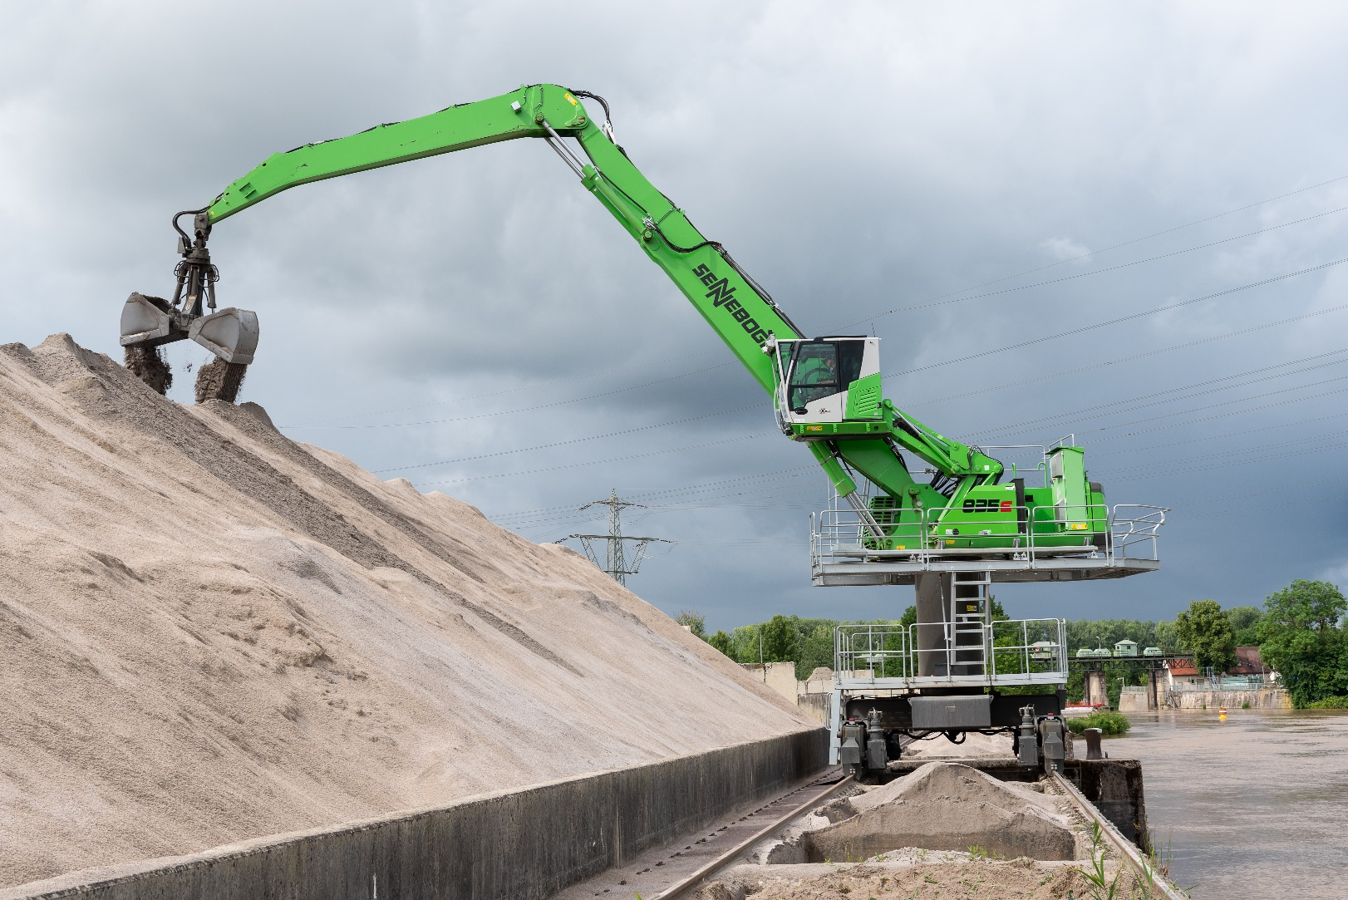
Thanks to the 835 E with powerful electric drive, tons of bulk material are handled efficiently
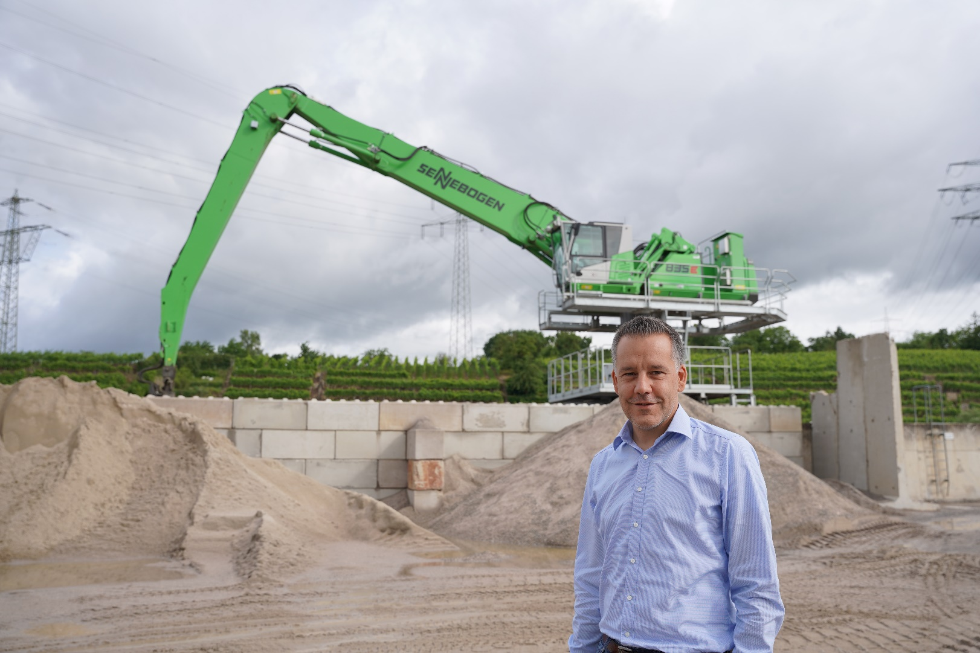

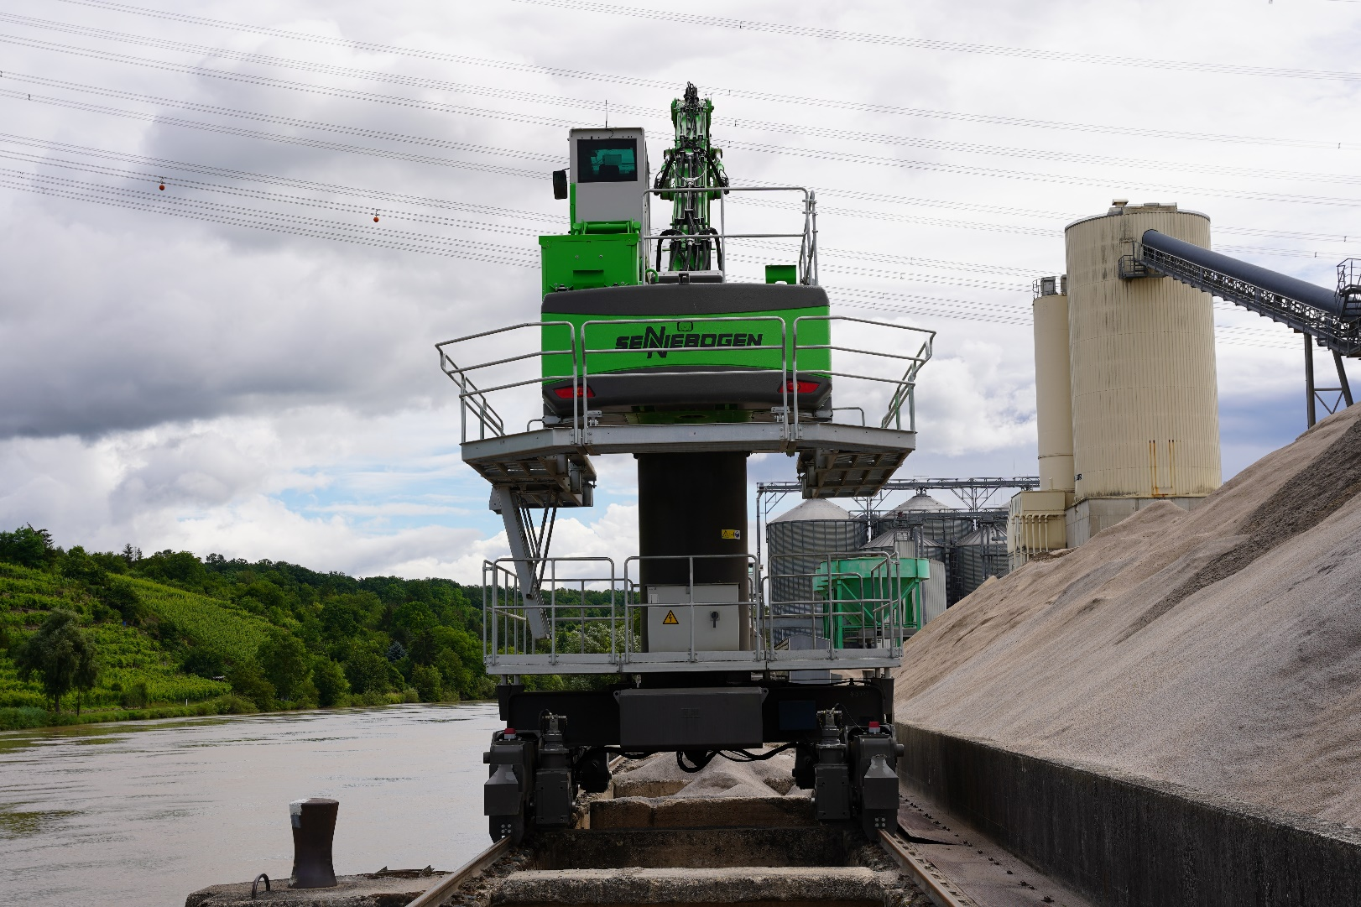
The rail undercarriage was specially adapted to the customer's needs

