Bild:
Editor Autor: Franziska Brielbeck
Photo Foto: Stefan Hanke
Location Ort: Antwerp, BE
Date Datum: Apr-22

Best overview in demanding bridge construction thanks to 50t telescopic crawler crane with elevating cab

Up high – to 5.4 m viewing height to be precise – is where the driver of this 50 t telescopic crawler crane from SENNEBOGEN goes during bridge construction in Belgium. On one of the largest construction sites in Europe, the SENNEBOGEN 653 E telescopic crane with elevating cab is in use for Artes.

In order to sustainably reduce congestion, but at the same time meet the mobility demands of the population, the government of the Belgian region of Flanders developed the so-called "Mobility Master Plan 2030". The primary intention is to improve accessibility to the Flemish capital Antwerp and the port. An important part of this project is the expansion of the Oosterweel Link highway, which will complete the ring road around Antwerp. The new section of highway is scheduled to open in 2030.

Bridge construction over the E17 highway with the robust 50 t telescopic crane
In order to realize this ambitious plan, numerous changes will have to be made to the existing infrastructure. These include the replacement or expansion of road sections, intersections and exits. In the first phase of the construction project, among other things, the connecting road to the E17 highway will be completely rebuilt. The Belgian construction company Artes, as part of the commissioned joint venture Rinkoniên, is responsible for the construction of the new bridges and is using one of its 50 t telecrawlers from SENNEBOGEN for this purpose.

Maximum safety and ergonomics during crane operations thanks to hydraulic cab adjustment
The fact that Artes had the telescopic crane equipped with a cab that can be elevated hydraulically by 2.70 m brings clear advantages for handling the formwork and rebars for which the crane is used. Thanks to a viewing height of up to 5.40 m, the operator always has an optimum view of his working area and can lean back easily in his seat at a maximum angle of 30° – an ergonomically ideal posture for permanently concentrated work with maximum precision. Additional headlights on the basic boom and on the upper carriage, roof windows made of bulletproof glass, and a programmable work area limitation that monitors the angle of rotation and boom radius also ensure maximum safety on the construction site.
Convinced by the elevating cab
Artes, served by Belgian sales and service partner VAN HAUT, has several SENNEBOGEN cranes with elevating cab in their fleet and really appreciates this feature. Since they have a lot to do with hydraulic engineering, they often work along waterways. "We specifically equip our telescopic cranes with the elevating cab because it increases productivity and safety. The crane operator can often see for himself when something needs to be lowered to a deeper point, for example when building a quay wall, and can then react directly himself instead of using walkie-talkies or hand signals. But also on other construction sites in civil engineering, the overview is much better for the crane driver, so he can work faster and safer," summarizes the technical superintendent at Artes, Wouter Van De Putte.

Captions:
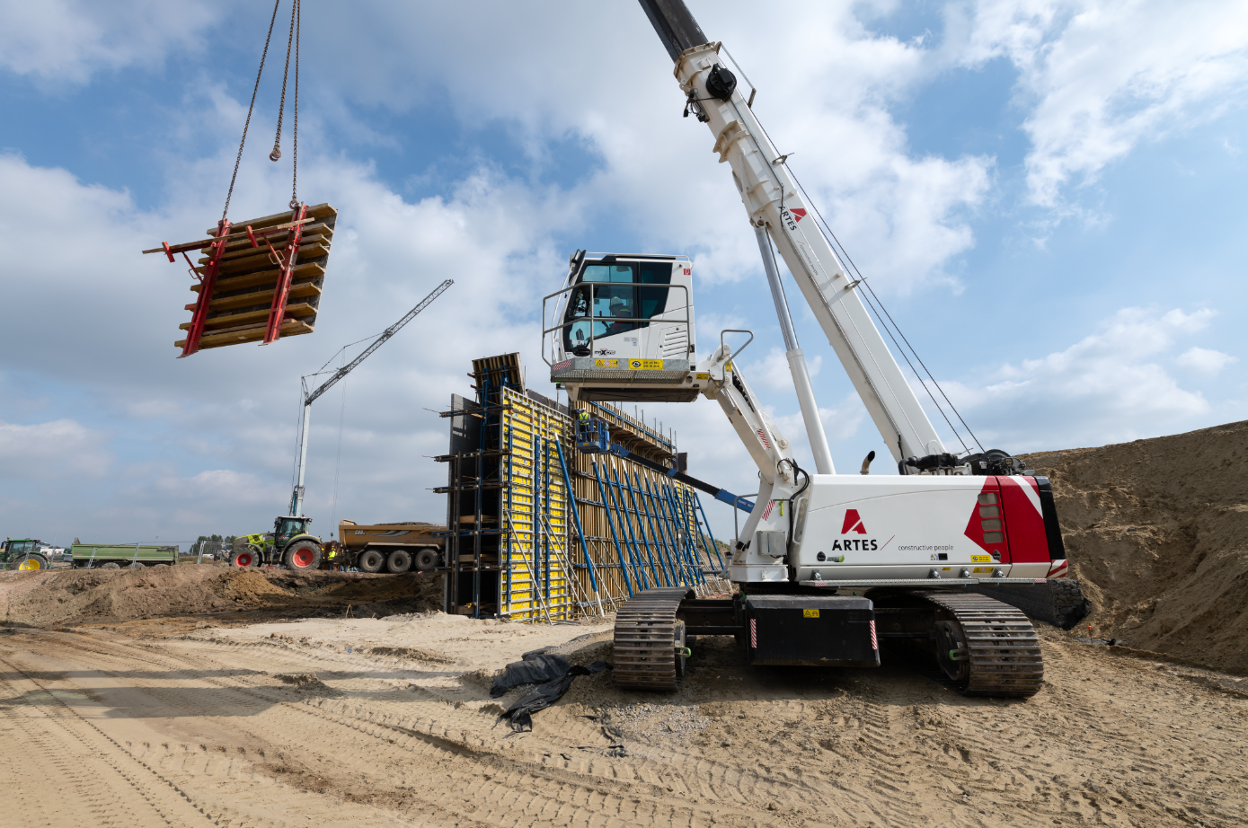
Image 1: With the help of the 50 t telescopic crawler crane from SENNEBOGEN, Artes dismantles the formwork of one of the new bridge piers on the E17 freeway near Antwerp.

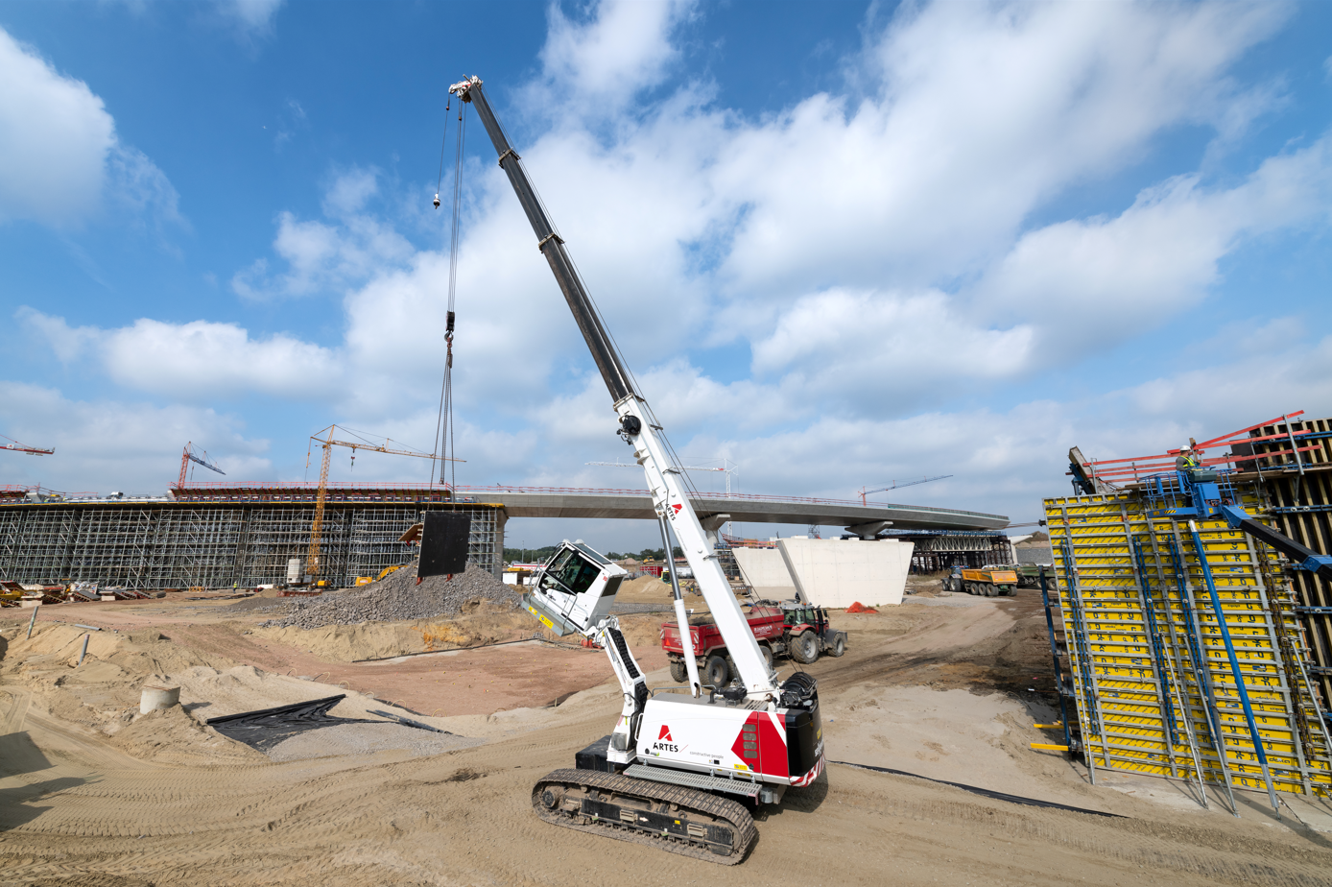
Image 2: The comfort cab, which can be raised hydraulically by 2.70 m and tilted by 30°, is ergonomically optimal for the operator and enables maximum productive and safe working on the construction site.

