Picture:
Location Ort: Iskenderun Port,
Turkey
Photo Foto: Forsen
Machinery
Editor Autor: Kerstin Wabner
Date Datum: 11/18/2020

SENNEBOGEN 9300 E mobile harbour crane with electric drive for bulk cargo handling in the port of Iskenderun

615 kW electric motor, approx. 290 t operating weight, 90 t load capacity, 56 tires, 14 axles – the SENNEBOGEN 9300 E mobile harbour crane with a jib length of 41 m can now also be found in the port of Iskenderun. Kalkavan Liman Hizmetleri, a stevedoring company with several locations in Turkey, invested in a powerful mobile harbour crane for Port Limak which can be used to handle anything from general cargo and bulk goods to containers. With a reach depth of around 20 m inside the ship and equipped with a 4-rope grab, the port colossus in Iskenderun unloads bulk carriers up to the Post-Panamax size.

In the rapidly growing port environment, requirements for operators are constantly increasing. In their role as gates to the inland, to Europe and the Middle East, Turkish ports in particular have recorded a positive growth trend for years. For that reason, streamlining and efficient management are the focus of all port professionals’ efforts. This also applies to Kalkavan, a Turkish stevedoring company represented in several ports in Turkey. For several years, the visionaries have relied on “green” support with regard to port handling equipment: now they use a total of five SENNEBOGEN material handling machines to unload ships. In 2019, the company finally put the SENNEBOGEN 9300 E mobile harbour crane with electric motor into operation, which now helps them reliably overcome all the challenges of everyday port life.

SENNEBOGEN 9300 E mobile harbour crane: Efficient and intelligent machine concept
When it comes to reach and high load capacity, the SENNEBOGEN 9300 E is the best choice for the port: 90 t load capacity at 19 m jib length, a total working radius of 41 m and a powerful 615 kW electric motor that drives the hydraulic circuit and thus powers all work movements. With the ability to handle containers as well, service providers in ports can react flexibly to the requirements of day-to-day business. Despite the maximum load of up to 1,200 t of grain per hour in Iskenderun, the 9300 E operates economically and effectively thanks to its electric drive, as Kalkavan's Managing Partner Senai Koçyiğit emphasizes: “Every day, we unload different bulk materials with high cycle rates, including grain, mineral raw materials and coal. Thanks to its intelligent design and robust construction, the SENNEBOGEN electric mobile harbour crane was well worth the investment. The electric drive also minimizes our operating costs on the long term.”

Compact mobile harbour crane with maximum stability and driving comfort
The star-shaped mobile undercarriage and its generous support base ensure optimal weight distribution and force transmission into the ground, thus increasing the stability of the machine. A motorized cable reel is also mounted on the undercarriage with a cable which supplies the machine with power over its 370 m travel distance. Right from the start, the machine needed to serve two more of Kalkavan's quays: SENNEBOGEN sales and service partner in Turkey, Forsen Machinery, developed a suitable mobility concept including an additional diesel generator, the SENNEBOGEN Powerpack, for short distance mobility. This makes it easy to disconnect the power supply to the undercarriage and reposition the machine with the Powerpack’s drive.

The two 45 t winches and all drive components are placed in the solid machine house, which can only slew within the area of the support base to prevent collisions. This way the operators are not only assured that they are working safely, they also benefit from the sophisticated crane design during daily machine checks or major maintenance work: Indeed, the engine housing in the rear with a hydraulically liftable roof impresses with its easy accessibility in all weather conditions. Another unique feature of the SENNEBOGEN 9300 E is the port cab, which can be elevated by 11 m: In the lower cab positioning, operators can comfortably enter the port cab by going up just a few steps and have a perfect view of the driving area because the cab is so close to the ground. Fully elevated the cab gives the operator a total viewing height of up to 21.2 m – ideal for positioning the mechanical 4-rope grab inside the ship and filling the hopper.

[Caption:]
SENNEBOGEN 9300 E electric mobile harbour crane while handling grain in the port of Iskenderun
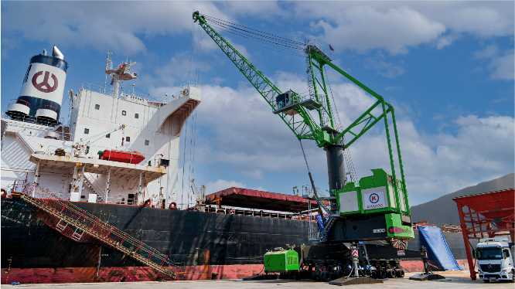
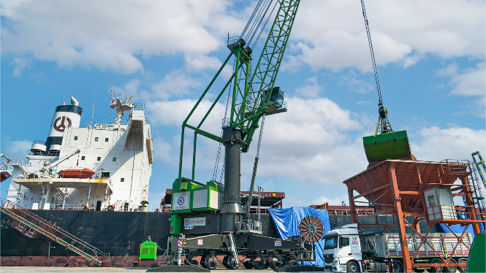

Intelligent design: Robust, star-shaped mobile undercarriage with 56 tires and motorized cable reel for easy e-mobility in the port
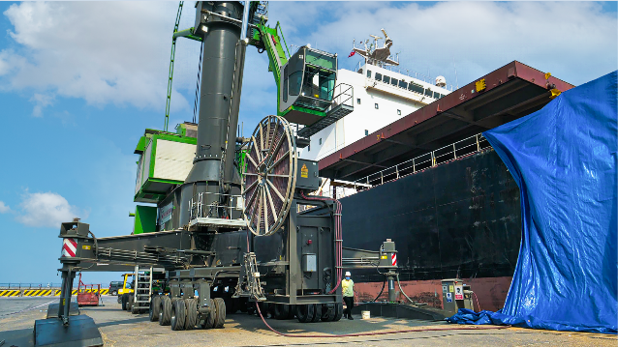
Thanks to the ergonomically designed Portcab, the operator can enjoy a clear view of their work area. As an additional feature, the zoom camera supports the operator when loading the grab inside the ship hull, conveniently visible on screens from the operator's seat
