Bild:
Location Ort: Worb (CH)
Photo Foto: Kerstin Wabner
Editor Autor: Kerstin Wabner
Date Datum: 16.09.2020

New logistics concept in Switzerland: The SENNEBOGEN 730 material handler in Pick & Carry operation with trailer

An approximately 50-year-old gantry crane was disassembled near Bern in 2019: The Swiss sawmill OLWO AG in Worb started into a new era with the 730 E from SENNEBOGEN in 2020. From now on, the combination of a mobile timber material handler and trailer will enable even more effective use of the available space in the sawmill.

OLWO AG in Worb, located in the canton of Bern in Switzerland, is a family business with a long-standing tradition: Established in 1926 by grandfather and founder of the company Otto Lädrach in Worb (OLWO), who began with the lease of a small sawmill, the company is now run successfully by the third generation and meanwhile operates at three different production sites.

In the course of the upcoming redesign of the logyard at the Worb site, the transport routes in the sawmill were analyzed. A new concept, consisting of the SENNEBOGEN 730 E series material handler and a trailer application, proved to be superior to the previous yard concept with a gantry crane. Today, the timber material handler is responsible for lifting the logs. But not only that, as the 730 E series with a trailer has many responsibilities and is in constant use: Every day it transports many tons of wood from the logyard to the sorting line, stacks logs, loads the trailer and feeds the saw.

Logistics with mobile SENNEBOGEN 730 E-Series material handler
After more than 50 years, a local demolition company started dismantling the approx. 52-tonne gantry crane. Production Manager Kurt Grossenbacher explains the numerous advantages that the new logistics concept has offered since then: "With the SENNEBOGEN, the log storage area, which is located at a certain distance, can also be reached. Now we can act much more flexibly and use the 730 with fully loaded 30 t trailer throughout the entire area. This reduces the need for expensive intermediate transports by truck". Moreover, thanks to the sensitive joystick control, which is ergonomically designed and allows the operator to handle the logs easily and intuitively, the operator can stack logs up to a height of 8 meters without encountering difficulties.

The solution was developed in cooperation with sales and service partner Kuhn in Switzerland: "Initially, we had the idea of installing a new crane portal. But the mossy soil foundation was too unstable and the mounting of the portal would have been too costly. With a mobile material handling solution including a trailer, we have now found a good, new path," Kurt Grossenbacher further explains the background of the project.

[Caption:]
- One machine, multi-purpose use at OLWO in Switzerland: 730 E series in Pick & Carry application with trailer for transporting, stacking, feeding the saw and loading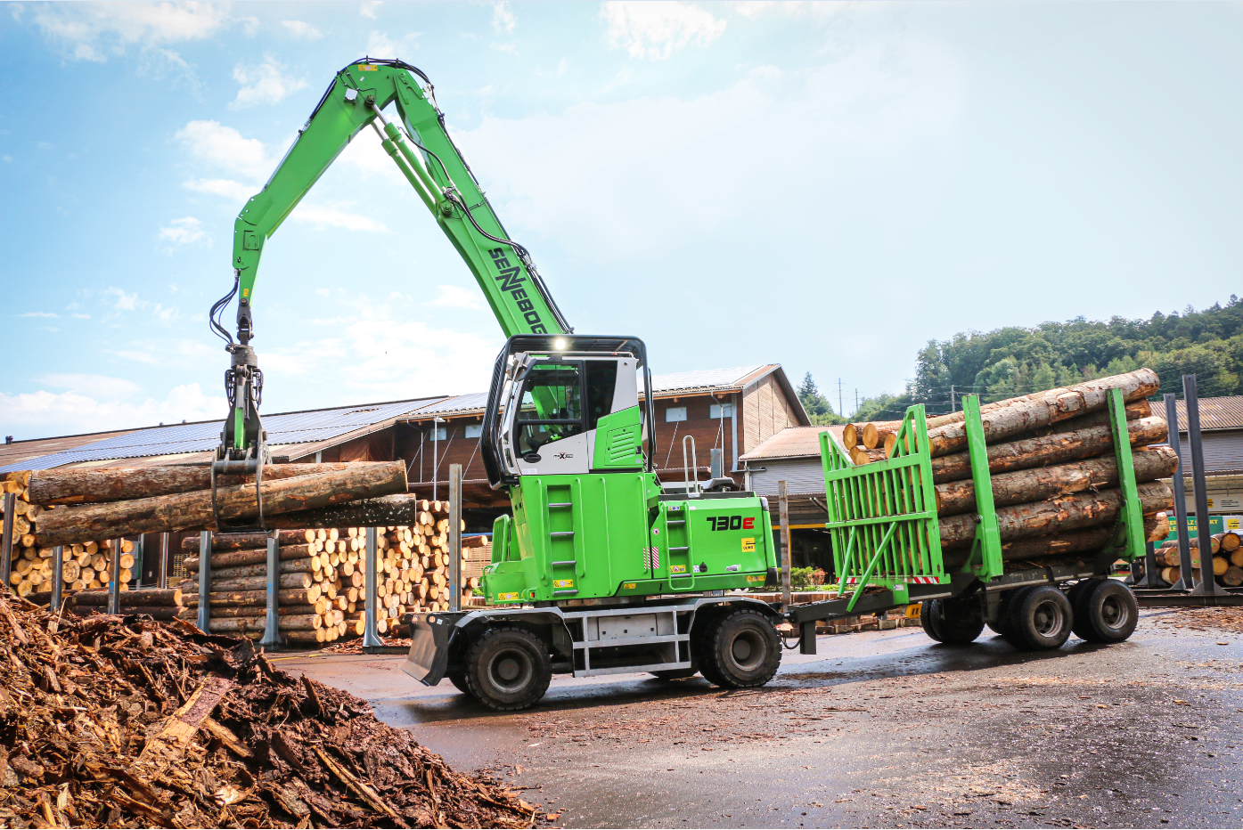
- Transport from the log piles to the saw: The SENNEBOGEN 730 E series charging the loading table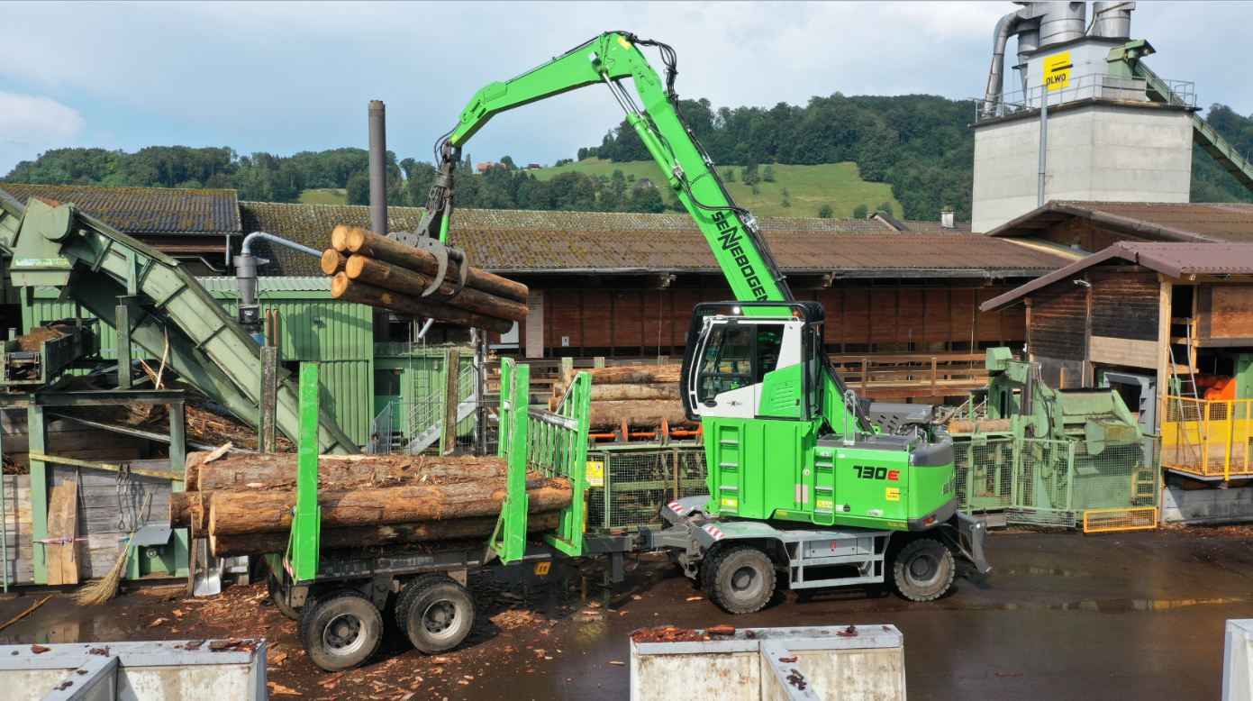
- Efficient use of travel routes: The 30 t trailer of the 730 E series pulls through narrow driveways with ease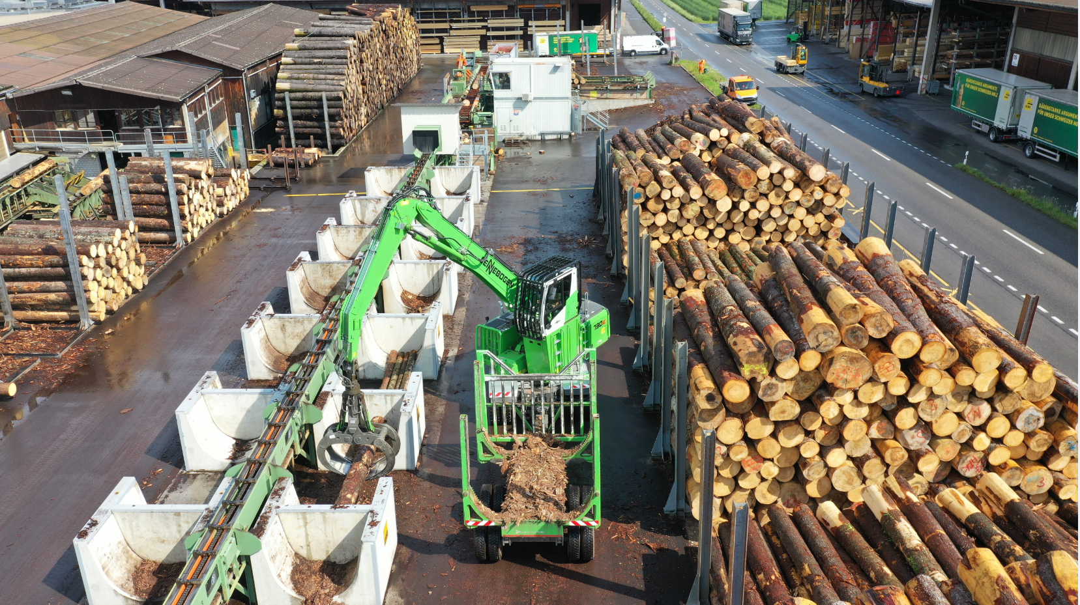
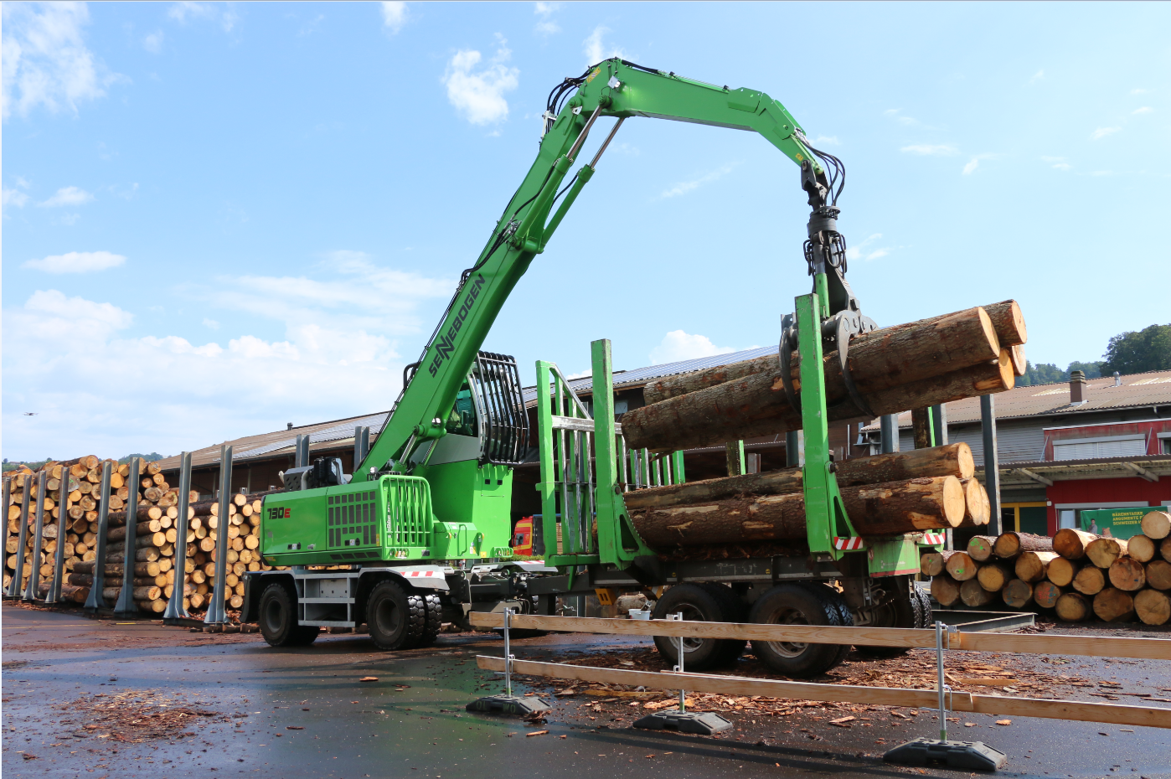
- OLWO's sawmill in Worb: Every year, about 55,000 solid cubic meters of large logs are processed