Editor Autor: Baublatt Österreich | Photo Foto: Baublatt Österreich | Location Ort: Liezen | Date Datum: Sep-20 | Photo Foto: Czech | Location Ort: Straubing | Date Datum: Sep-20

Two SENNEBOGEN 355 E telehandlers replace three wheel loaders at AWV Liezen in Styria, Austria

For over 40 years AWV Liezen has been the central location for waste management in the Liezen district. Using state-of-the-art systems, around 16,000 t of residual waste are processed here each year, among other things. Recently there were some changes to the vehicle fleet - two new SENNEBOGEN 355 E telehandlers were introduced to take on the material handling tasks previously carried out by three wheel loaders.

In addition to the state capital, Graz, which takes care of its own waste management, Styria is divided into 16 waste management associations. AWV Liezen, which has been led by engineer and managing director Ludwig Bretterebner since 1996, looks after almost the entire Liezen district through its 22 member communities. Bretterebner: “At our Liezen site we handle residual waste, organic waste, bulky waste and problem materials for our member communities. We also handle smaller quantities of commercial waste. The majority of the waste is delivered to us, but we collect bulk waste on the communities’ behalves using 136 collection containers. We have various types of landfill site here, including a mass waste landfill, a residual waste landfill and, coming soon, a construction waste landfill. We buy in some services, for example construction waste is processed by a contractor.”

Since 1981, AWV Liezen has used a mechanical-biological waste treatment system. It means that all the residual waste can be handled on site and processed in two fractions. One fraction is subject to multiple stages of heat treatment for further use as fuel, and the other fine fraction is treated as biological waste and put into landfill. Material that cannot be reused is put into the mass waste landfill, organic waste is turned into organic compost and put back into circulation. Bulk waste, used timber and metals are all sent for recycling as appropriate.

A total of 21 employees work on the site. The vehicle fleet includes three trucks for various transport tasks, a material handler for sorting tasks and loading containers, and finally, five wheel loaders. These were mainly used for handling material in the different areas - from filling the pits and feeding the treatment systems to putting materials in the bioreactors and loading trucks. As part of a recent vehicle fleet upgrade, three of the five wheel loaders were replaced with two new SENNEBOGEN 355 E telehandlers.

Bretterebner again: “At the start of the year, the company Ascendum gave us a SENNEBOGEN 355 E telehandler to use for a week. Our operators used the machine for all the work processes we have, and I also tried it out myself. We then weighed up the pros and cons and we all agreed that the 355 E would suit us really well. As three of the wheel loaders needed to be replaced anyway, we rearranged our entire material handling system and agreed to invest in two SENNEBOGEN 355 Es. Thanks to the huge versatility of these machines, with two 355 Es we can cover a wider range of tasks than we could with the wheel loaders. This decision also meant that we could go from three machines down to two. Obviously, we looked at various telehandlers during this time, but the numerous benefits of the SENNEBOGEN 355 E’s elevating cab were what swayed us in the end. The other big advantage of SENNEBOGEN for me is the stable construction. As I have personally worked as a master mechanic on construction machines, I am well placed to assess these qualities.”

The technical strengths of this versatile machine at a glance: with an operating weight of just under 12 t the SENNEBOGEN 355 E telehandler can reach a stacking height of 8.5 m and has a maximum load capacity of 5.5 t. The variable travel drive always supplies generous amounts of power thanks to the combined efforts of the stage IV diesel engine and the hydraulic pumps.

Swen Luger, the relevant supervisor at Ascendum, explains: “Both of the SENNEBOGEN 355 Es at AWV Liezen are the latest generation, the machine has been redesigned from the ground up and uses state-of-the-art technology. The 355 E’s particular strength is obviously the elevating cab. Its height of over 4 m provides the operator with an excellent view when carrying out various operations. The cab offers an outstanding all-round view, thanks to its large glass panels, contributing significantly to work site safety. In addition to the elevating cab, the machine has top-quality equipment. This includes a completely enclosed underbody, as well as the series standard reversible fan. In its basic configuration, this machine is well equipped for working in the recycling industry, the only optional extra that AWV Liezen required was SEKA protective ventilation. Last but not least, the 355 E’s quick change system means that it is compatible with a whole host of attachments. All of these benefits are appreciated by a growing number of recycling operations.”

At AWV Liezen, the SENNEBOGEN 355 E, which is also licensed for road use, operates a traditional universal bucket with a hold-down, pallet forks and a sweeper.

In conclusion, Bretterebner stresses: “We expand and modernize our operations every year as both our work and our areas of activity are growing continuously. This year our focus was on renewing our vehicle fleet and I am certain that we have made an excellent choice with these two new SENNEBOGEN 355 Es. The positive experience we had in the test phase has continued now that we are using them full time. The operators really appreciate the comfort and user-friendliness of the machines, which is no small thing. This is an important point, as it is only when we ensure full efficiency in all areas, that AWV Liezen can carry out its demanding tasks now and in the future.”

Revised text and pictures courtesy of “Baublatt Österreich”.

Captions:
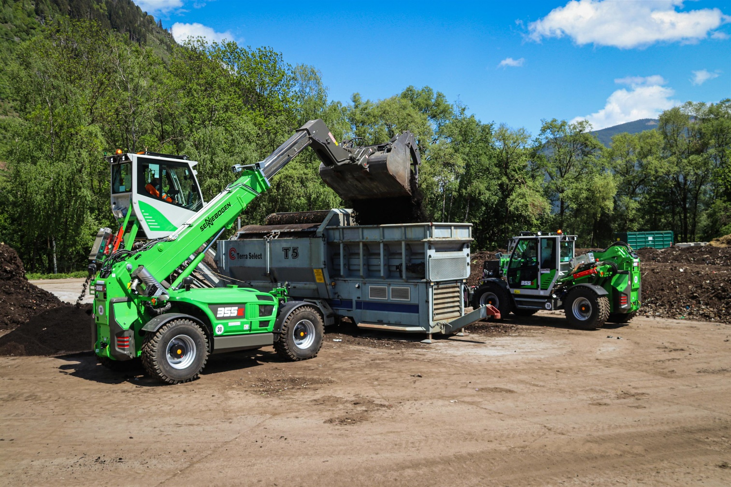
Thanks to the huge versatility of the SENNEBOGEN telehandlers, AWV Liezen needs one less machine than previously. The range of tasks previously carried out by three wheel loaders are now done by just two SENNEBOGEN telehandlers.

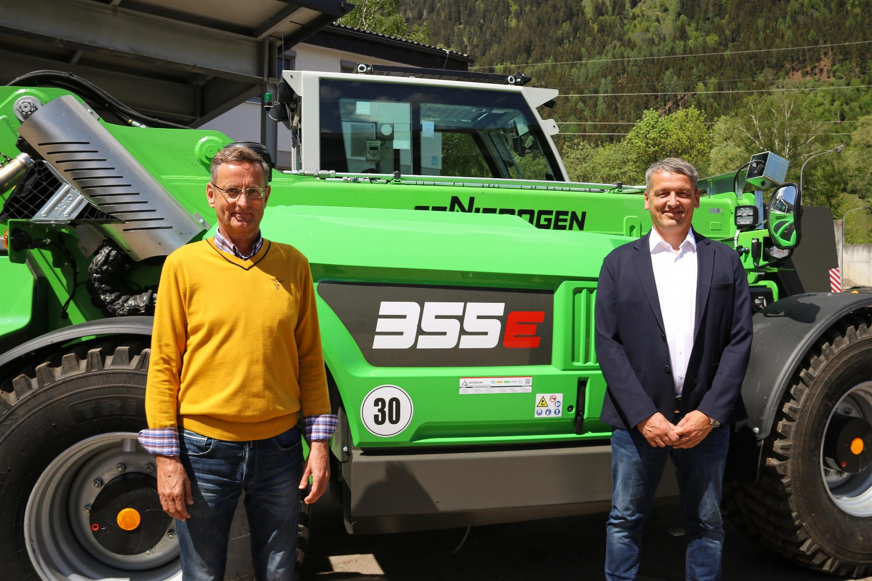
Left to right: Managing director and engineer, Ludwig Bretterebner (AWV Liezen), is very impressed with the versatility and efficiency of the two new SENNEBOGEN 355 E telehandlers. Swen Luger (relevant supervisor at Ascendum) points out the comprehensive equipment and state-of-the-art technology on the latest generation of 355 Es.

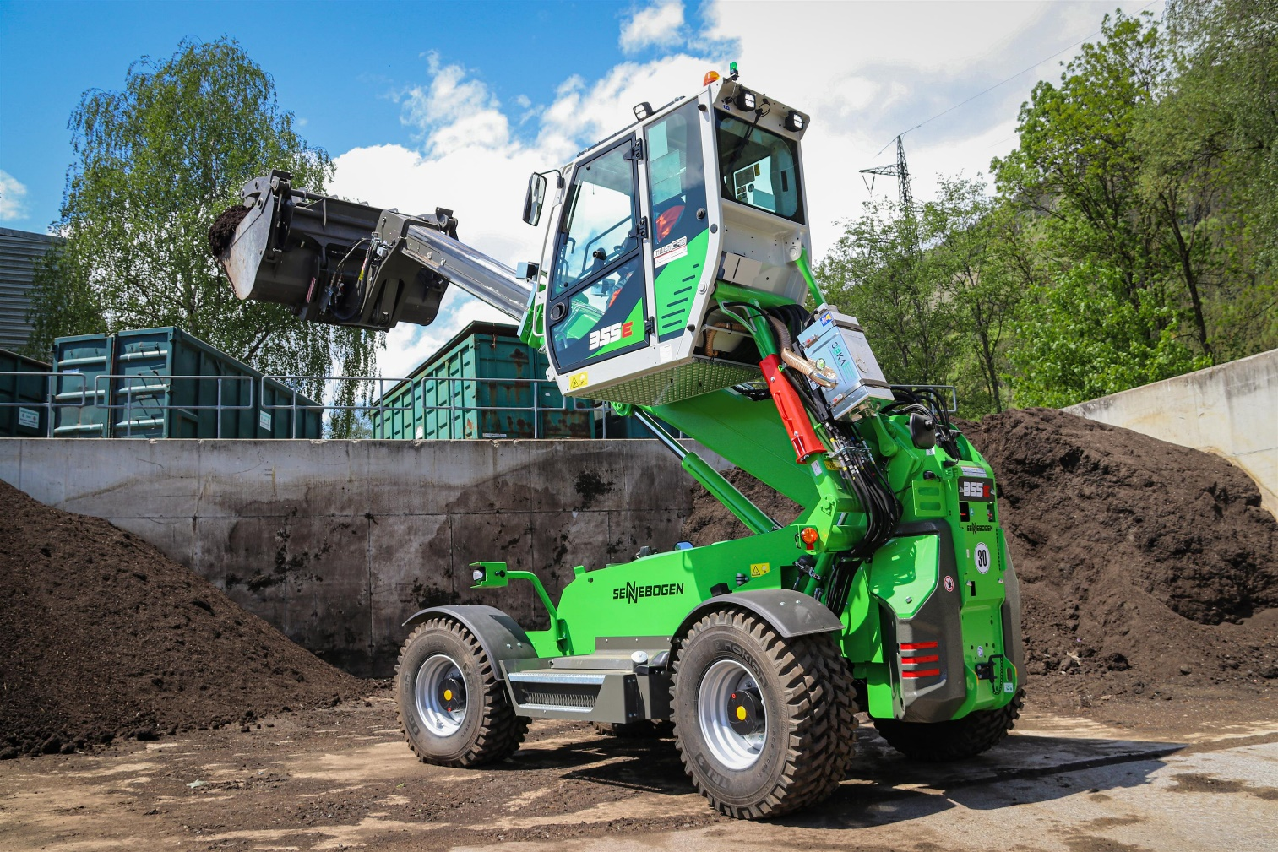
The details of the SENNEBOGEN 355 E telehandler are impressive - from the drive and the kinematics to the boom and other ingenious options.

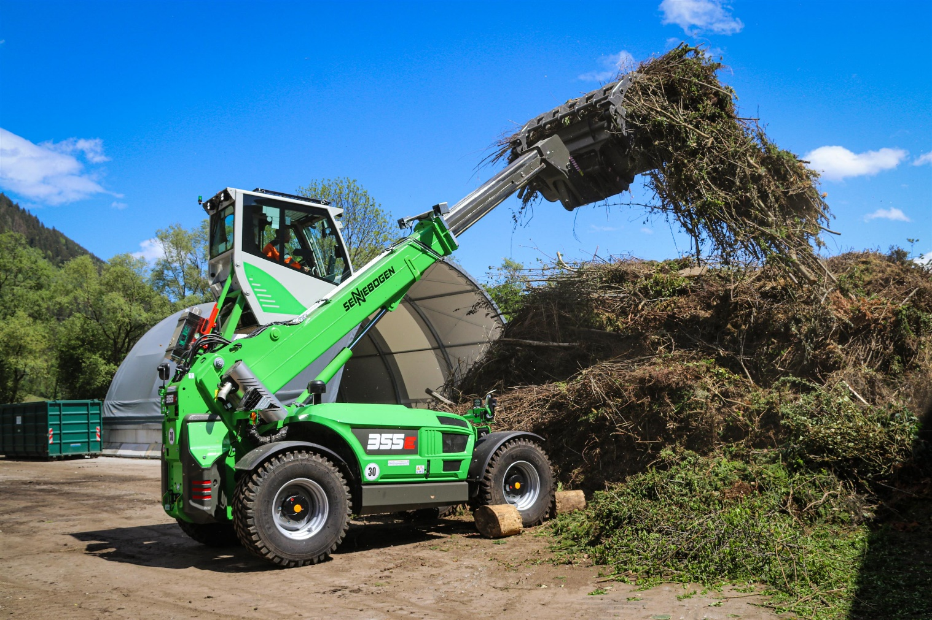
A versatile powerhouse: with a quick-changer and a range of attachments, the SENNEBOGEN 355 E can be used in numerous ways. The Z kinematics direct power perfectly to the bucket.

